Presbyterian Press
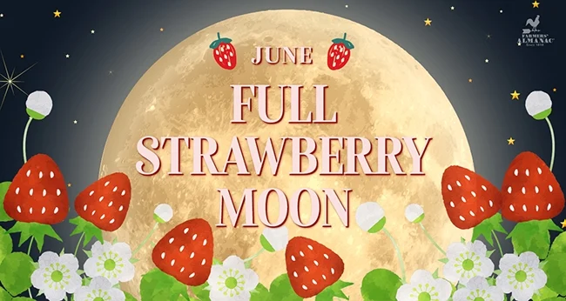

June 2025


A note from the Pastor . . .

Greetings and blessings to all. We have had a busy but blessed Easter season, and it is hard to imagine that Pentecost is upon us, and that the summer is all but here. Speaking of Pentecost, it is Sunday June 8th, and I, unfortunately, will be out of town on a family vacation that Sunday. We will however be blessed by having Cody Myers fit the pulpit for us that Sunday. Pentecost is an important but also somewhat overlooked date on the Christian calendar. The word Pentecost is derived from a Greek word, pentekoste which literally means fiftieth. It is fifty days after Easter. But that it not the most significant aspect of the day. This is the day that we celebrate as the beginning of our recognizing the presence of the Holy Spirit in our world. It is the recognition of the constant presence of God in the form of the Holy Spirit. Jesus most often referred to this presence as “the Advocate.” The Greek word there is parakletos which translated literally means “one who comes alongside” in other words, the presence of God alongside of us. Some translations use the words “helper” or “counselor.” However regardless of what word we choose to describe the presence of God, it remains the most powerful force in our lives. Because the Holy Spirit rested above the heads of each of the disciples on the first day of Pentecost, as though there were tongues of flame above the, we celebrate by wearing red and we talk about light and flame. So, if you remember, wear something red on Sunday and be reminded that God is always with us and the Holy Spirit comes along side us as helper, counselor and advocate.

I mentioned that we have had a busy time in the life of the church and that is true. So much has been accomplished in the last few months that it is somewhat difficult to express it all. Quite notably we had the sanctuary wall that is in the courtyard repaired. Not only is it nice to not have holes in the stucco, but it is also all the same color for the first time in many years. Gratefully we were able to pay the over $73,000 bill from some of our endowment funds so that we did not have to secure a lone from a financial institution, however it is necessary that we diligently and faithfully replace those funds as soon as possible. This is part of being good stewards of what God and our predecessors have given us in this amazing building. It is also an important aspect of looking into the future of this congregation, this building and this community. To that end, we are beginning the journey of a capital campaign to replenish the funds that were used. This will allow us to continue to gain interest from the funds in those accounts, but also to plan for future needs such as roofing, and other major repairs to our beloved facility. I hope that you will prayerfully consider making a contribution to this important effort.

Each time I sit at my desk to write this note for the monthly new letter, I am struck with the same thought and that is of how blessed we are to share this ministry together. How blessed we are as a congregation and a community to have the love and support of friends and family and friends who have become family. But also, how blessed we are to be able to be that love and support for others as well. Many thanks to all of you for what you do here at 1st UPC and in Bellefontaine, and I pray that we all continue to serve well the children of God.


Did You Know . . .
What do you think of when you look at the moon? Particularly a full moon.

Children might imagine a giant ball of green cheese. Some folks may envision stepping into the shoes of Neil Armstrong and what it was like to be a part of the Apollo landing. Many could reminisce and remember a warm evening of catching fireflies in their backyards. Still others might see a rabbit pounding mochi (Rice cakes) in the moon, a folklore story from China.

As with every month of the year, June brings us a full moon, known as the Strawberry Moon. This year it will fall on June 21, just one day after the summer solstice on June 20. The two only coincide every 20 years.

So… will the moon look like a strawberry in the sky? The answer is yes and no. While the moon will not magically take on the shape of a juicy strawberry, the color of the moon may have a bit of a rosy glow. If the atmospheric conditions are fitting, the moon will take on a warm, golden color with a slight tinge of red.

The Strawberry Moon is a cultural term, not a scientific one. It is a way of marking the full moon in June and connecting it with the natural world. This traditional name began with many Native American tribes, such as the Algonquin, Dakota, Ojibwe, and Lakota. So named to correspond with the gathering season for wild strawberries.
Each full moon marks the end of the monthly moon cycle, and it reflects something similar in a spiritual sense: it's the culmination of positive energy after a period of work or effort. It also serves as a reminder of the natural cycles of the year, also being seen as a time for reflection, gratitude and celebrating the fruits of labor.

Occurring in March, the Worm Moon signals the time of year when the ground thaws and earthworms begin to emerge. The Harvest Moon in September lasts for three nights indicating the beginning of the season of harvest to store food for the winter. The Cold Moon of December with its rich, silvery glow was seen by the Native Americans as a guide for hunters navigating the harsh winter months.

So, when June 21 rolls around this year, hopefully to be a nice warm Saturday night, give yourself a sweet treat. Find an old jar, poke some holes in the lid and catch some fireflies. Fantasize being an astronaut and stepping onto the surface of the moon. Try to envision what size of fondue set you might need for that green ball of cheese. Look very closely to identify the rabbit pounding mochi. Dish up that strawberry shortcake, or take a long sip of a cold strawberry smoothie, then just sit back and enjoy the beauty of the moon.

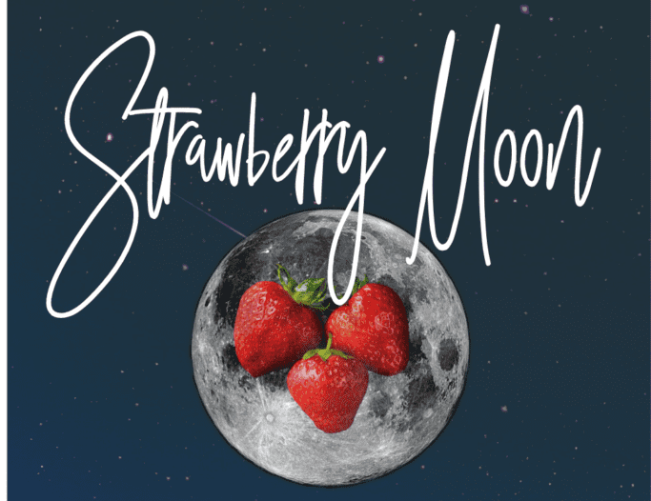
Good News . . .


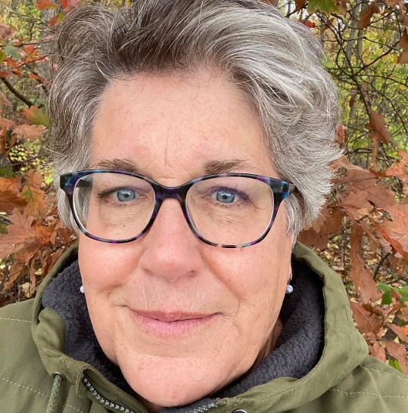


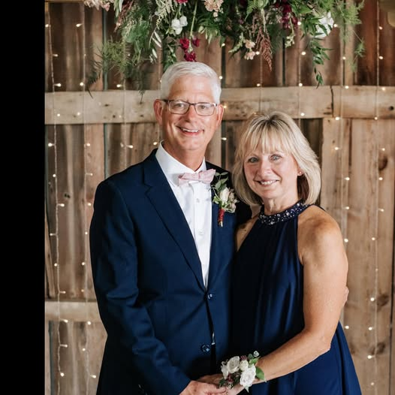
Jill Butler
Martha Lang

Dr. Todd Heydinger

You have worked hard for so many years,
You deserve to relax and take it easy for a change!!

ENJOY IT!
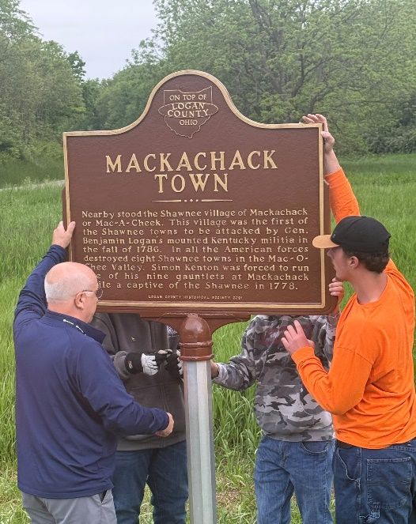
A special shout out to Mark Butler, Career Awareness Coordinator at Ohio Hi-Point Career Center, and the students that helped restore the Mackachack Town Historical Marker!

Their goal is to refurbish two markers a year, whether that is painting them or setting new posts to display their rich history.

Mark stated what was most rewarding during this process were the questions that students asked regarding the information on the marker. They found themselves researching the Mackachack village, General Benjamin Logan and the Piatt Castles. So, not only was a commendable service provided, but students were also presented with a local history lesson as well.
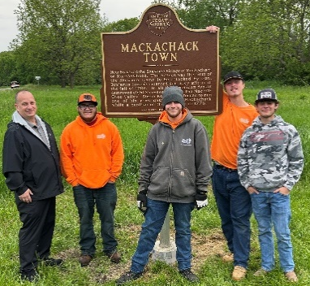

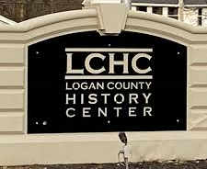
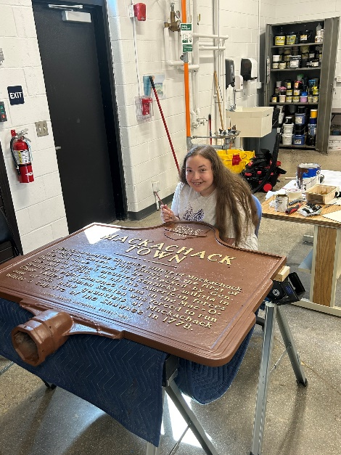
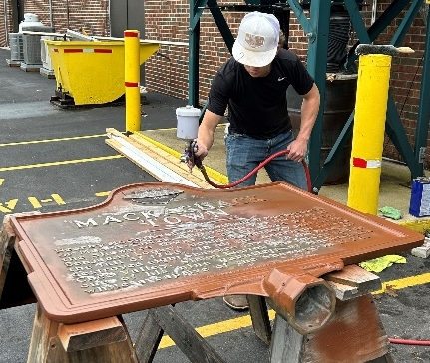




Please introduce yourself to our new accompanist, Susan Tennant!!

We look forward to hearing the beautiful music that Sue will be bringing us each week!!

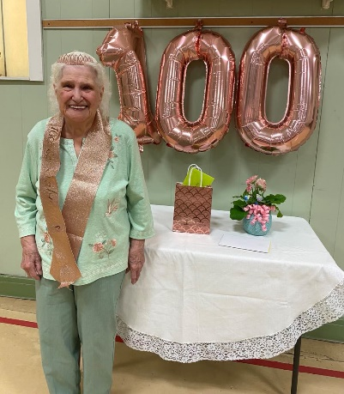
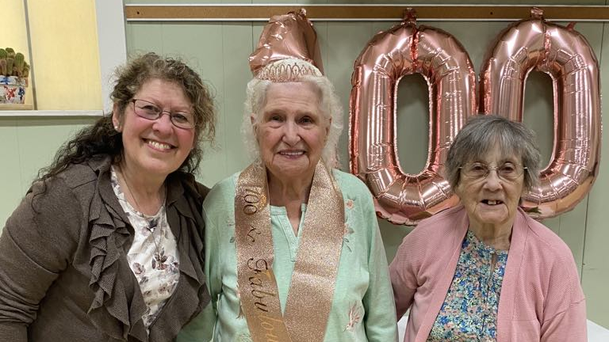
The Lady of the Hour! Who would believe that Marcella is 100 years old!!
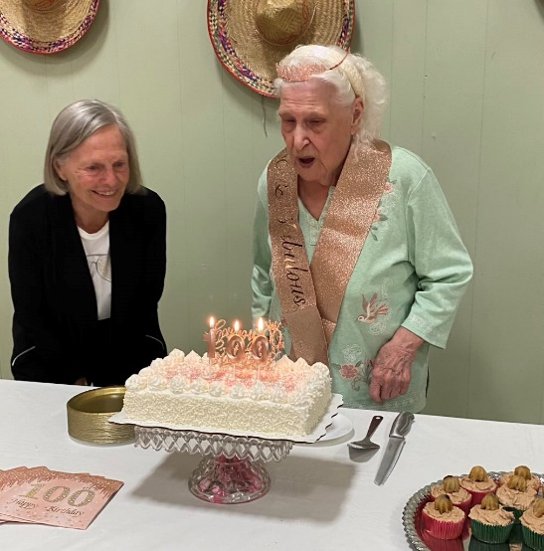
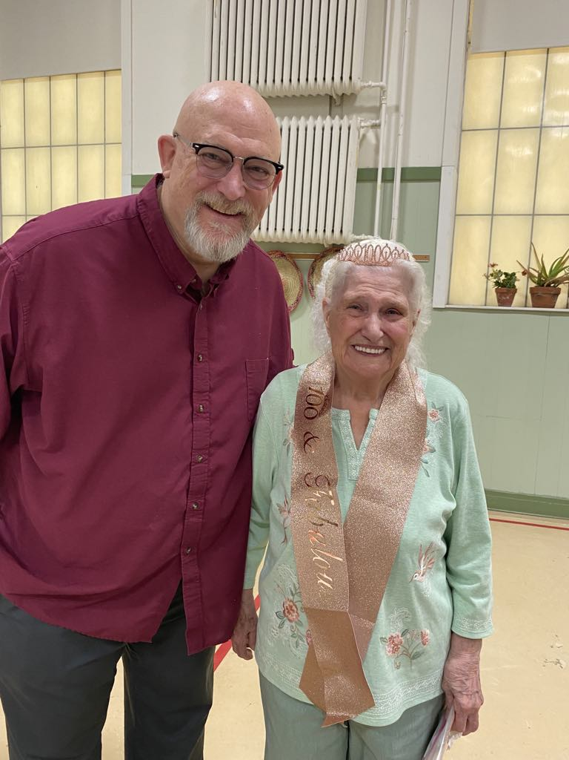
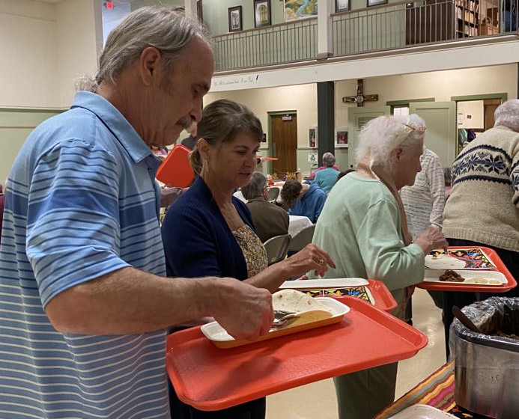

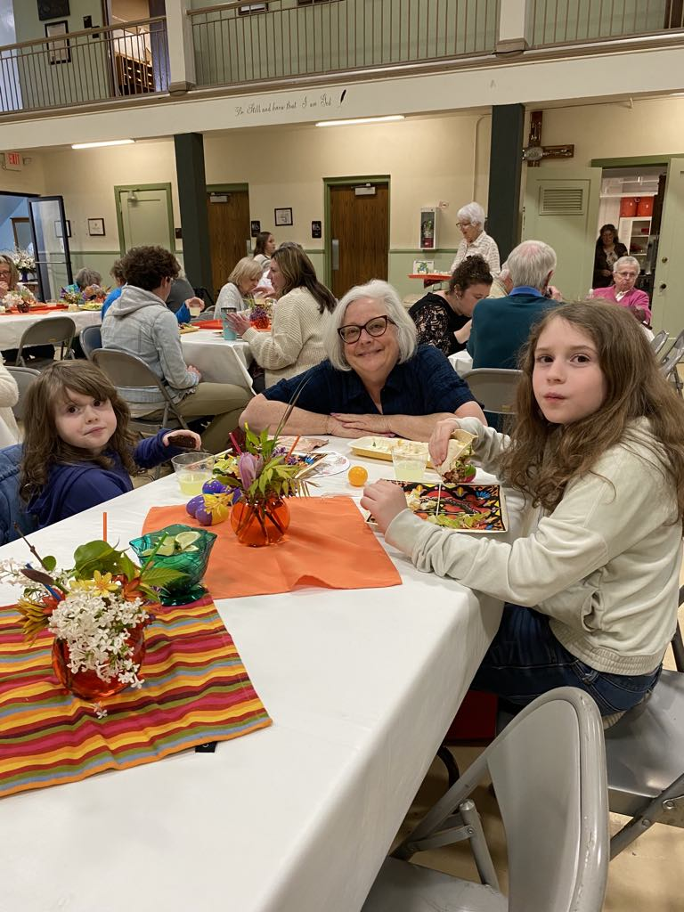
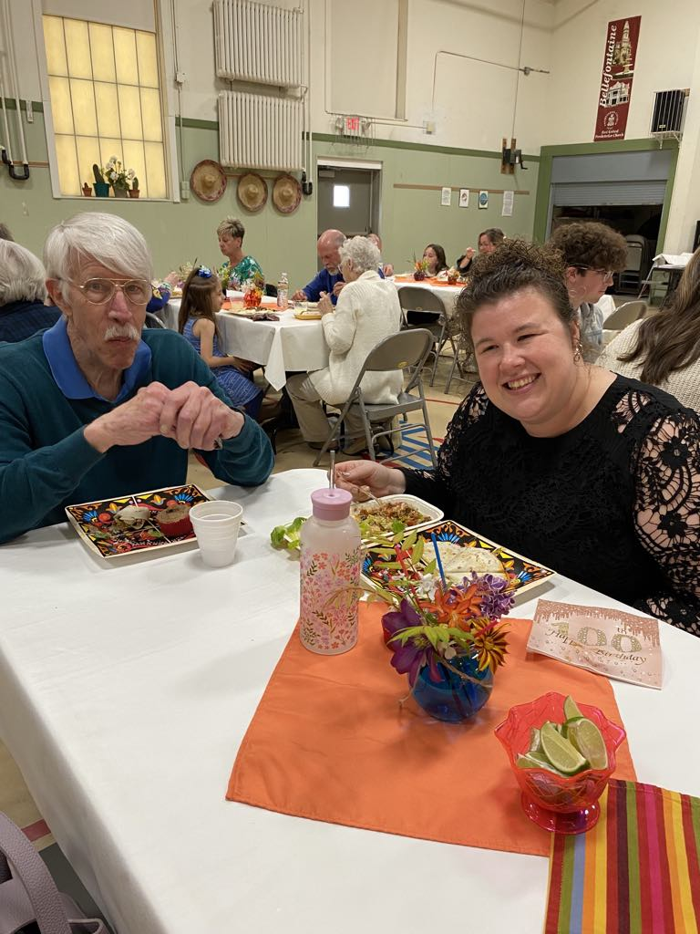
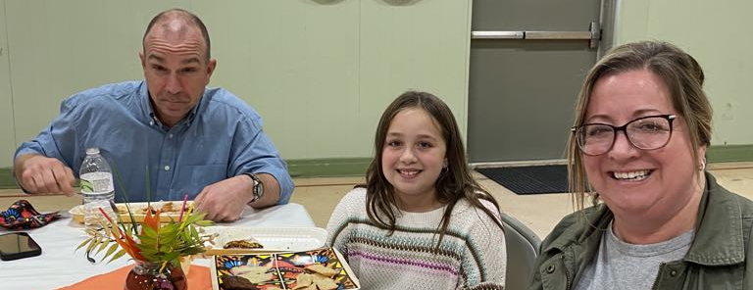
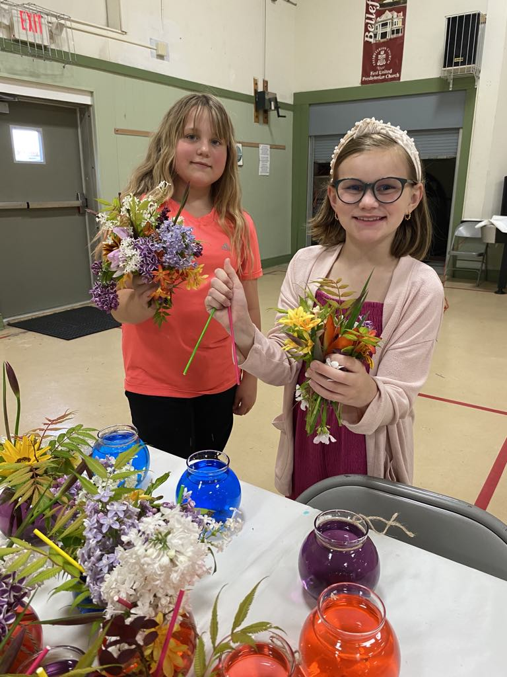


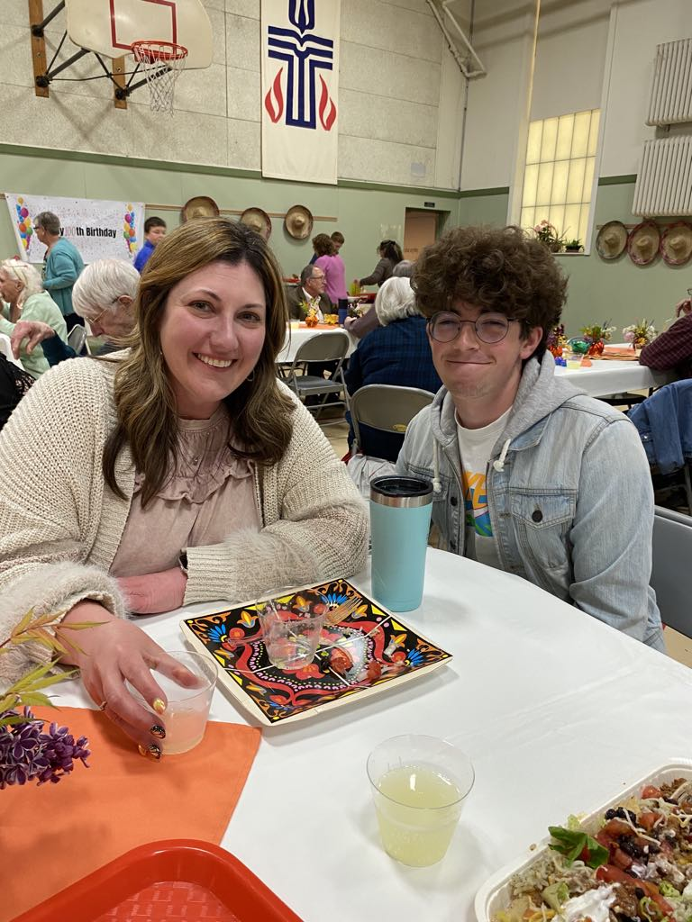
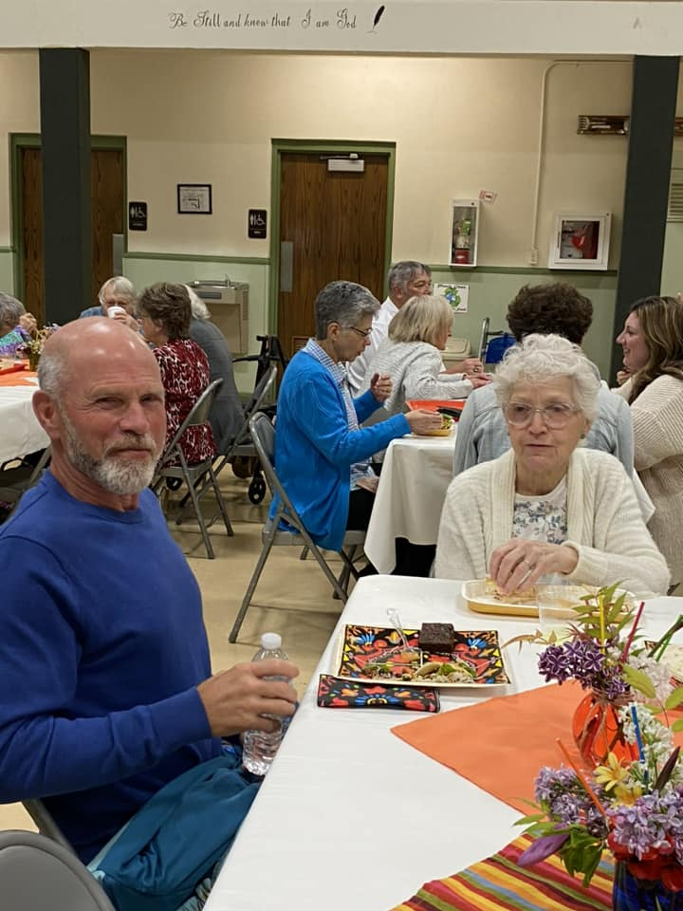
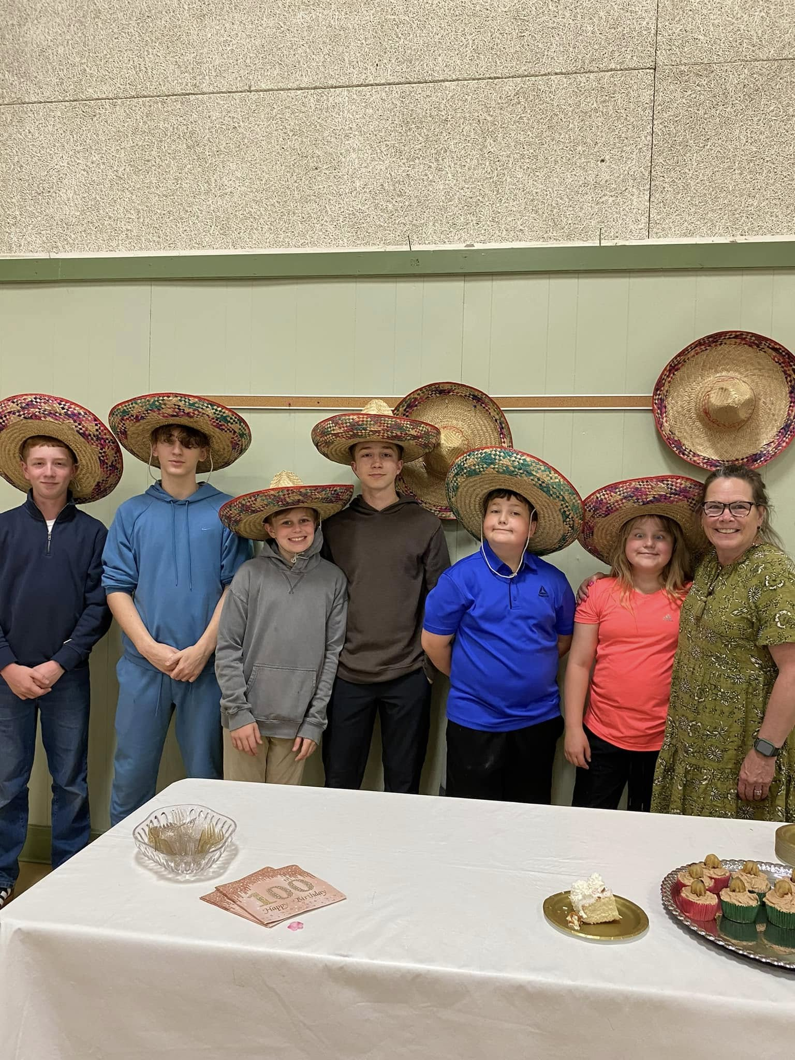
Congratulations to this Grupo De Ellos (group of kids) and Senora Stahler who did an amazing job of running the Taco Bar!! Raising money for the Youth Mission trip was NUMERO UNO! By the time this newsletter is printed, the opportunity of the Youth Mission trip will have begun, and we can’t wait to hear about the experience!! A special MUCHAS GRACIAS to everyone who has graciously donated to offset the trip cost!

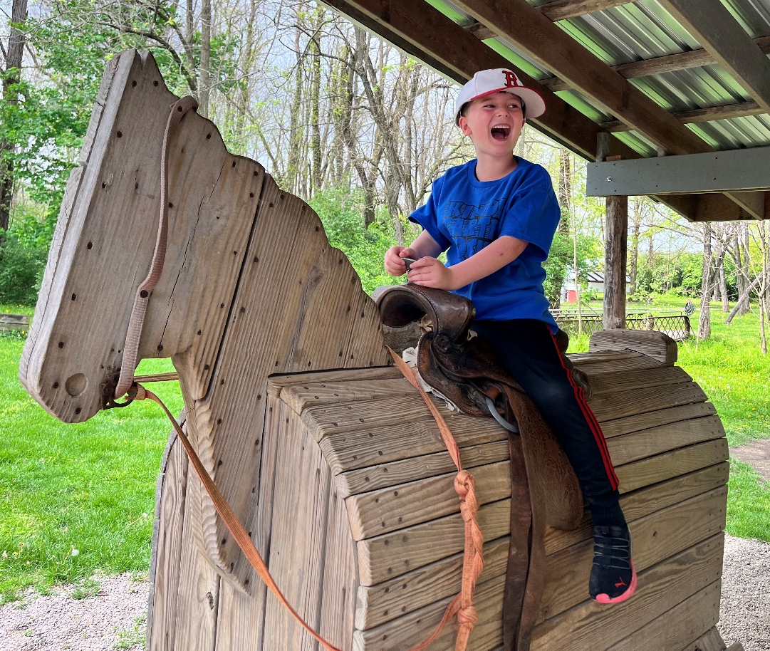
For Jameson Reed, Life doesn’t get much better than this!!

Higher Education Scholarship Recipients

Congratulations to our 2025 Higher Education Scholarship Recipients! Our thanks and remembrance to the generosity of those who came before us and established these endowments for the continuing education of Logan County Presbyterians:

Richard and Evaline Knief Memorial Scholarship: Multiple scholarships to students pursuing higher education and have membership in any Presbyterian Church (PCUSA) in Logan County. Knief Recipients (students & church they attend listed under their name):



Chloe Anderson Luke Anderson Mason Beres Jordan Butler

Belle Center Belle Center Huntsville Bellefontaine

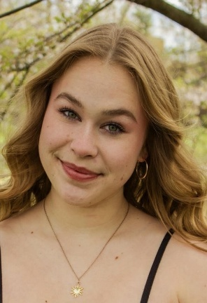
Olivia Eader Vivian Eader Regan Ross Jacob Zarnosky
Bellefontaine Bellefontaine Huntsville Huntsville


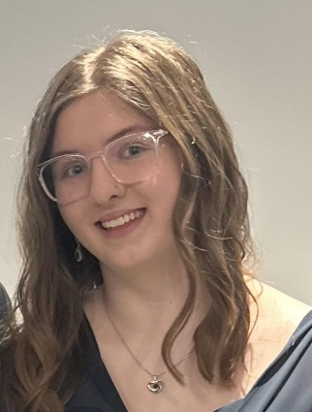
The Wayne and Pearl Lawrence Memorial Scholarship is Awarded to Ellie Lloyd and Ben Sailors (Bellefontaine 1st UPC). It is awarded to a male and female student with at least a 2.5 GPA, with membership at 1st UPC.
Nancy J. Merrilees Memorial Scholarship was not awarded in 2025 due to no 1st UPC Education major applicants.

Ben Sailors Ellie Lloyd

A total of $16,000 has been awarded through the interest of these endowments.

Our thanks to the scholarship committee:
Michael Brady, Brenda Oda, Beth Powers, Sara Stahler, chair: Anne Brienza
Congratulations to our 2025 College Graduates!

Caroline Eader, Master of Divinity, Austin Presbyterian Theological Seminary. She is currently seeking a call in a Presbyterian Church. She will visit 1st UPC on June 1 and hope you can all attend and visit with her.


Chloe Lloyd graduates from Bowling Green State University’s Schmidthorst College of Business, earning a Bachelor’s of Science in Business Administration with specializations in Management and International Business She is moving to upstate New York for her first year in a Human Resources Development Program. This program allows her the opportunity to move around the country for the next three years, with an incredible amount of exposure to Human Resources and the United States! “I am incredibly thankful to 1st UPC for your endless love and support!

Ben Sailors graduates this weekend with both a Bachelor’s degree and Master’s degree from The University of Pennsylvania, with degrees in Materials Science and Engineering/Mathematics. In the fall, he will continue his education at Massachusetts Institute of Technology, pursuing a doctorate degree in Materials Science and Engineering.

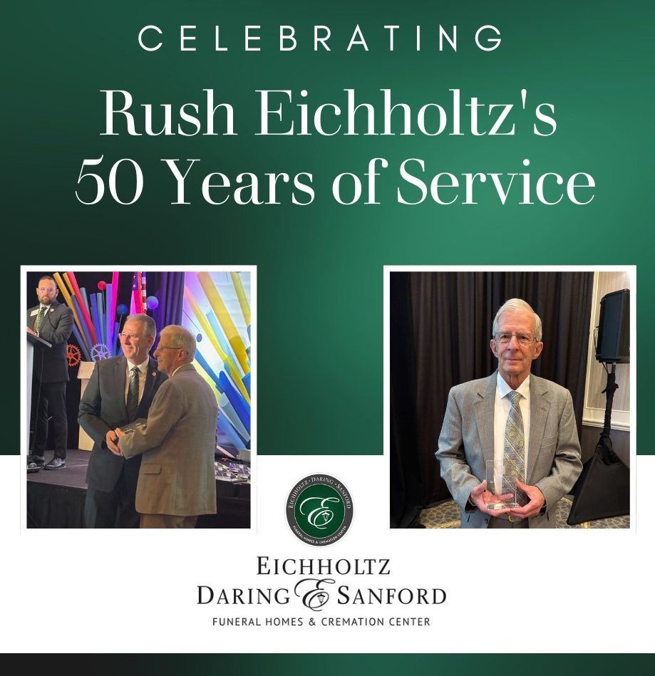

A huge and hearty congratulations to Rush “Bud” Eichholtz for 50 years of continuous service as a licensed funeral director and embalmer! He received a 50-year pin and recognition at the Ohio Funeral Directors Association convention this year. Bud’s dedication and commitment are an inspiration and so many families across the years have benefited from your kindness and care. Congratulations!

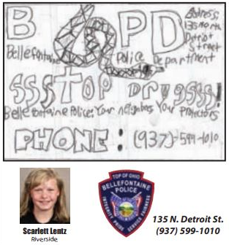

Scarlett Lentz was recently featured in the Special Advertising Section of the Bellefontaine Examiner as part of the Design-An-Ad program!
Great job Scarlett!!



Paris France is our shining star,
A wondrous city that’s not too far.
There’re landmarks to see and places to go,
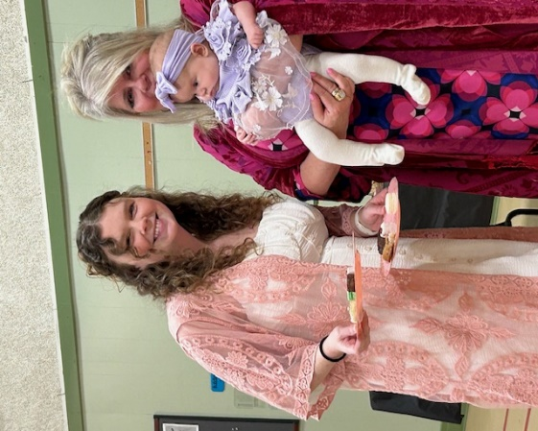
Whether you’re in the sun, the rain or the snow.
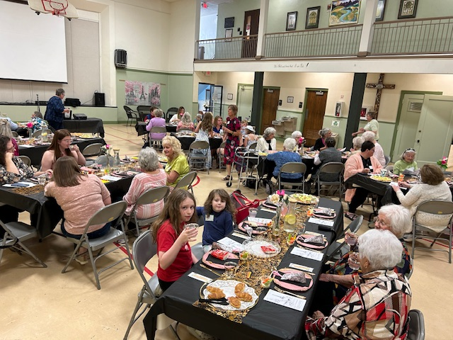
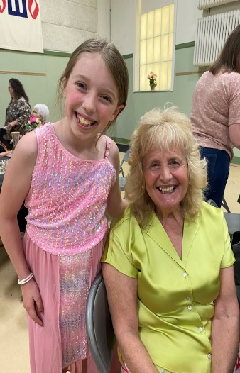

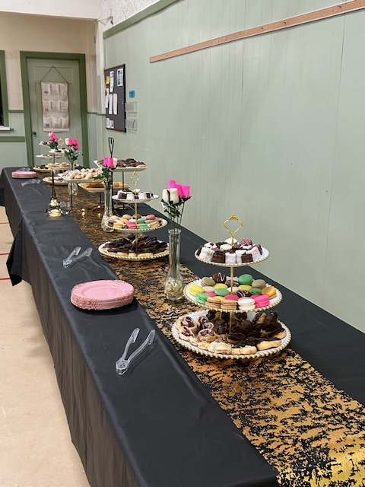
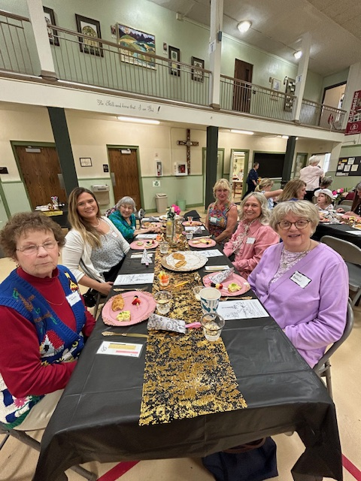

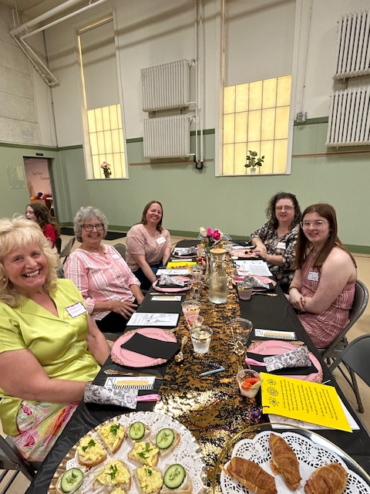
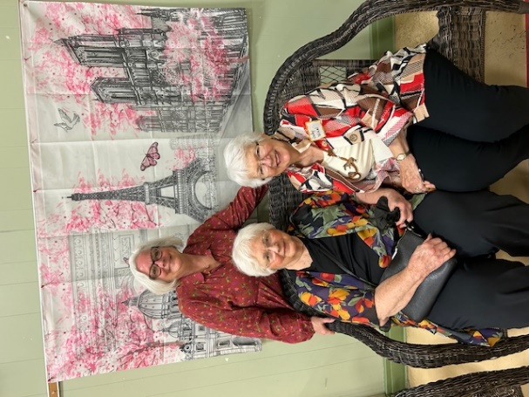

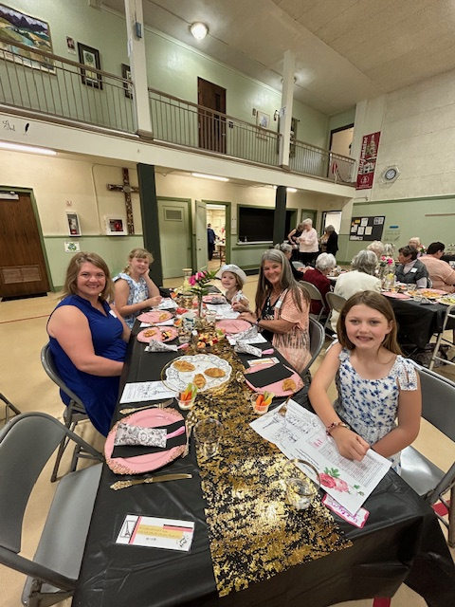

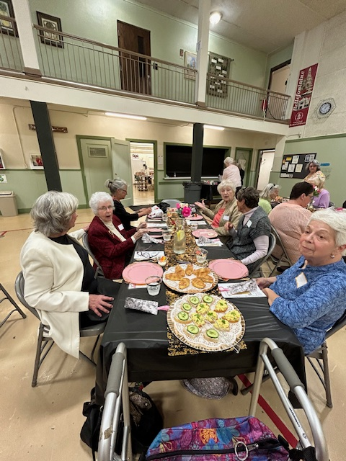
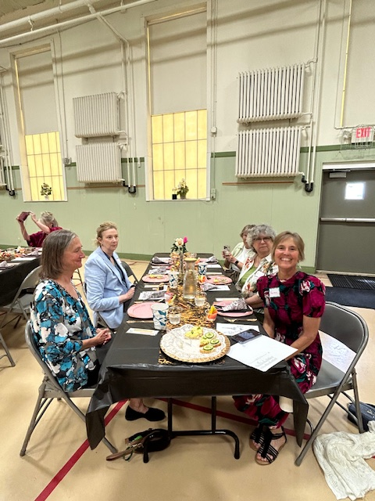

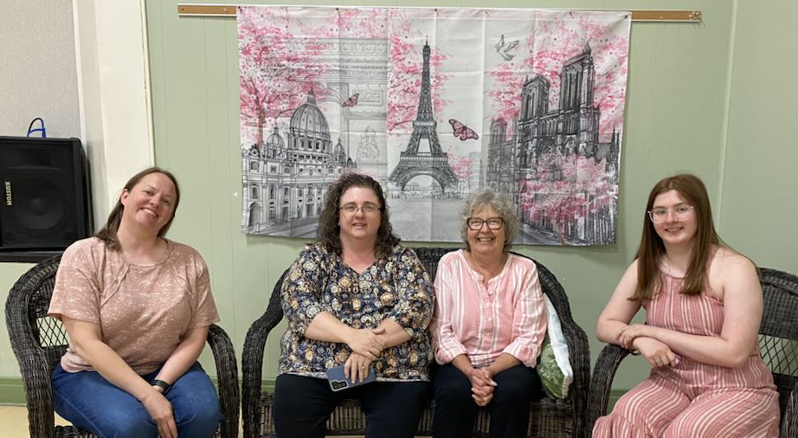



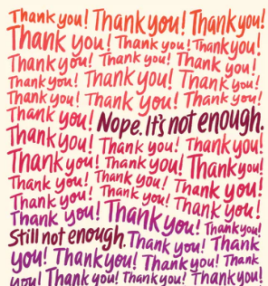
We are so blessed to have many, many people who volunteer in various areas of the church!! We can not thank everyone enough for their time and talents!! God has truly blessed us with this church family!! And though we can’t say it enough, THANK YOU!!

A special thank you to the youth of our church, who question, examine and review many lessons to earn their Building Blocks!


Our Building Block Recipients!

PreK – K: Blair Ericksen

Grades 1 – 2: Lincoln Core, Tilly Jervis, Abby Justice, Nora Lentz, Jameson Reed!

Grades 3 – 5: Charlotte Burkhardt, Salem Ericksen, Dori Jervis, Scarlett Lentz, Evelyn Lentz, Nora McClelland, Finley Reed!

Middle School: Griffin Burkhardt, Lyrik Core, Zoe Jervis, Cole McClelland, Calen McClelland!


Our Sunday School Teachers!

Karen Brady, Michael Brady, Lauren Burkhardt, Bob Core, Jenny Jervis, Sara Stahler, Joliece Reed, Vicky Shields, Sara Stahler!


Our wonderful Nursery Attendant, Brenda Jenkins!

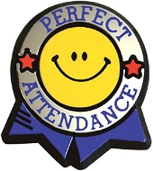
Our faithful Sunday School Attendance Keeper, Nancy Stokes!


Our fantastic acolytes, who can’t wait to get the chance to bring in the Light of God!!
Charlotte Burkhardt, Griffin Burkhardt, Lyrik Core, Salem Ericksen, Zoe Jervis, Dori Jervis, Tilly Jervis, Abby Justice, Scarlett Lentz, Evelyn Lentz, Nora Lentz, Cole McClelland, Calen McClelland, Nora McClelland, Finley Reed, Robbie Robinson, Renee Robinson!

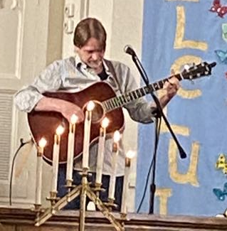
Our multi-talented Mark Amidon, who brings us a beautiful monthly reminder of God’s love for us!

Thank you, as well, to our many, many volunteers who bring special music to the sanctuary throughout the year!!

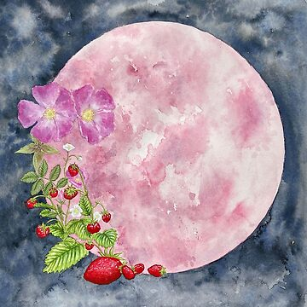
Thank You’s . . .

Thank you dear Church Members for my lovely Easter Basket! It was so pretty and filled with so many goodies. I really enjoyed receiving it. Thank to everyone for their thoughtfulness. I really appreciate their kindness. In Christian Love, Anne Heinlen

Dear 1stUPC Congregation, I wanted to take a moment to thank you all for your significant support and love over the years. I have just completed my undergrad at BGSU and will be joining Owens Corning Human Resourses Development Program. 1stUPC tauht me the most foundational lessons of my faith that I hold so incredibly close to my heart. This foundation has held me in the good and the bad and has taught me how to lead in grace and love. I love you all dearly! ~Chloe Lloyd

Dear 1stUPC, Thank you for your love and support, especially during seminary! I hope you can join me in this special celebration! Blessings, Caroline Eader


From the Riverside Local School District to two incredible teachers!!

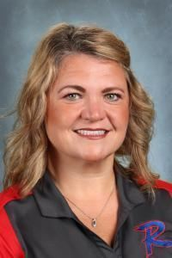

Thank You to Our Amazing English Teacher! Mrs. Lentz
Thank you for inspiring a love of reading, sharpening our writing skills, and teaching us to think critically and express ourselves clearly. Your passion, patience, and dedication make a lasting impact every single day. We appreciate everything you do!

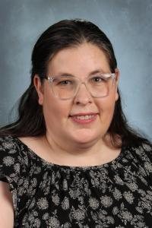
Thank you to our wonderful Highpoint Teacher! Mrs. Suman
We would like to celebrate the heart of Highpoint here at Riverside! Your dedication, kindness, and commitment to our students make a lasting impact every single day. Thank you for inspiring minds, nurturing hearts, and helping our school shine. We are so grateful for you!

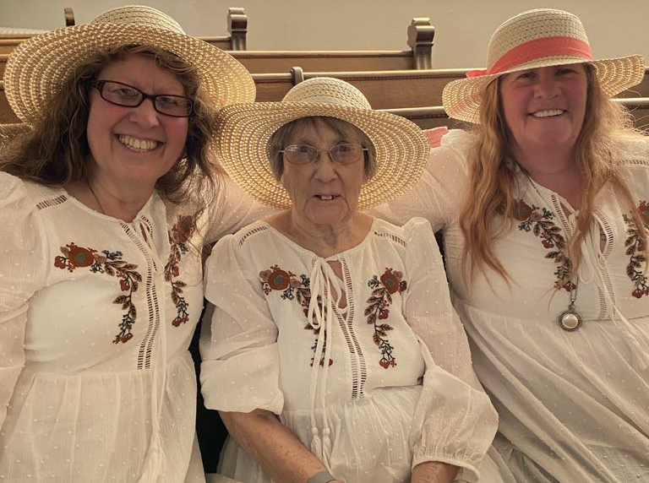
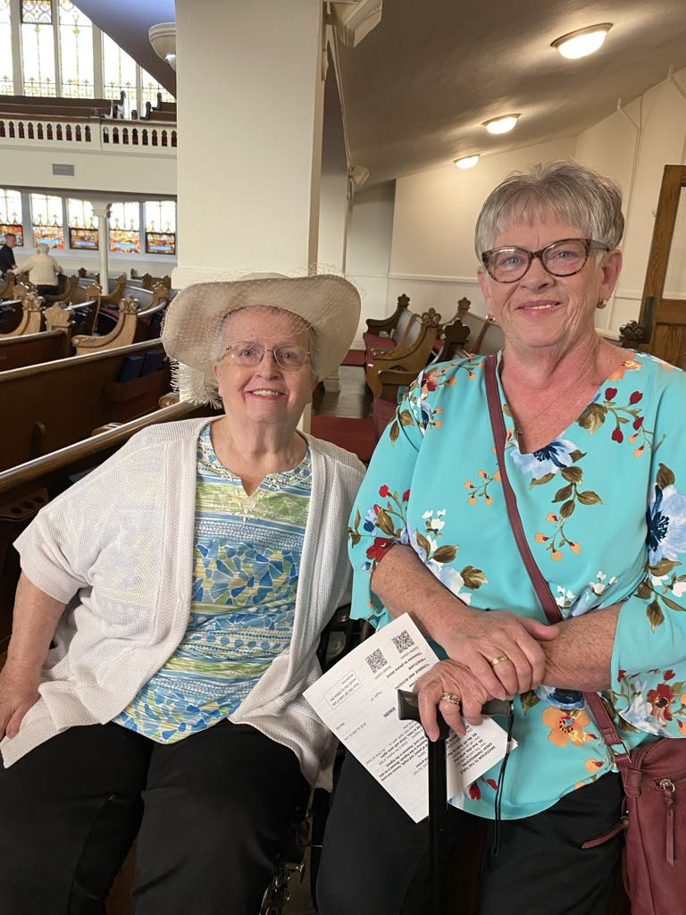

Mother’s Day Merriment!


Those needing our special prayers . . .
Eleanor Brewer Carol Hess Craig Sickles Celynn Taylor
Carl Wunderle Bud Jackson Roxanne Fischer The Amidons
Anne Heinlen Tina Deardurff Mary Jane Baker Kris Sutterfield
Alissa Ritter David Ritter Marge Hines



With us in spirit . . .
Sue Albano *104, 2739 Co. Rd. #91 Belleft. 43311
Vera Miller 10536 Manatee Drive Huntsville 43324
June Coil 6557 US Rt. 68 S. West Liberty 43357
Send them a card to say HELLO!!
Joyce Core 2450 Co. Rd. #118 Rushsylvania 43347
Bud and Mona Eichholtz 1328 Omaha Rd. Belleft. 43311
Anne Heinlen 741 E. Sandusky Ave. Belleft. 43311
Marcella Neeld 541 Center St. Belleft. 43311
Nate Weber 608 Newford Dr. Belleft. 43311


Celebrating a Birthday in June . . .
June 1: Gary McKenzie June 21: Tara Bair
June 4: Nancy Farrington June 22: Robbie Robinson
June 5: Nate Weber June 23: Tom Ark,
June 8: Cole McClelland Dana Heydinger
June 14: Warren Taylor June 24: Brad Flora June 15: Nancy Wisse June 26: Caroline Notestine June 16: Julie Stephens, Emma Suman June 30: Claire Kennedy

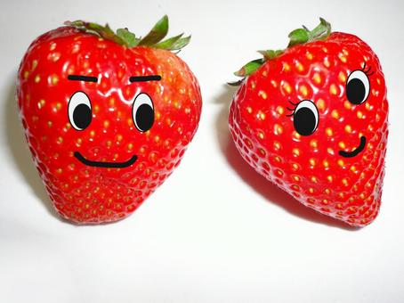
Celebrating a Wedding Anniversary in June . . .
June 10: Michael & Sandi Chervenak June 21: Woody & Katie Amidon
June 14: Matt & Jamie McClelland June 22: Mark & Molly Amidon
June 15: Jim & Linda Hilliker June 24: Jim & Elaine Thompson
Eric & Krista Adelsberger June 27: Mac and Carol Smith
June 20: Bill & Judy Wical
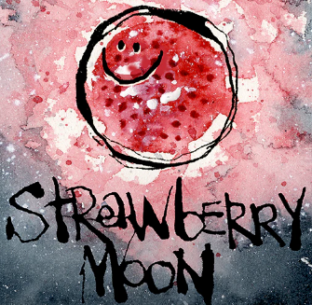
Kid’s Corner . . .

Strawberry Heart Craft Materials Needed: Glue, Scissors, Red, Green, White and Black Paper
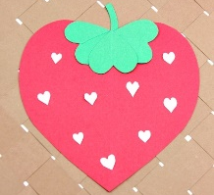
Start by cutting out one large red heart, 3 smaller green hearts, a few tiny white hearts and one green stem.

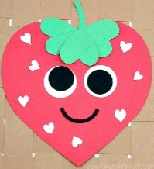
Using the red heart as the body of the strawberry, glue the green hearts upside-down as the leaves of the berry and add the stem to the top.

Glue the white hearts onto the body of the strawberry to represent the seeds.

Give your strawberry some personality by using the black and white paper to make eyes! Or use googly eyes to make it look silly!!
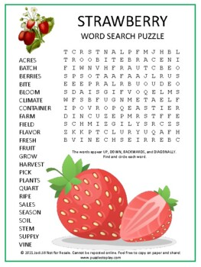



In the Kitchen . . .


SINGLE STRAWBERRY SMOOTHIE

Ingredients: 1 C. heaping fresh or frozen strawberries 1 C. sliced banana
¾ - 1 C. Milk Dairy or Non-Diary 1/2tsp. vanilla extract

Add the strawberries, banana, milk, and vanilla extract to a blender. If you plan to add any, add optional ingredients to the blender.

Turn the blender on and blend until creamy and smooth. If the smoothie is too thick, add a bit more milk. Add a few ice cubes and blend until smooth for an icy cold smoothie!

STRAWBERRY ICE POPS

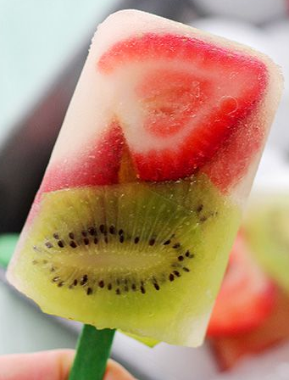
Ingredients: 1 C. Strawberries, hulled and chopped 2 Kiwi fruit, peeled and chopped

1&1/2 C. Lemonade 6 disposable plastic cups and 6 pop sticks or 6 popsicle molds

Place the sliced strawberries and kiwi fruits into each disposable cup or popsicle mold. Pour the lemonade over the fruits and insert a pop stick into each mold or cup. Freeze the ice pop stick for 4 hours or overnight.

To remove the ice pop from the mold, run it under hot water. It can be one of the great and refreshing easy strawberry recipes for kids to make!!


SINGLE STRAWBERRY YOGURT PARFAIT

Ingredients: 1 C. sliced fresh Strawberries 1 tsp. white sugar ¼ C. granola
½ C. nonfat plain Greek yogurt

Combine strawberries and sugar in a small bowl and let stand until the berries start to release juice, about 5 minutes. To assemble parfait, layer yogurt and the strawberries with their juice in a 2-cup container. Top with granola.

STRAWBERRY GELATIN CAKE

Ingredients: 1 Box White Cake Mix 3oz. Strawberry Gelatin ¾ C. oil
½ C. water 4 Eggs (Room Temperature) ½ C. Heaping strawberries

Mix all ingredients and pour into a well-greased 1/4 sheet cake pan. Bake at 350 degrees for 30-35 minutes or until a toothpick comes out clean and the cake has begun to pull away from the edges of the pan. Leave in the pan and cool on a cooling rack.


Committee Calendar . . .

Coming June 1!! The Stewardship and Finance Committee will host a Spaghetti Luncheon as we kick off our Capital Campaign!! We will be fundraising to replenish the Patterson Fund after our current repairs of $73,000 for the West wall. Lunch will include spaghetti, salad, bread sticks and dessert! (And maybe a nice birthday cake for Mr. McKenzie.) We will be taking donations during the lunch as well as in the offering during our Worship Services. We are so very lucky to have this beautiful building where we can worship freely, let’s do our best to keep it in beautiful condition!!

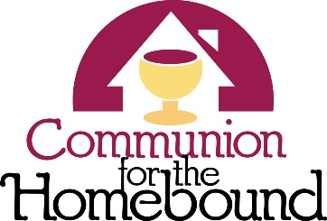
ATTENTION ELDERS AND DEACONS!! If you are interested in visiting and serving communion to our homebound members, please see Pastor Greg!!

Pastor Greg will bless the elements and you will have instructions on how to proceed. What a wonderful outreach to our members who cannot be with us on a Sunday morning!!

Sign up now to spend a Sunday Morning with the kids!! You can sing songs, color, dance, whatever you want!! These kids are game for everything!! There is a sign-up sheet in the Narthex. What skill do you have that you can teach them?? Any questions? Contact Sara Stahler!


Our Daily Bread Bakers deliver desserts to Our Daily Bread on the third Monday of
each month between the hours of 8:30am and 6:00pm.

June 12 - 19
Sara Stahler, Nancy Stokes, Judy Wical, Katie Amidon, Tara Bair




JULY 13 - 17



Pastor Greg would LOVE to put together a Youth Sunday and give our kids another chance to lead the service!! If your kids would be interested in participating in a Sunday, please contact the Church Office!! The more the merrier!


If you are interested in providing flowers for the Communion table on a Sunday, to honor
someone, or just because, please contact Holly in the Church Office (937) 592-6611 or
secretary@bellefontainepres.com for more information.


Volunteers to help in the nursery are always welcome!! You can spend time with our
little ones, coloring or playing games! Brenda Jenkins, our Nursery Attendant is happy
to have you during the time of the Worship Service. Contact Ruth Bowden.


If you are fascinated by those who serve as Worship Leaders on Sunday morning and
want to take a leap of faith to help out, please contact Ruth Bowden for availability dates.


The more Special Music, the BETTER!! We are looking for anyone and everyone who would like to participate in special music for our Worship Services! You can do just about anything!! Sing alone, sing in a group, play an instrument!! Age doesn’t matter, we want everyone to enjoy being a part of the musical section of the service! If you are available to participate, please contact the Church Office for more information!

How we love to see our acolytes bringing the Light of God and the Holy Bible each Sunday morning! This is not just an activity for the young ones, we would like to see our adults active in this part of the service! We would especially be happy to have family members working together! For more information, contact Sue Crawfis!


Do you have any small household projects that you just can’t get to due to mobility?
That pesky lightbulb that needs to be changed? An outlet that needs repair? A leak that
needs a small washer replaced?

The Mission Committee sponsors HELPING HANDS! We have members of the church
who would be happy to help you through those small jobs that you just can’t quite get to! Applications are available in the Narthex and at the Elevator entrance from the alley.

There is no charge for this service! We just want everyone to be safe and comfortable in their own home!! Of course, there are some requirements. . .

If we are able to help you in any way, please fill out an application today, drop it in the offering plate or email it to the Church Office at 1stupc@bellefontainepres.com. If you have any questions, please call the Church Office (937) 592-6611 for more information.


Meeting in June . . .
The Book Study will meet Tuesdays, 11:00am.

The PWA Leadership meets Sunday June 1, 12:00pm.

The Property Team meets Thursday June 5, 2:00pm.

The Worship Team meets Tuesday June 10, 1:30pm.

The Deacons meet Tuesday June 10, 5:00pm.

The Mission Team meets Tuesday June 10, 6:00pm.

The Stewardship and Finance Team meets Wednesday June 11, 12:00pm.

The CE Team meets Wednesday June 11, 5:30pm.

The Book Club meets Tuesday June 17, 6:30pm.

The Session meets Thursday June 19, 6:00pm.

The Church Growth and Member Care Team meets Sunday June 22, 12:00pm

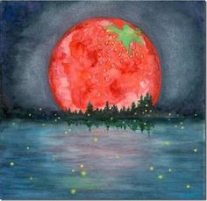
Serving in June . . .
Deacons On-Call: Nancy Farrington, Betty Lloyd

Welcome Team: Nancy Wisse, Joanne Ritter, Karen Brady, Bridget Hawkins

Worship Leaders: Church Open and Close: Nursery Assistants:

June 1: Greg Menssen June 1: Betty Lloyd June 1: Joliece Reed
June 8: Brenda Oda June 8: Sue Crawfis June 8: Carla Murdock
June 15: Sue Crawfis June 15: Anne Brienza June 15: Ellie Lloyd
June 22: June 22: Bridget Hawkins June 22: Ellie Lloyd
June 29: June 29: Karen Brady June 29: Ellie Lloyd

The Strawberry Moon


The Strawberry Moon, a summer treat, With berries ripe, a sweet, sweet feast!
The moon shines bright, a silver gleam, A summer night, a waking dream.

The moon above, a smiling face, Observing kids in happy place.
The fields are filled with sweet berry scent, A summer night, a happy event.

The Strawberry Moon, a perfect time, To gather berries, a sweet climb.
With friends and family, near and far, The moon above, a shining star.
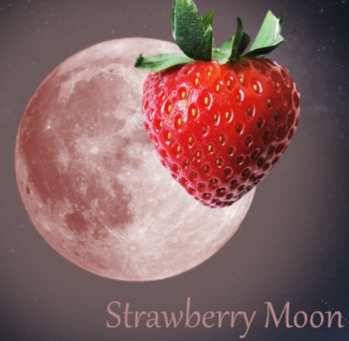
Financial Focus . . .
May 4, 2025

On-Line Attendance: 9

Sunday School Attendance: 32 Sunday School Offering: $38.00

Worship Attendance: 71 Weekly Giving: $2831.77

Received To Date: $75,143.72

May 11, 2025

On-Line Attendance: 11

Sunday School Attendance: 36 Sunday School Offering: $53.00

Worship Attendance: 82 Weekly Giving: $2316.00

Received To Date: $77,459.72

May 18, 2025

On-Line Attendance: 12

Sunday School Attendance: 35 Sunday School Offering: $32.50

Worship Attendance: 85 Weekly Giving: $3424.47

Received To Date: $80,884.19

May 25, 2025

On-Line Attendance: 21

Sunday School Attendance: 19 Sunday School Offering: $24.00

Worship Attendance: 65 Weekly Giving: $1467.47

Received To Date: $82,351.66

Looking Ahead . . .
Our Daily Bread Bakers deliver desserts to Our Daily Bread on the third Monday of each month between the
hours of 8:30am and 6:00pm.

July 10-17
Karen Brady, Anne Brienza, Debbie Day, Nancy Farrington

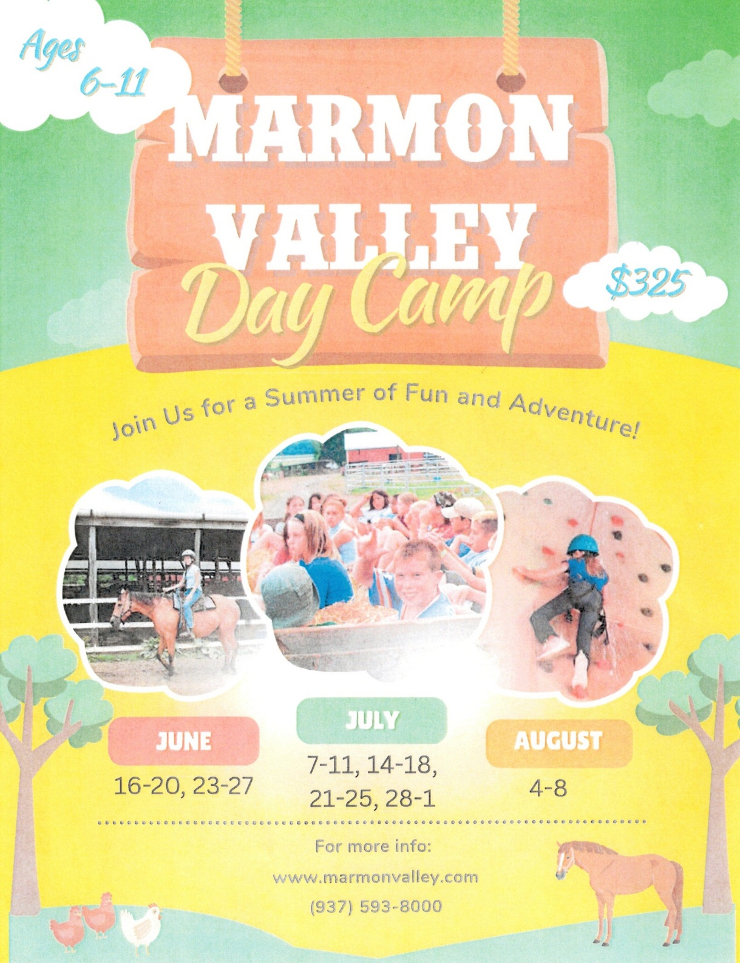
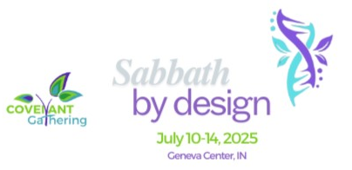

From the Presbytery . . .

The 2025 Covenant Gathering will be held July 10-14 at the Geneva Center, Indiana and online. This year's theme is “Sabbath By Design” and will feature collaborators, the Rev. José Manuel Capella-Pratts and Vilmarie Cintrón-Olivieri, Regional Liaisons for the Caribbean.

The Covenant Gathering is an intergenerational faith-play event meant to equip participants for ministry in their families, churches and communities; For spiritual renewal of those who lead others; To create a greater appreciation for a connectional church; To model the Kingdom of God in our life together.

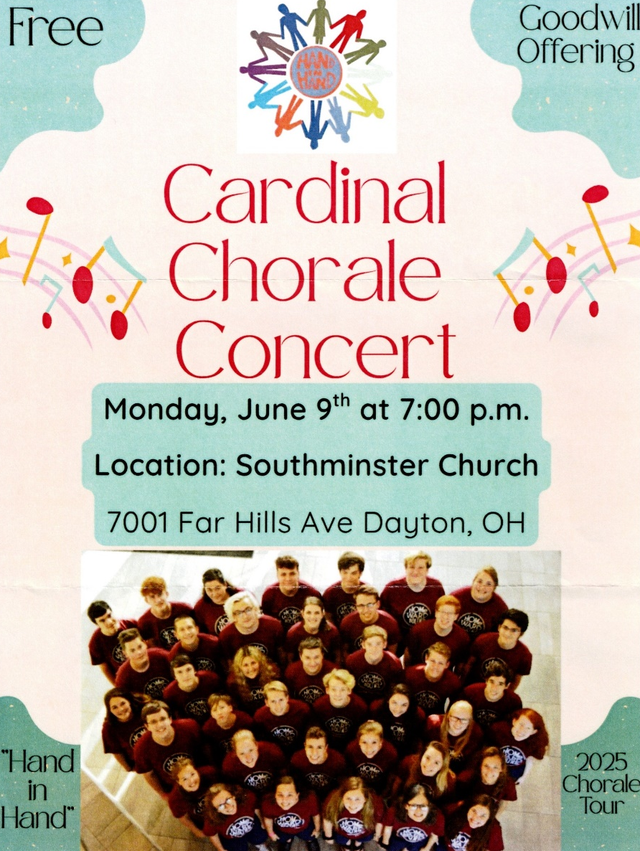

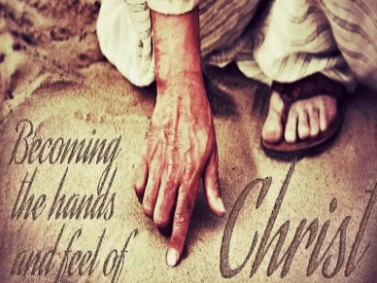
Therefore, my beloved brothers, be steadfast, immovable,
always abounding in the work of the Lord,
knowing that in the Lord your labor is not in vain.
~1 Corinthians 15:58


Each month, the Board of Deacons encourages you to help meet the needs of our 1stUPC family through your donation to our 2 Cents for Compassion Offering. Your donation will support the Deacons in their efforts to support those members of our church who are in need. Donate 2 Cents (or more) for every compassionate thought or deed you have experienced in the past month and place it in the “2 Cents for Compassion” envelope included in the Sunday bulletin.
Our Lord Jesus said, “I desire mercy, not sacrifice.”

DINNER AT THE PRES! Our next dinner of the season will be June 24! If you would like to volunteer, please contact Vicky Shields! Our Daily Bread will continue to need our help with serving on certain days of each month. If you are available to help, please contact Evelyn at 937-592-6325!

God is not unjust; he will not forget your work and the love you have shown him as you have helped his people and continue to help them.


Through the Community Cash Program, shop at Community Market, bring in your receipts and place them in the Donation Centers outside the Sanctuary or in the Fellowship Hall and you can contribute! A portion of your sale will support the 1stUPC Sharing Fund, providing assistance to our church families as needed.

“Whoever brings blessing will be enriched
and one who waters will himself be watered.”


Using your Kroger Reward Card will support Youth Mission Trips! To make an automatic donation with your Kroger Plus Card, go to krogercommunityrewards.com. Log in or set up a new account. Our NPO (non-profit) ID number is HD313, and listed as First (not 1st) United Presbyterian Church. Each year, through the graciousness of our 1stUPC shoppers, this fund contributes $800 - $1000 to support our youth mission trips.
