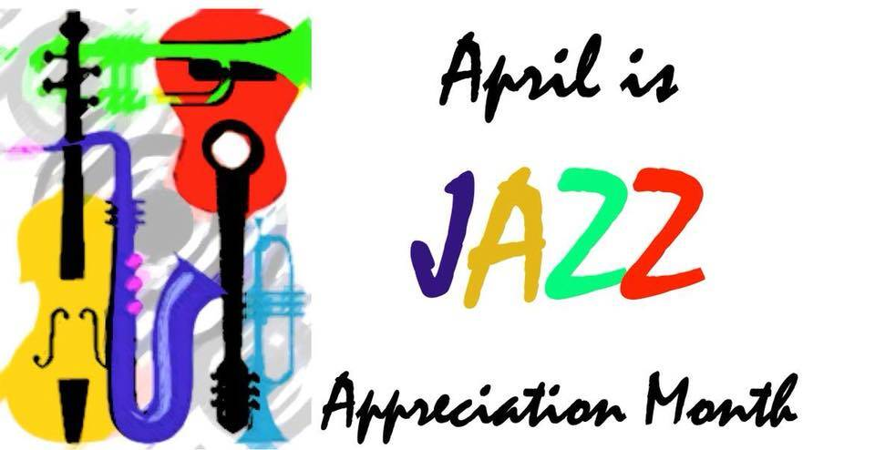
Presbyterian Press

April 2025


A note from the Pastor . . .
As we continue our journey through Lent, I pray that it has proven to be a time of reflection for all of you. For me personally, I enjoy a time of renewed focus on who Christ is in our lives, and how God has chosen to love us, not from afar, but up close and involved in our day to day lives. As we get closer to Holy Week, I want to remind everyone that we will be having many opportunities to engage with each other and with our wonderful faith tradition. First, I want to tell everyone that we will be celebrating the confirmation of 5 young people into the membership of our congregation on Palm Sunday which is April 13. We will be celebrating communion, and celebrating the joyous occasion of confirmation. There will also be a reception that will follow the service to further celebrate our young people. Then on Thursday, Maundy Thursday, we will be celebrating this Holy Day with the community at a service hosted by the Methodist Church. Please look for details on this over the next week but if you wish to mark your schedule, it will be at 7:00 pm on Thursday April 17th. Friday April 18th is Good Friday and there will be two opportunities for community worship. The first is at noon here in our chapel and will be a contemplative reading of the events leading up to the crucifixion. Then at 7:00 that evening, there will be a service at the First Christian Church on Sandusky St. The worship committee is also hoping to provide meditations stations in the fellowship hall for the entire day of Good Friday. This also provides a scriptural trip through the events leading up to the crucifixion along with meditations to help us to engage in the difficult journey that Jesus walked for our salvation. Easter Sunday is April 20th, and we will be once again having a breakfast before our worship service, please plan on attending, and bring your friends and neighbors. We want to share the blessing of this amazing congregation of people with as many people as possible.

I want to apologize for the difficulties that we have been having with our live streaming technology. We have identified and fixed many issues, but it seems that as soon as we fix one thing something else becomes an issue. Please know that we are working hard to insure that this important aspect of our congregational worship works smoothly and without issue.

Finally, I want to thank all of you for not just coming to church but for being the church, in this community and in this world. It is quite evident as we work and serve together in this community that our congregation is committed not only to the worship of God but to the service to God’s children. It is such a blessing to see the body of this church not only serve, but serve joyfully with loving hearts. We are so blessed to not only be the congregation of First United Presbyterian Church but to be fully functioning members of the body of Christ.



Did you know . . .
Some of them you know by one name, Monk, Yardbird, Ella. Others you will recognize as Louis Armstrong, Duke Ellington, Miles Davis, the list goes on and on. These are the greats of Jazz.

Just exactly how did jazz get its start? The roots of jazz are primarily ragtime, marching bands, and blues. Ragtime developed naturally in the American south, featuring African-American rhythms and styling combined with more traditional European music. It became a part of minstrel shows, allowing it to spread through many regions within the American south.

Marching bands were primarily aimed to keep morale high. These sounds became widespread during that era and were viewed as uplifting, even if they were mainly associated with a challenging period in history. The blues also developed as a genre during the Civil War. Word songs, minstrel shows, and spiritual music influenced that genre. Folk music and other popular sounds of the era also made their way into the blues genre, further diversifying the sound stable blues itself.

Generally, jazz is viewed as a blending of those styles, incorporating their musical elements and many of the sounds and emotions present in them. But jazz also brought something new to the table, particularly when it came to improvisation.

Jazz has many characteristics, some that is shared with other genres and others that are generally unique to the genre, at least during the origins of jazz. Improvisation is one of the most classically defining traits. However, syncopation, polyrhythms, and irregular rhythms are potential hallmarks, too.

Solos are also a traditional part of the jazz genre. Most early jazz also featured calls and responses, where one musician in a band would offer a phrase, and another would essentially reply to it.
Generally, jazz is a genre that seems to embody musical freedom. While some subgenres do have a distinct sense of melody, harmony, and rhythm, many others include unexpected elements as a form of expression. Often, it’s those unanticipated moments that make the genre highly unique, setting it apart from many other types of music.

So, is jazz just jazz? Oh no, just like any music genre, there are many offshoots.

Swing Jazz started in the late 1920s, becoming broadly popular by the mid-1930s and remaining so until the mid-1940s. Most consider the years between 1930 and 1945 as the Swing Era, a time when big bands led by legends like Duke Ellington and Count Basie were making waves.

The 1940’s brought us Modern Jazz, Cool Jazz, BeBop, and Latin Jazz. Modern Jazz gave musicians more freedom for improvisation, Bebop style introduced scat to the masses, Cool Jazz is a bit more retrained and Latin Jazz brought us Cuban and Spanish Caribbean rhythms showcasing traditional jazz instruments and compositions.

Jazz fusion began developing in the 1960s. During that era, jazz musicians started integrating sounds more widely associated with rock music and R&B.

Smooth jazz began in the 1970s, emerging as a form of crossover jazz designed to have broad commercial appeal. Comparatively speaking, it’s an easy-listening version of jazz, incorporating more predictability and gentleness than you find in many other types of jazz. Essentially, the goal was to reach a wider audience, so the genre added pop-inspired elements and features commonly associated with R&B ballads.

While all of the Jazz greats had their explanation of just exactly jazz was and is, the best quote comes from Louis Armstrong . . . “If you have to ask what jazz is, you’ll never know.

Good News . . .
Meet Our Confirmands!
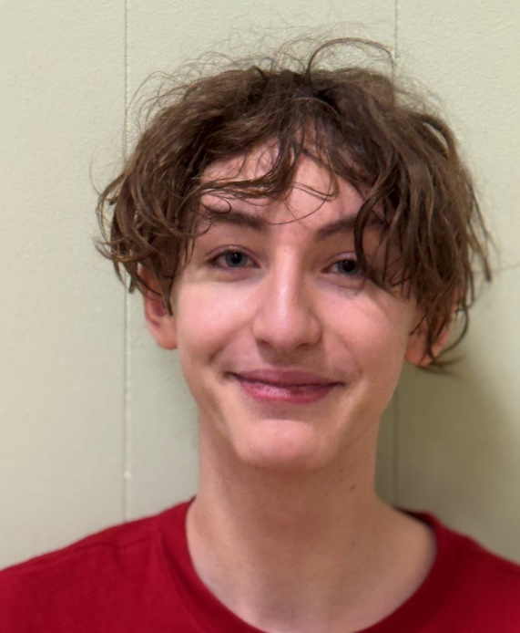


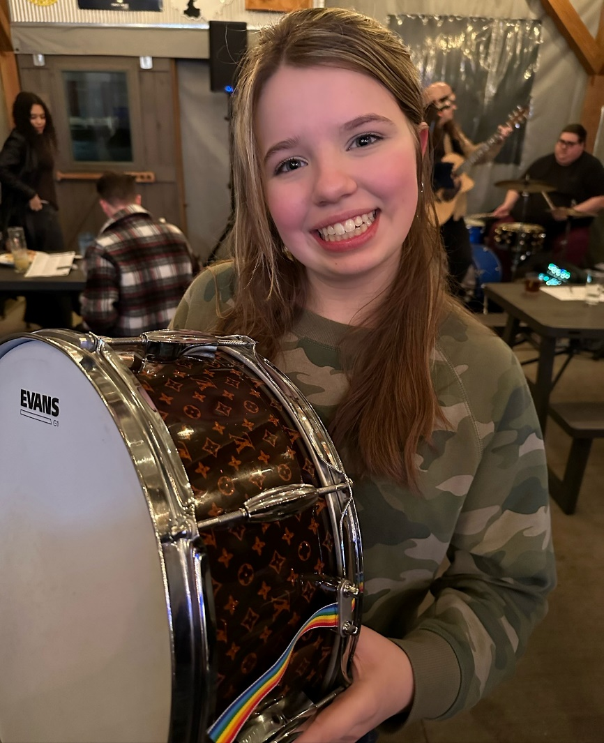
Lyrik Core
Griffin Burkhardt

Cole McClelland
Calen McClelland
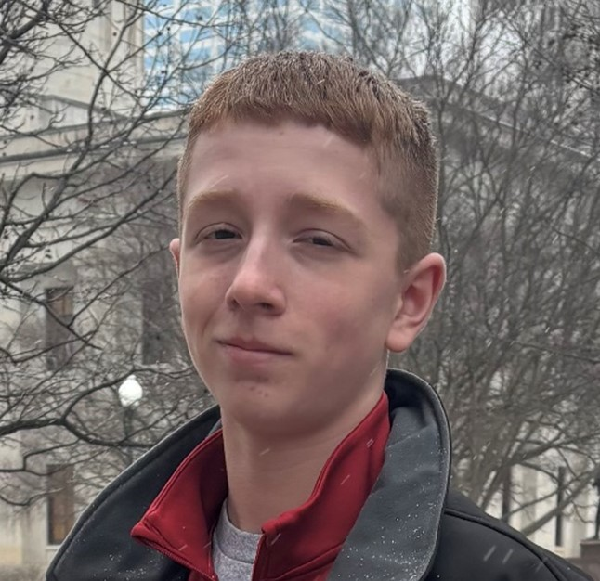
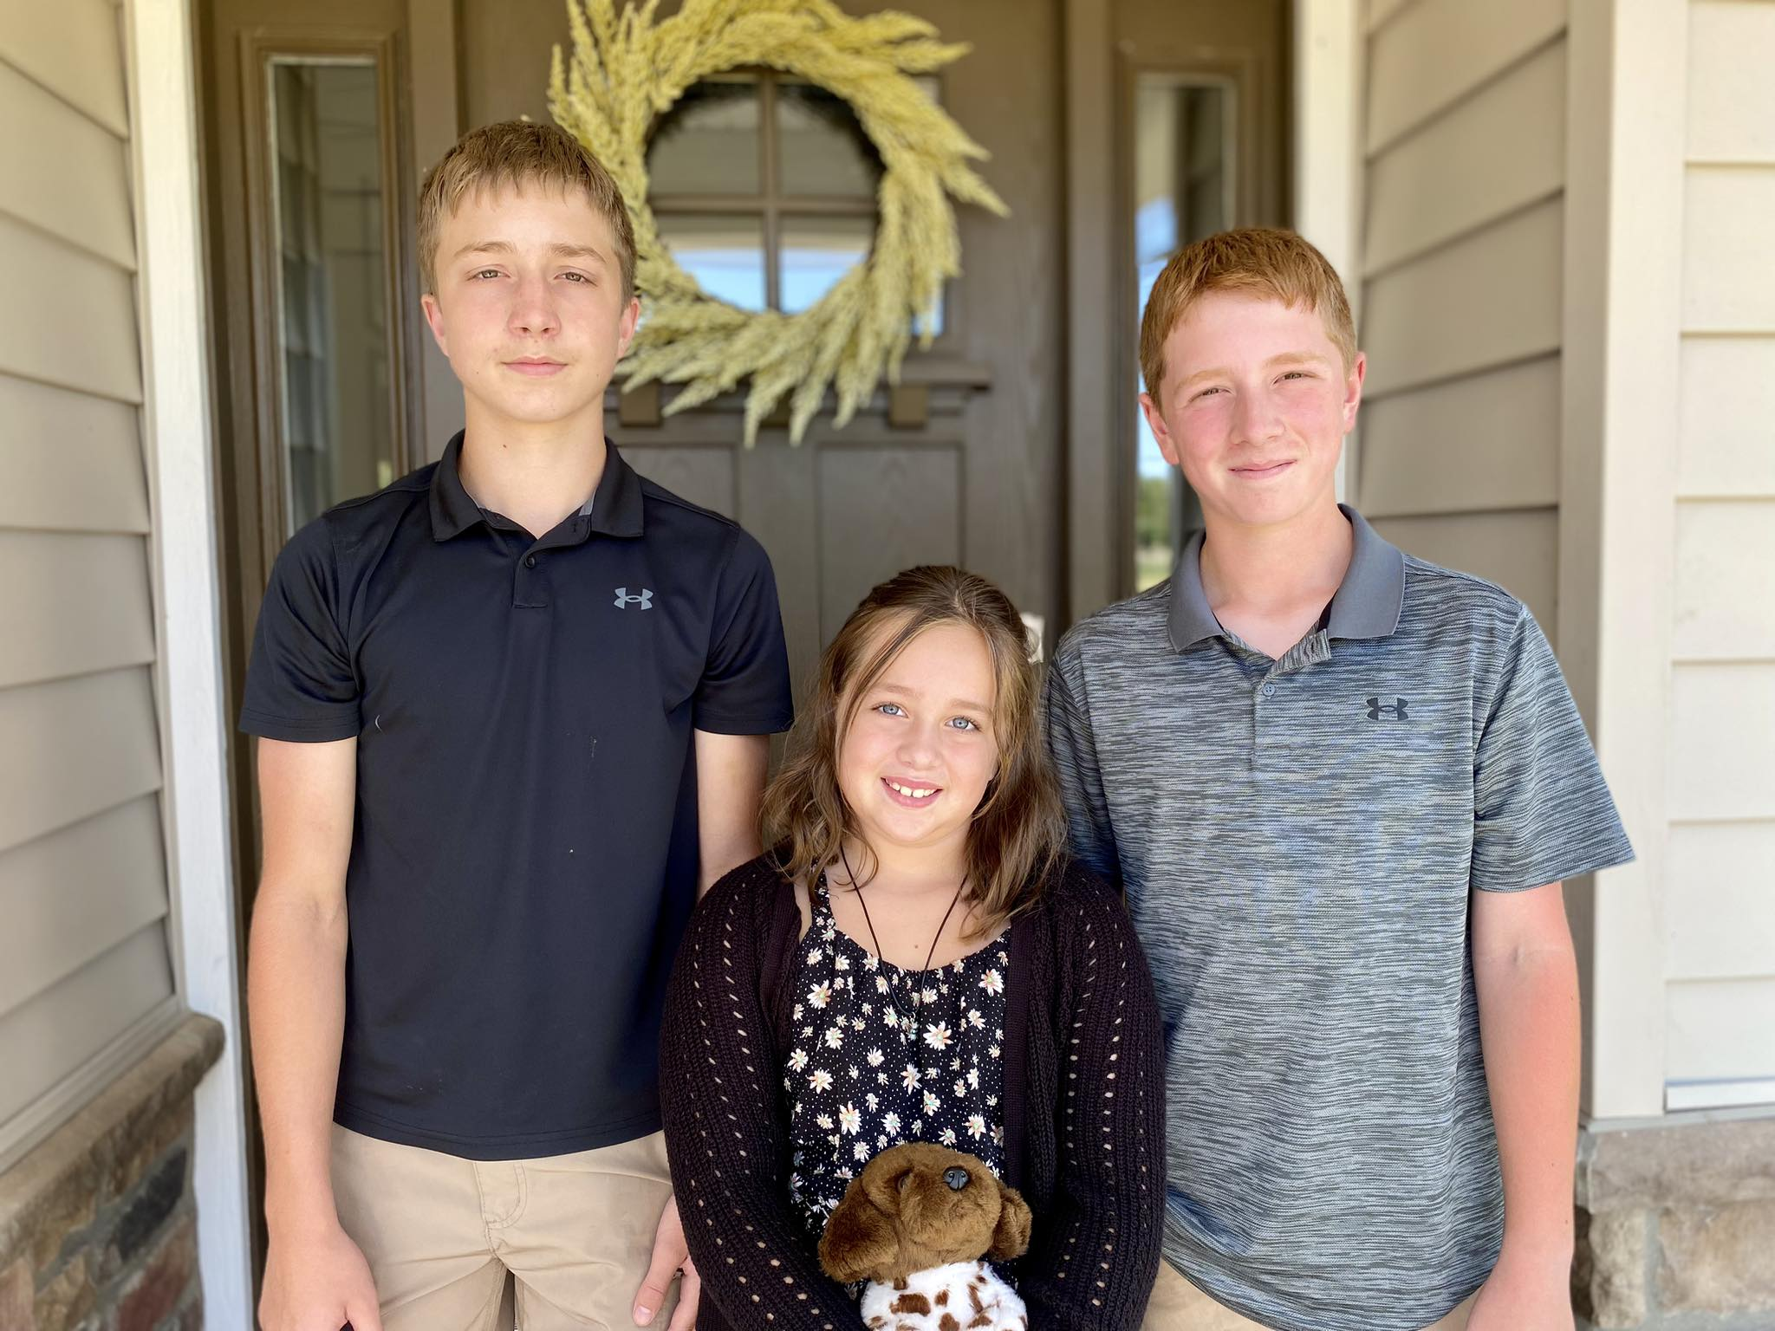
Zoe Jervis

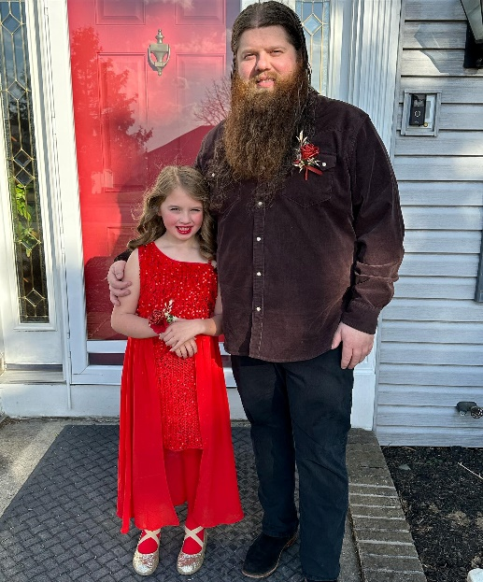
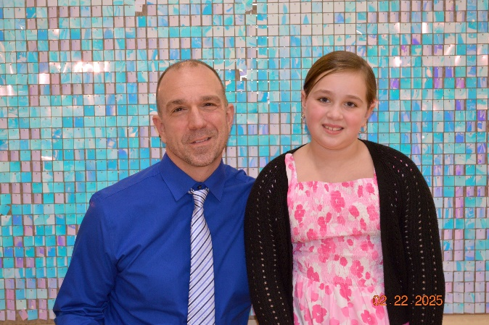
Jesse and Tilly Jervis
enjoyed the Father/Daughter dance at the Bellefontaine City Schools!
Matt and Nora McClelland enjoyed the Father/Daughter dance at the Indian Lake Schools!

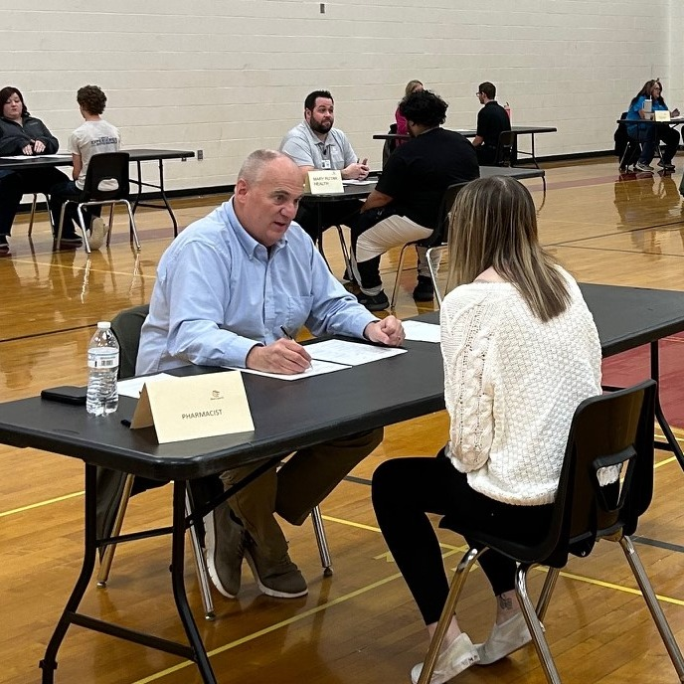
Ben Stahler chats with a BHS student who took their future to the next level at the Power Pace Interviews! Students in our Work Study Program, DECA, and seniors with post-grad employment plans had an incredible opportunity to connect with local business leaders in a fast-paced, high-energy speed interview session! They didn’t just answer questions—they sharpened their skills, built confidence, and received expert feedback to prepare for real-world job interviews. From resume tips to professional insights, the day was all about growth and career success!

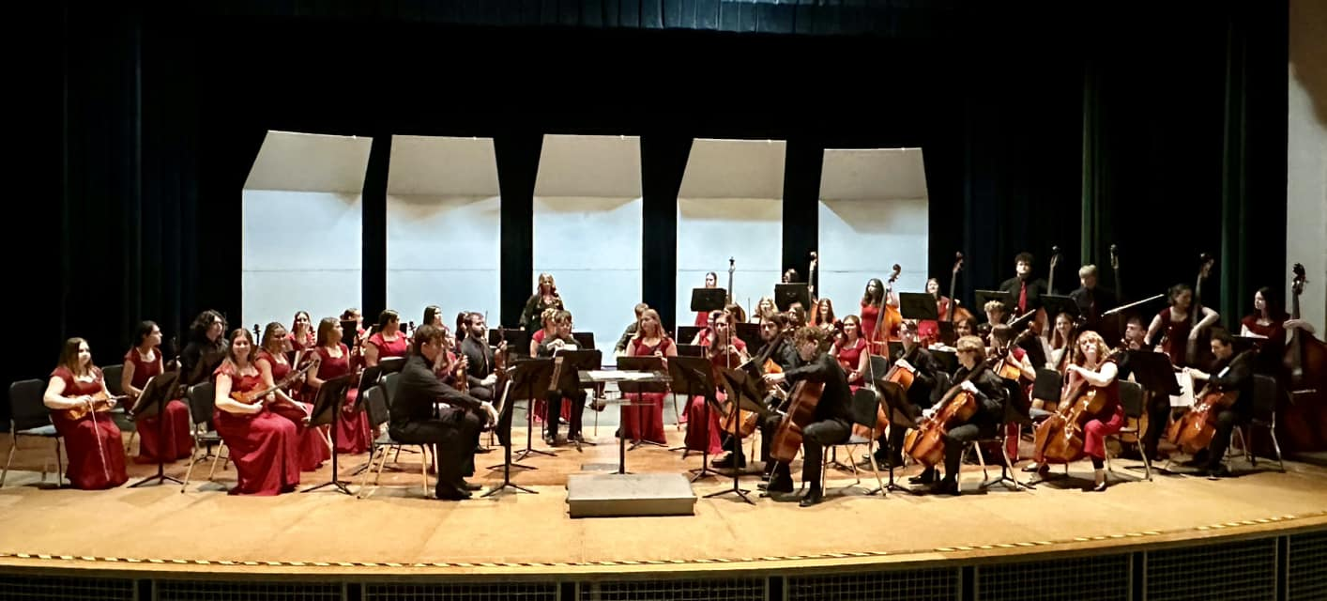
Congratulations to Emma Suman and her Orchestral peers! The Bellefontaine High School Strings Orchestra earned an Excellent rating at the OMEA State Orchestra Adjudicated Event on Saturday. The Ohio Music Education Association State Orchestra competition was held at Dublin Scioto High School.
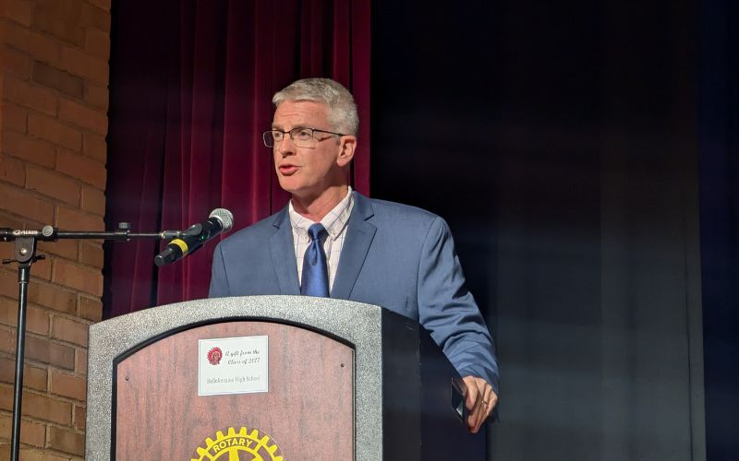
Brandon Standley, Trusted Elite Consultant and Advisor for Athletes and Organizations speaks at the Annual Rotary Honors Night.

Two hundred sixty students from the Logan County schools were honored, having attained a GPA of 3.56 or hight over the past seven semesters.

In Brandon’s speech he spelled out what “SERVICE” means and how that will effect these kids’ lives in their future.

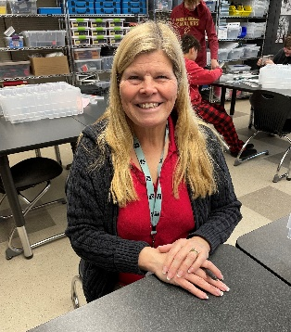
Congratulations to Sandi Chervenak who was recently honored as a
Bellefontaine City Schools “Tribe Member of the Week”!

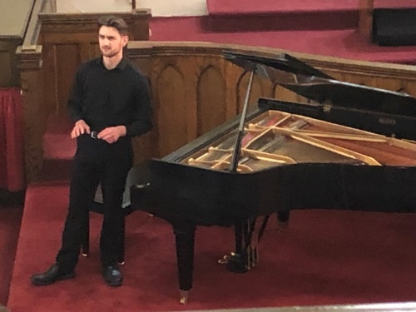
We were very happy to have Anthony Zamora give his piano recital in our sanctuary!
A group of roughly 80 people were here to enjoy his talent and outstanding music!
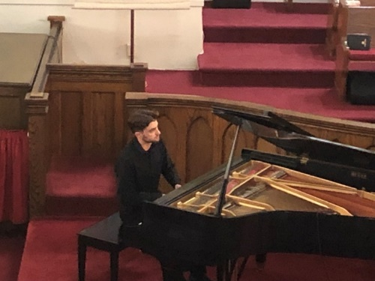


Caroline Eader will graduate from Austin Presbyterian Theological Seminary this May, receiving her Master of Divinity degree. She will be seeking a call at a church serving as a Minister of Word and Sacrament.

We would like to shower her with cards of encouragement and love, as well as provide her with a gift, depending on the amount of funds received.

We will have envelopes in the bulletin to receive your gifts, or you have drop your cards/gift in the office. Questions? Contact Anne Brienza



PALM SUNDAY – April 13 Communion Sunday, Confirmation Sunday, Confirmation Coffee Hour

MAUNDY THURSDAY – April 17 The service will be at the Methodist Church, time to be determined.

GOOD FRIDAY – April 18 12:00pm Service 1st UPC, 7:00pm Service 1st Christian Church.

EASTER SUNDAY – April 20 Easter Breakfast start time to be determined.


Downtown Bellefontaine Easter Eggstravaganza
Saturday, April 12 from Noon - 2:00 pm
(The actual event is from 11:00 - 4:00 - we are doing shorter hours).

The Church Growth and Member Care Ministry team is looking for volunteers to help lead carnival games for community kids and their parents.

You will be in charge of one game and play with the families. All supplies are provided. We will not do this event if the weather doesn't cooperate!
Please contact Anne Brienza to volunteer!


Thank you’s . . .

1st UPC Youth, Thank you for the Valentine card. It was a nice surprise! It is the small things that bring joy to all. ~Belva Lantz

I want to say again THANK YOU to everyone for the cards, texts, and words of encouragement, they mean so very much to us. I’ve had my last scheduled chemo and rang the bell! My surgery is scheduled for April 1st. After that we will know the next steps in this journey.
~Carol Hess

Dear First United Presbyterian Church, Thank you so much for your financial support of this ministry. Your gift encourages, inspires and propels us forward in pursuing the vision God has for this ministry. May the Lord bless you. ~Rev. Carey Odum, Children’s Development Mission

Dear 1st UPC Board of Deacons, We are very grateful for your generous donation in memory of Byron Fullerton. We will put those funds to good use by hosting a special resident event or purchasing a new piece of therapy equipment. Blessings to you and yours! ~Residents and Staff of Logan Acres

Dear Members of the Board of Deacons, Thank you so much for your kind donation to our hospice, in memory of Lois Ashworth. Your generosity willhelp us provide comfort and support to our patients and their families during their end-of-life journey. We are grateful for your support. Thank you!
~ Universal Home Health and Hospice Care

Thank you for the Valentine Cards and the goodies!! ~Marcella Neeld


Those needing our special prayers . . .
Eleanor Brewer Carol Hess Craig Sickles Keren Keaton
Carl Wunderle Bud Jackson Roxanne Fischer The Amidons
Anne Heinlen Tina Deardurff Mary Jane Baker Kris Sutterfield
Alissa Ritter David Ritter Celynn Taylor



With us in Spirit . . .
They would love to hear from you!!
SEND A CARD!
Sue Albano *104, 2739 Co. Rd. #91 Belleft. 43311
Celynn Taylor *103, 2739 Co. Rd. #91 Belleft. 43311
Vera Miller 10536 Manatee Drive Huntsville 43324
June Coil 6559 US Rt. 68 S. West Liberty 43357
Joyce Core 2450 Co. Rd. #118 Rushsylvania 43347
Bud and Mona Eichholtz 1328 Omaha Rd. Belleft. 43311
Anne Heinlen 741 E. Sandusky Ave. Belleft. 43311
Marcella Neeld 541 Center St. Belleft. 43311
Nate Weber 608 Newford Dr. Belleft. 43311


Celebrating a birthday in April . . .
April 1: Jamie McClelland, Scarlett Lentz April 14: Arden Neer
April 2: Calvin Kennedy April 15: Lois McKenzie
April 3: Patty Fitzpatrick April 24: Natasha Kennedy
April 6: Karl Kennedy April 26: Pat Orti
April 7: Sue Dearwester April 28: Cindy Jenkins
April 10: Vicky Shields April 29: Brenda Oda
April 11: Phyllis Lyons

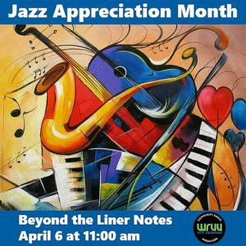
Celebrating a wedding anniversary in April . . .
April 4: Greg and Patty Fitzpatrick April 23: Jenny and Jesse Jervis


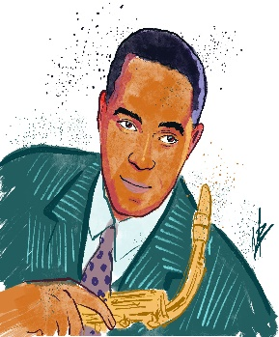


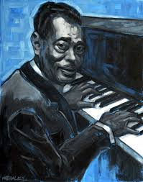

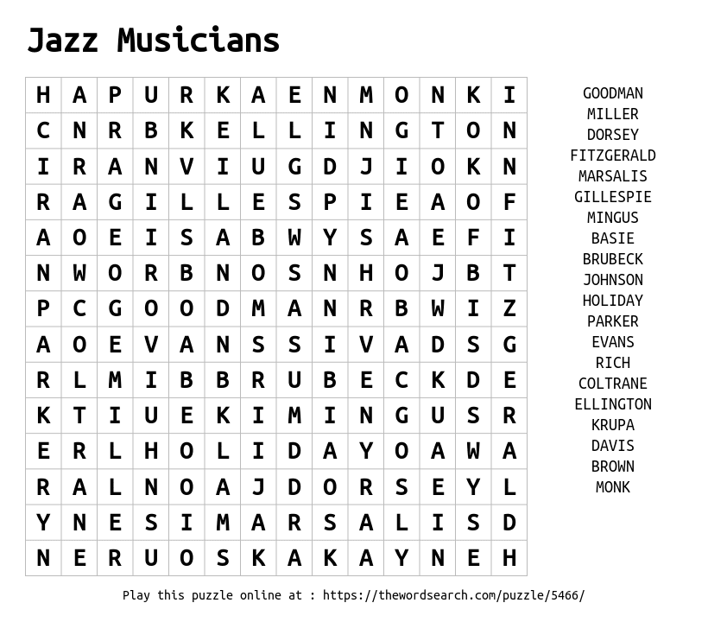
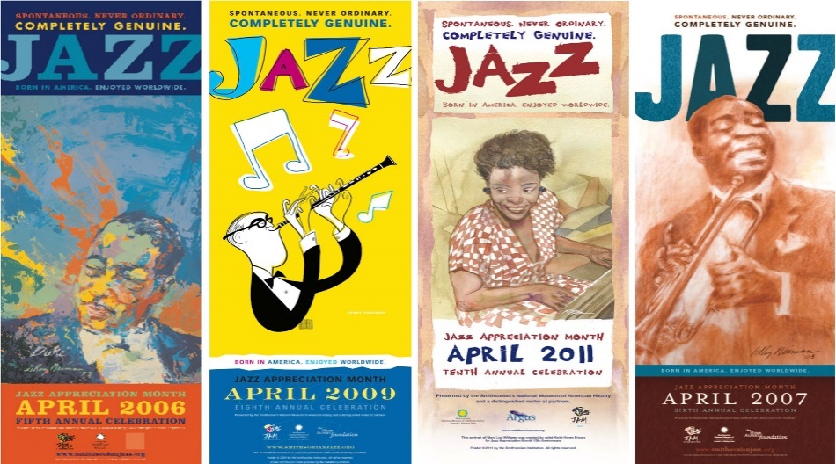
Kids Corner . . .

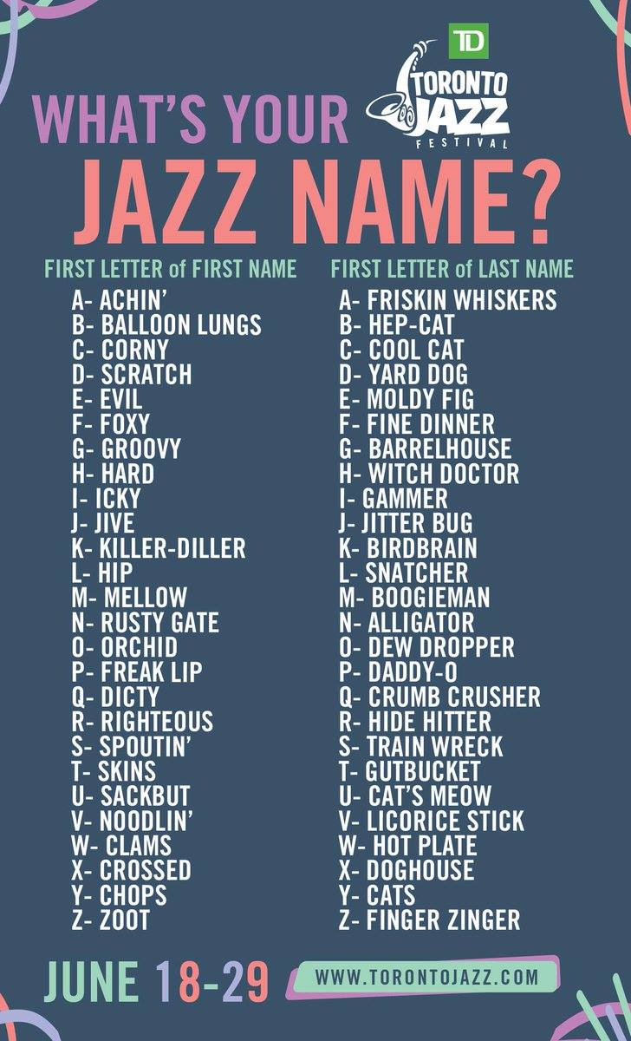



From the Kitchen . . .
Swingin’ Saucy Meatball Sandwich


Ingredients
2 eggs, lightly beaten
1 ½ cups soft whole wheat breadcrumbs
½ cup finely chopped onion (1 medium)
½ teaspoon salt
½ teaspoon dried Italian seasoning, crushed
2 pounds lean ground beef
2 (26-28 ounce) jars red pasta sauce
12 hoagie buns or bratwurst buns
½ cup grated Parmesan cheese

Make Meatballs
Preheat oven to 350°F. In a large bowl combine eggs, breadcrumbs, onion, salt, and Italian seasoning. Add ground beef; mix well. Shape into 48 meatballs. Arrange meatballs in a large roasting pan or 15x10x1-inch baking pan. Bake for 15 to 20 minutes or until done (160°). Drain well.

Heat and Serve
In a 4-quart Dutch oven combine the pasta sauce and meatballs. Heat through. Split buns or hollow out tops of unsplit buns. Spoon hot meatball mixture into buns. Spoon any remaining sauce over the meatballs. Sprinkle cheese over meatballs. If buns are split, top with bun halves. Let stand for 1 to 2 minutes before serving.

Ragtime Chicken and Wild Rice Soup
Ingredients
1 small – medium chicken breast 32oz chicken broth 1-4.3oz box Rice A Roni Wild Rick
1 C. chopped celery 1 C. chopped carrots 1 Onion chopped
1 C. heavy cream or milk 1 clove garlic 1 tsp. basil
1tsp. oregano 2 Tbls. Olive oil 2 Tbls. cornstarch

Instructions

Place the Instant Pot on sauté, add oil, garlic, onion and veggies in the instant pot.

Add chicken (mine was frozen).

Add chicken broth, Rice A Roni and packet of seasoning.

Add basil and oregano.

Place the pot on 30 minutes manual high pressure or just use your soup button.

Do a quick release.

Remove chicken and shred.

Add to your soup.

Place pot on sauté.

Mix 1C. of your broth with 2 Tbls. cornstarch to make a slurry, continue to sauté until it thickens.

Note: It does thicken more as it stands! Enjoy!

Committee Calendar . . .

The Coffee Hour for April will be sponsored by the Christian Education Committee, but a week later than usual, Sunday April 13 immediately following the Worship Service. We will honor our Confirmands at that time!


We’re never too old for an Easter Basket!! The Sunday School Youth will be assembling 10 baskets April 13, to be delivered to our homebound members during Holy Week. There is a basket in the gym to collect donations of items going into the baskets. Please consider adding to their Easter joy!!

Cards Slippers/socks with grippers Crosswords/Sudoku books Lotions/soaps
Teas Pens/colored pencils Adult coloring books small plant
Lip Balm Wipes Combs Tissues
Treats Small stuffed animals Drawings Your own idea


Our Daily Bread Bakers deliver desserts to Our Daily Bread on the third Monday of
each month between the hours of 8:30am and 6:00pm.

April 10 - 17, 2025
Bridget Hawkins, Janet Kelley, Betty Lloyd, Amy McIntyre

Higher education Scholarships are available to any Logan County PC(USA) member who is pursuing post high school education on a full-time, part-time, continuing education or trade school basis. Applicants must complete an application https://form.jotform.com/222255908542053, provide an unofficial copy of their transcripts to be uploaded with the application and provide one reference. https://form.jotform.com/223026328931149.

Application Deadline: 4:00 pm, April 15, 2025. Late applications will not be accepted.


We have recently been gifted two walkers and two shower seats for anyone who may need to borrow them! The First Christian Church had been collecting items for their own use and ended up with many more than they really need. They have reached out to all the churches and offered to pass them along! A thank you card has been sent, but if you know anyone from that church, please thank them for their generosity!!

Pastor Greg would LOVE to put together a Youth Sunday and give our kids another chance to lead the service!! If your kids would be interested in participating in a Sunday, please contact the Church Office!! The more the merrier!


If you are interested in providing flowers for the Communion table on a Sunday, to honor
someone, or just because, please contact Holly in the Church Office (937) 592-6611 or
secretary@bellefontainepres.com for more information.


Volunteers to help in the nursery are always welcome!! You can spend time with our
little ones, coloring or playing games! Brenda Jenkins, our Nursery Attendant is happy
to have you during the time of the Worship Service. Contact Ruth Bowden.


If you are fascinated by those who serve as Worship Leaders on Sunday morning and
want to take a leap of faith to help out, please contact Ruth Bowden for availability dates.


The more Special Music, the BETTER!! We are looking for anyone and everyone who would like to participate in special music for our Worship Services! You can do just about anything!! Sing alone, sing in a group, play an instrument!! Age doesn’t matter, we want everyone to enjoy being a part of the musical section of the service! If you are available to participate, please contact the Church Office for more information!

How we love to see our acolytes bringing the Light of God and the Holy Bible each Sunday morning! This is not just an activity for the young ones, we would like to see our adults active in this part of the service! We would especially be happy to have family members working together! For more information, contact Sue Crawfis!


Do you have any small household projects that you just can’t get to due to mobility?
That pesky lightbulb that needs to be changed? An outlet that needs repair? A leak that
needs a small washer replaced?

The Mission Committee sponsors HELPING HANDS! We have members of the church
who would be happy to help you through those small jobs that you just can’t quite get to! Applications are available in the Narthex and at the Elevator entrance from the alley.

There is no charge for this service! We just want everyone to be safe and comfortable in their own home!! Of course, there are some requirements. . .

If we are able to help you in any way, please fill out an application today, drop it in the offering plate or email it to the Church Office at 1stupc@bellefontainepres.com. If you have any questions, please call the Church Office (937) 592-6611 for more information.




Meeting in April . . .
The Book Study will meet Tuesdays, 11:00am.

The Worship Team meets Tuesday April 8, 1:30pm.

The Deacons meet Tuesday April 8, 5:00pm.

The Mission Team meets Tuesday April 8, 6:00pm.

The Stewardship and Finance Team meets Wednesday April 9, 12:00pm.

The CE Team meets Wednesday April 9, 5:30pm.

The Property Team meets Thursday April 10, 2:00pm.

The PWA Leadership meets Sunday April 13, 12:00pm.

The Book Club meets Tuesday April 15, 6:30pm.

The Session meets Thursday April 24, 6:00pm.

The Church Growth and Member Care Team meets Sunday April 27, 12:00pm.


Serving in April . . .
Deacons On-Call: Cindy Jenkins, Holly VanBuskirk

Welcome Team: Mark Butler, Cindy Jenkins, Pat Ortli, Holly VanBuskirk

Worship Leaders: Church Open and Close: Nursery Assistants:

April 6: Betty Lloyd April 6: Bridget Hawkins April 6:
April 13: Cindy Jenkins April 13: Betty Lloyd April 13: Elaine Thompson
April 20: Karen Brady April 20: Anne Brienza April 20:
April 27: Janet Kelley April 27: Sue Crawfis April 27: Joliece Reed



Financial Focus . . .
March 2, 2025

On-Line Attendance: 29

Sunday School Attendance: 32 Sunday School Offering: $29.00

Worship Attendance: 74 Weekly Giving: $7646.47

Received To Date: $39,666.33

March 9, 2025

On-Line Attendance: 8

Sunday School Attendance: 23 Sunday School Offering: $41.00

Worship Attendance: 75 Weekly Giving: $3140.30

Received To Date: $42,806.63

March 16, 2025

On-Line Attendance: 0

Sunday School Attendance: 21 Sunday School Offering: $26.60

Worship Attendance: 68 Weekly Giving: $6496.38

Received To Date: $49,303.01

March 23, 2025

On-Line Attendance: 0

Sunday School Attendance: 24 Sunday School Offering: $32.00

Worship Attendance: 81 Weekly Giving: $3715.47

Received To Date: $53,018.48

March 30, 2025

On-Line Attendance: 0

Sunday School Attendance: 37 Sunday School Offering: $28.00

Worship Attendance: 67 Weekly Giving: $2040.70

Received To Date: $55,059.18


Looking Ahead . . .


Our members of the Confirmation Class will host a Cinco De Mayo Taco Bar, May 4!! Immediately following the Worship Service, this will be a fund raiser for their May Youth Mission Trip!! Everyone is invited to attend and make a donation!

May 30 – July 2!! The kids will be taking a trip to Sandusky Ohio in conjunction with First Presbyterian Church of Sandusky where they will do service work Friday, Saturday and Sunday, also participating in that church service. Monday will be a fun day before they return home. If you would like to donate to offset their fees for this trip, please drop your marked donation into the offering plate any Sunday or mail it to 1st UPC PO Box 579, Belleft. 43311.
Our Daily Bread Bakers deliver desserts to Our Daily Bread on the third Monday of each month between the hours of 8:30am and 6:00pm.

May 8-15, 2025
Lois McKenzie, Carla Murdock, Pat Ortli, Joliece Reed, Carol Smith

Women of the Presbytery of the Miami Valley are invited to attend the 2025 Presbytery Women’s Spiritual Nurture Retreat April 25-27 at Kirkmont Center, Zanesfield.

The retreat is co-sponsored by Presbytery of the Miami Valley, The Blessing Center Collaborative, Xenia United Presbyterian Church, and Kirkmont Center.

This year’s theme is “Woven Together: Unity Through Biblical Friendships.” Worship and discussion leaders for the weekend are the Rev. Annie Melick, the Rev Dr. Jacqueline Nowak, Beth Pool, the Rev. Emily Haddox, and Dr. Cindy Wakeland.

Women of all ages are invited to this two-day sabbath retreat. Participation will connect you with other women throughout the presbytery and beyond through Bible study topic discussions and activities to renew your spirit and deepen your faith, while providing a time to recharge in God’s miraculous creation.

There will be laughter and prayer, games and singing, worship and study, all within an atmosphere which honors each participant’s needs and personality. A relaxed schedule allows participants to choose to participate in all arranged activities or do just what interests them. If you cannot commit for the weekend, a Saturday only option is offered.


Sign up now to spend a Sunday Morning with the kids!! You can sing songs, color, dance, whatever you want!! These kids are game for everything!!
BUILDING BLOCK SUNDAY!!

MAY 18, 2025


The Ladies’ Tea will be May 18! More information will be forthcoming from the PWA!


The 2025 Covenant Gathering will be held July 10-14 at the Geneva Center, Indiana and online. This year's theme is “Sabbath By Design” and will feature collaborators, the Rev. José Manuel Capella-Pratts and Vilmarie Cintrón-Olivieri, Regional Liaisons for the Caribbean.

The Covenant Gathering is an intergenerational faith-play event meant to equip participants for ministry in their families, churches and communities; For spiritual renewal of those who lead others; To create a greater appreciation for a connectional church; To model the Kingdom of God in our life together.



JULY 13 - 17




From the Presbytery . . .


The 2025 Covenant Gathering will be held July 10-14 at the Geneva Center, Indiana and online. This year's theme is “Sabbath By Design” and will feature collaborators, the Rev. José Manuel Capella-Pratts and Vilmarie Cintrón-Olivieri, Regional Liaisons for the Caribbean.

The Covenant Gathering is an intergenerational faith-play event meant to equip participants for ministry in their families, churches and communities; For spiritual renewal of those who lead others; To create a greater appreciation for a connectional church; To model the Kingdom of God in our life together.

For more information, contact Anne Brienza.

"Presbyterian per capita" refers to a set amount of money that each active member of a Presbyterian church is asked to contribute annually, which is used to fund the administrative costs of the wider Presbyterian denomination, including the General Assembly, Synods, and Presbyteries, essentially allowing all congregations to share in the broader church's operations and ministries through a per-member contribution.

Connectional Support: $40.00
Synod: $ 3.40
General Assembly: $10.84
$54.24 per active member
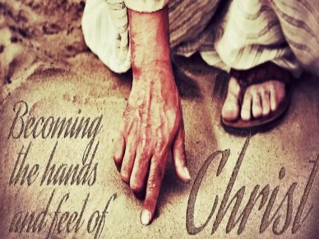
Therefore, my beloved brothers, be steadfast, immovable,
always abounding in the work of the Lord,
knowing that in the Lord your labor is not in vain.
~1 Corinthians 15:58


Each month, the Board of Deacons encourages you to help meet the needs of our 1stUPC family through your donation to our 2 Cents for Compassion Offering. Your donation will support the Deacons in their efforts to support those members of our church who are in need. Donate 2 Cents (or more) for every compassionate thought or deed you have experienced in the past month and place it in the “2 Cents for Compassion” envelope included in the Sunday bulletin.
Our Lord Jesus said, “I desire mercy, not sacrifice.”

DINNER AT THE PRES! Our next dinner of the season will be April 29! If you would like to volunteer, please contact Vicky Shields! Our Daily Bread will continue to need our help with serving on certain days of each month. If you are available to help, please contact Evelyn at 937-592-6325!

God is not unjust; he will not forget your work and the love you have shown him as you have helped his people and continue to help them.


Through the Community Cash Program, shop at Community Market, bring in your receipts and place them in the Donation Centers outside the Sanctuary or in the Fellowship Hall and you can contribute! A portion of your sale will support the 1stUPC Sharing Fund, providing assistance to our church families as needed.

“Whoever brings blessing will be enriched
and one who waters will himself be watered.”


Using your Kroger Reward Card will support Youth Mission Trips! To make an automatic donation with your Kroger Plus Card, go to krogercommunityrewards.com. Log in or set up a new account. Our NPO (non-profit) ID number is HD313, and listed as First (not 1st) United Presbyterian Church. Each year, through the graciousness of our 1stUPC shoppers, this fund contributes $800 - $1000 to support our youth mission trips.


