Presbyterian Press



February 2025


A note from the Pastor. . .
From the pastor’s desk:

It sure seems like January flew by but there has been a lot going on in the life of the church. We have installed and accepted our new elders and deacons, and we are excited for what is ahead of us as we lean into discerning God’s will, and working toward it’s service. For me personally, it seems somewhat surreal that on February 14th I will have been here at First United Presbyterian for a year. I feel so blessed, and so encouraged as I reflect on my 12 months here so far. We have been able to accomplish a great deal during that time, and one of those things is wonderful progress toward the completion of our mission study. This document should be ready for review by session and submission to the presbytery by the end of February. Once we get approval from the presbytery, we will nominate a PNC, Pastor Nominating Committee, and move forward toward hiring an installed pastor. I am very proud of the mission study team as this work can often take far longer, and I feel that they have done a wonderful job of expressing who we are as a church, and how we see ourselves moving into the future.

Something that has become an item of much conversation is that we are asking our children to remain in church as much as possible. I want to explain that a little more. While we understand that some of our younger worshipers may have difficulty sitting for the full length of worship, we also feel that it is an essential part of the development of our youth to be a part of our worship service. There is actually a great deal of research that suggests that people who worship with their family and congregation as children tend to stay in the church as adults. This is of course the decision of each family, but the preference would be that as many as possible stay as active in worship as possible. To that end, we are also trying to get more young people involved in more elements of the service to help them to realize that they too are important in what it is that we do as a congregation. All of this being said, it is also important that our young people are not unsupervised in the building and so when younger persons must leave worship, we must also make certain that they have supervision. We are grateful for each and every person that chooses to worship together, and we appreciate what all who enter here bring to this place and to our collective worship. On a personal note, I love to see our youth as involved and attentive as possible during worship. They are a blessing to us and to God and it feels very good to celebrate them.

One of my goals as a pastor is to help to remind everyone that our great commandment is to love each other. In the Gospel of Mark the 12th chapter verse 30 and 31, Jesus is responding to the religious leaders asking Him what is the greatest commandment. His answer…you shall love the Lord your God with all your heart and with all your soul and with all your mind and with all your strength.’ The second is this, ‘You shall love your neighbor as yourself.’ There is no other commandment greater than these.” Part of my great joy over the last 12 months has been watching, hearing and experiencing this congregation do just that; love God and love others. Blessings on your month.


Did you know. . .
For many, summer fun means thrill rides rule that soar, swirl, and defy gravity. But if you need a break from holding your breath, there's one attraction that lets you catch it: The Ferris wheel, a slow-moving salvation from all that speed.

Ferris wheels have been turning for more than 130 years, the first one constructed for the 1893 World's Columbian Exposition in Chicago, designed by George Washington Gale Ferris.

Paul Durica, director of exhibitions at the Chicago History Museum, notes that Ferris was an up-and-coming engineer in the early 1890s, when an announcement went out from the World's Fair organizers seeking a large-scale attraction, one that would top the pièce de resistance at the previous World's Fair in Paris, the Eiffel Tower. "What a lot of people were responding with were designs that were very similar: We'll just build a bigger tower than the Eiffel Tower," Durica said. "But it was George Washington Gale Ferris who had the idea to make something on a similar scale but allow it to move."

Legend has it he was inspired watching a water wheel turn. "He believed all along in the science, in the engineering, and he knew that it could work, even though it hadn't been done," Durica said.
Built in less than six months, his wheel opened to the public in June 1893. The steel structure was massive, climbing 264 feet, with 36 cars, each carrying 60 passengers. At the time, it was the tallest object in Chicago.

"It was an experience unlike people had ever really had before," Durica said. "You really sort of lose yourself in the experience as the world below you faded away and then suddenly came back into view, faded away again…"

It's a sensation that endures to this day, with Ferris wheels (or observation wheels) spinning worldwide, in London, Las Vegas, and in Dubai, where one rises more than 800 feet.

Imagine paying a visit to the 300-foot-tall Dream Wheel in New Jersey. "The original Ferris wheel was steam-driven; we are 100 percent electronic. No steam, no hydraulics, just all electronics," said David Moore, the general operations manager.

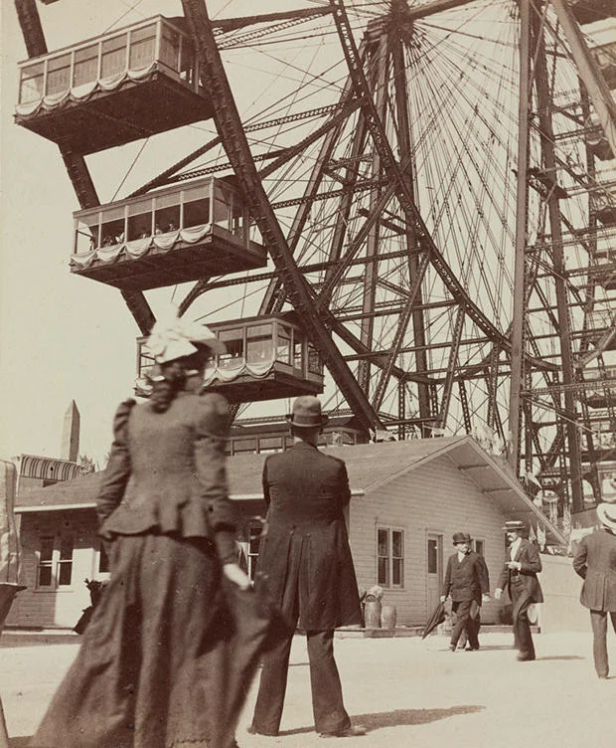
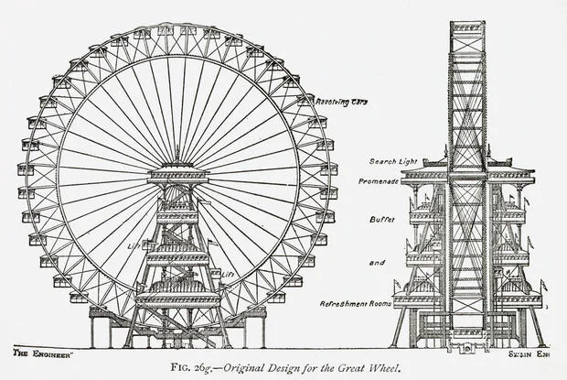
What makes a wheel so enticing to engineers? "The size, the movement, and it's a pure work of art in the sky, spinning, with people on it enjoying themselves," Moore said.

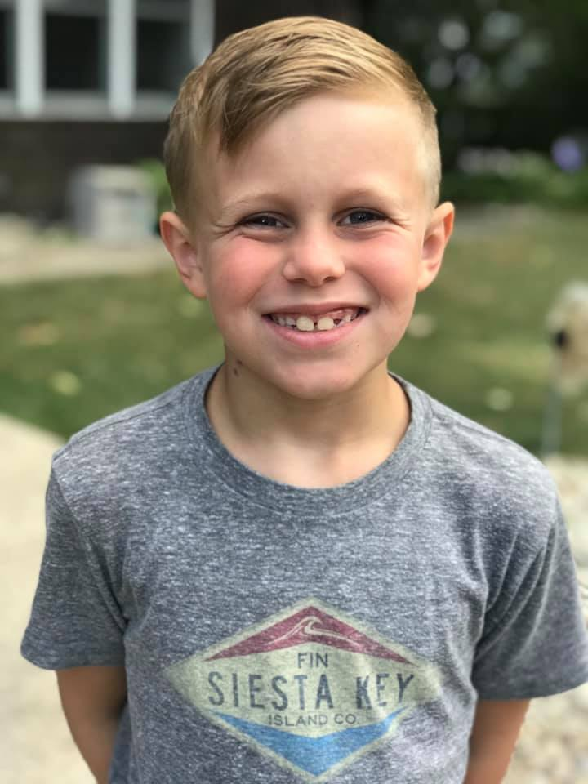

Good News . . .

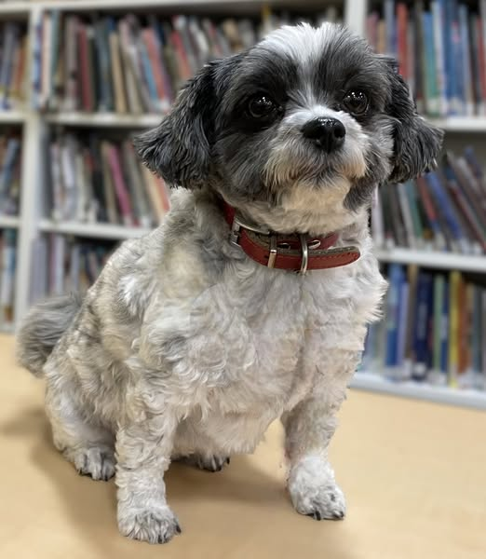

You don’t want to miss Zoe Jervis, Griffin Burkhardt, and Dottie (Anne Brienza)
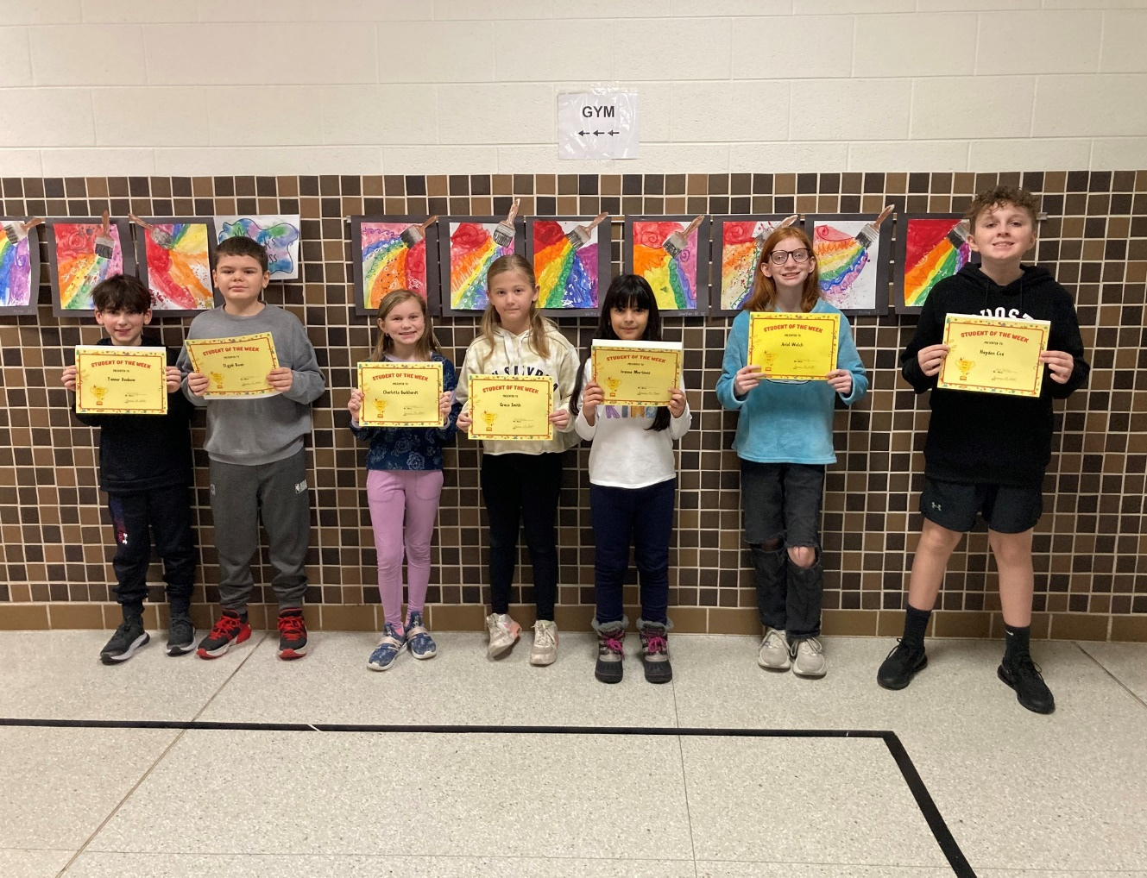
starring in The Wizard of Oz!!
February 7 and 8 at the Holland Theatre!!

Congratulations to Charlotte Burkhardt who was recently named a Student of the Week for BCS!

Cole and Calen McClelland are playing hoops for the Indian Lake School System!
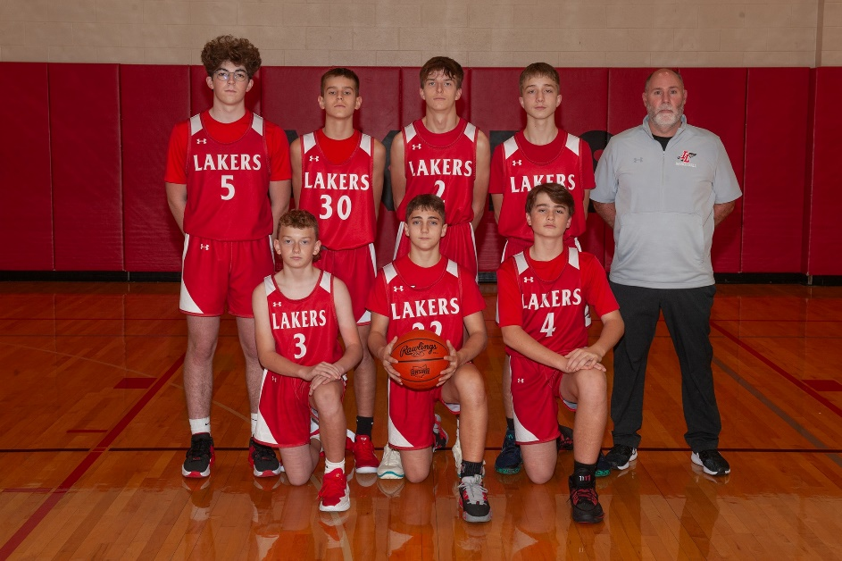
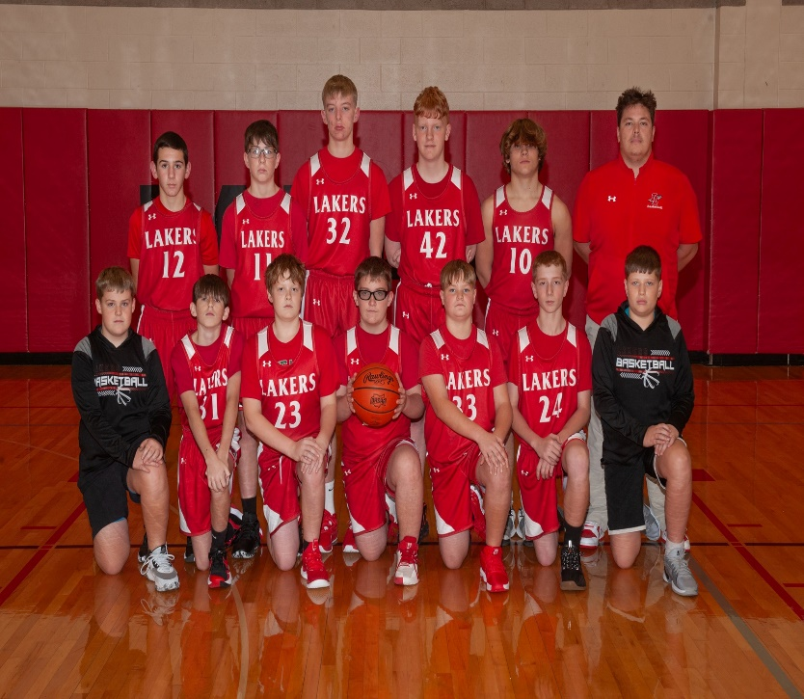

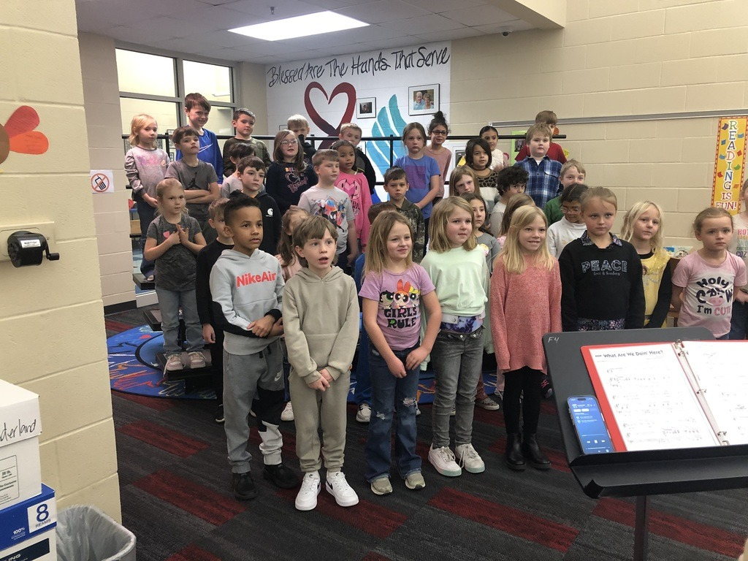
Nora Lentz and friends sing for the Senior Citizens!!

Evelyn Lentz performs in a class skit!!
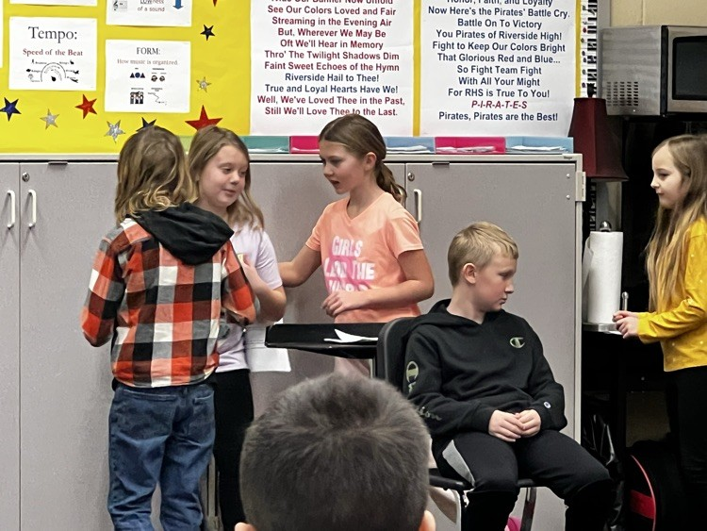


Thank You’s . . .
Receiving the We Care Poster the other day was a ray of sunshine on a cold, dreary, snowy day. Thank you to all who signed it, made my day. ~Carol Hess


Those needing our Special Prayers . . .
Eleanor Brewer Carol Hess Craig Sickles Keren Keaton
Carl Wunderle Mark Amidon Bud Jackson Roxanne Fisher
The Amidons Anne Heinlen Tina Deardurff Mary Jane Baker
Chris Suman Alissa Ritter David Ritter


With us in spirit . . .
Sue Albano *104, 2739 Co. Rd. #91 Belleft. 43311
Byron Fullerton *316, 2739 Co. Rd. #91 Belleft. 43311
Vera Miller 10536 Manatee Drive Huntsville 43324
June Coil 6559 US Rt. 68 S. West Liberty 43357
Bob Carter 6559 US Rt. 68 S. West Liberty 43357
Joyce Core 2450 Co. Rd. #118 Rushsylvania 43347
Bud and Mona Eichholtz 1328 Omaha Rd. Belleft. 43311
Anne Heinlen 741 E. Sandusky Ave. Belleft. 43311
Marcella Neeld 541 Center St. Belleft. 43311
Nate Weber 608 Newford Dr. Belleft. 43311


Celebrating a Birthday in February. . .
February 3: Olivia Eader February 14: Barb Neff
February 6: Becky Weber February 16: Joyce Core, June Coil, Pam Ark
February 7: Joan Smith February 17: Caroline Eader, Rod Bair
February 12: Hannah Suman February 20: Bridget Hawkins
February 21: Michelle Suman
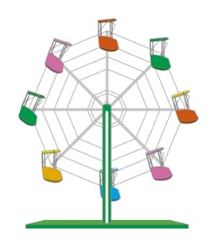

Celebrating a Wedding Anniversary in February. . .
February 25: Andy and Natasha Kennedy


Meeting in February . . .
The Church Office will be CLOSED, February 17, in observance of Presidents Day!

The Book Study will meet Tuesdays, 11:00am.

The Property Team meets Thursday February 6, 1:30pm.

The PWA Leadership meets Sunday February 9, 12:00pm.

The Worship Team meets Tuesday February 11, 1:30pm.

The Deacons meet Tuesday February 11, 5:00pm.

The Mission Team meets Tuesday February 11, 6:00pm.

The CE Team meets Wednesday February 12, 5:30pm.

The Stewardship and Finance Team meets Saturday February 15, 9:00am.

The Session meets Thursday January 16, 6:00pm.

The Church Growth and Member Care Team meets Sunday February 23, 12:00pm.


Serving in February . . .
Deacons On-Call: Jim Wical, Andy Wunderle

Welcome Team: Nancy Wisse, Joanne Ritter, Bridget Hawkins, Karen Brady

Worship Leaders: Church Open and Close: Nursery Assistants:

February 2: Ben Stahler February 2: Karen Brady February 2: Betty Lloyd
February 9: Sue Crawfis February 9: Holly C, Eva R. February 9: Elaine Thompson February 16: Ruth Bowden February 16: Sue Crawfis February 16: Joliece Reed
February 23: Bridget Hawkins February 23: Betty Lloyd February 23: Joliece Reed

Kids Corner . . .



In the kitchen . . .
FERRIS WHEEL SANDWICHES
Ingredients
16oz. cream cheese 1.5oz. Hidden Valley Ranch Seasoning
½ C. Shredded Cheddar Cheese 5 Flour Tortillas ½ C. Finely chopped ham

In a medium bowl, mix together the cream cheese, ranch mix and shredded cheese.
Spread 1/5 of the cream cheese mixture onto each tortilla in a ¼ inch layer.
Sprinkle each tortilla with ham.
Roll up the tortilla tightly to make sure the cream cheese binds the tortilla together.
Place in the refrigerator until fully chilled, about 1-2 hours.

Cut each tortilla into ½ inch wheels and serve.

FERRIS WHEEL RASPBERRY COOKIES
Ingredients
8 oz. cream cheese ½ C. butter 1&1/2 C. All purpose flour, SIFTED
½ tsp. salt 1/3 C. seedless jam Powdered sugar for sprinkling on top
Cream together butter and cream cheese. Mix in salt and flour until combined and a ball starts to form.
Roll the dough into a ball, pressing down on the top so it’s flat and will be easier to roll out. Wrap in plastic wrap.
Chill 30 minutes.
Generously flour your counter, put the dough on the counter and sprinkle some flour over the top. Use a rolling pin to roll out a 10 x 12 rectangle.
Sprinkle the top with more flour, as well as your counter underneath the dough. Flip the dough over so the top is now facing the counter.Sprinkle more flour on top of dough and roll it out to 10 x 30.
Spread jam all over the dough, roll the dough into a log, chill for 15 minutes.
Preheat oven to 375*, slice log into ¼ - ½ in. slices. Line these up flat on parchment lined baking sheet.
Bake 17 – 20 minutes. Remove from oven, transfer to cooling rack. Once they have cooled, sprinkle powered sugar on top and serve.

Committee Calendar . . .


Our Daily Bread Bakers deliver desserts to Our Daily Bread on the third Monday of
each month between the hours of 8:30am and 6:00pm.

February 13 - 20, 2024
Nancy Stokes, Judy Wical, Katie Amidon, Tara Bair, Karen Brady


It’s Cookies for Kairos time again! This year the Mission Committee has committed to baking 200 dozen cookies for Pastor Greg’s Kairos Weekend! Volunteers are needed to help with the baking! For more information, please see Vicky Shields, Cindy Jenkins, Holly VanBuskirk, Bridget Hawkins or Mark Butler!


We have recently been gifted two walkers and two shower seats for anyone who may need to borrow them! The First Christian Church had been collecting items for their own use and ended up with many more than they really need. They have reached out to all the churches and offered to pass them along! A thank you card has been sent, but if you know anyone from that church, please thank them for their generosity!!

Pastor Greg would LOVE to put together a Youth Sunday and give our kids another chance to lead the service!! If your kids would be interested in participating in a Sunday, please contact the Church Office!! The more the merrier!
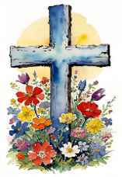

If you are interested in providing flowers for the Communion table on a Sunday, to honor
someone, or just because, please contact Holly in the Church Office (937) 592-6611 or
secretary@bellefontainepres.com for more information.


Volunteers to help in the nursery are always welcome!! You can spend time with our
little ones, coloring or playing games! Brenda Jenkins, our Nursery Attendant is happy
to have you during the time of the Worship Service. Contact Ruth Bowden.


If you are fascinated by those who serve as Worship Leaders on Sunday morning and
want to take a leap of faith to help out, please contact Ruth Bowden for availability dates!


The more Special Music, the BETTER!! We are looking for anyone and everyone who would like to participate in special music for our Worship Services! You can do just about anything!! Sing alone, sing in a group, play an instrument!! Age doesn’t matter, we want everyone to enjoy being a part of the musical section of the service! If you are available to participate, please contact the Church Office for more information!

How we love to see our acolytes bringing the Light of God and the Holy Bible each Sunday morning! This is not just an activity for the young ones, we would like to see our adults active in this part of the service! We would especially be happy to have family members working together! For more information, contact Sue Crawfis!


Do you have any small household projects that you just can’t get to due to mobility?
That pesky lightbulb that needs to be changed? An outlet that needs repair? A leak that
needs a small washer replaced?

The Mission Committee sponsors HELPING HANDS! We have members of the church
who would be happy to help you through those small jobs that you just can’t quite get
to! Applications are available in the Narthex and at the Elevator entrance from the alley.

There is no charge for this service! We just want everyone to be safe and comfortable in their own home!! Of course, there are some requirements. . .

If we are able to help you in any way, please fill out an application today, drop it in the offering plate or email it to the Church Office at 1stupc@bellefontainepres.com. If you have any questions, please call the Church Office (937) 592-6611 for more information.


Looking ahead . . .

Our Daily Bread Bakers deliver desserts to Our Daily Bread on the third Monday of
each month between the hours of 8:30am and 6:00pm.

March 13 - 20, 2024
Anne Brienza, Debbie Day, Nancy Farrington, Patty Fitzpatrick

The PWA will host a Soup Sampler lunch in the Fellowship Hall, Sunday March 9, immediately following the Worship Service. Everyone is invited to attend!!


The Ladies’ Tea will be May 18! More information will be forthcoming from the PWA!

Financial Focus . . .

January 5, 2025

On-Line Attendance: 10

Sunday School Attendance: 19 Sunday School Offering: $20.00

Worship Attendance: 55 Weekly Giving: $6087.00

Received To Date: $6087.00

January 12, 2025

On-Line Attendance: 28

Sunday School Attendance: 30 Sunday School Offering: $47.00

Worship Attendance: 95 Weekly Giving: $6045.47

Received To Date: $12,132.47

January 19, 2025

On-Line Attendance: 21

Sunday School Attendance: 29 Sunday School Offering: $50.00

Worship Attendance: 79 Weekly Giving: $4320.01

Received To Date: $16,452.48

January 26, 2025

On-Line Attendance: 12

Sunday School Attendance: 25 Sunday School Offering: $36.00

Worship Attendance: 63 Weekly Giving: $1,907.00

Received To Date: $18,359.48

Ferris Wheel Facts
There are over 1,500 Ferris wheels in operation around the world.
The tallest Ferris wheel in the world is the Ain Dubai, which is located in Dubai, United Arab Emirates. The Ain Dubai is 828 feet (252 meters) tall and has 48 cars, each of which can hold up to 40 people.

The Ferris wheel was very popular at the World's Columbian Exposition, and it is estimated that over 1.4 million people rode it.

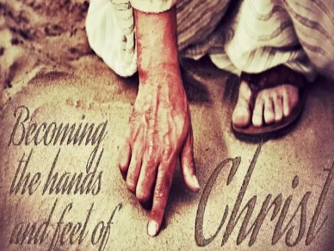
Therefore, my beloved brothers, be steadfast, immovable,
always abounding in the work of the Lord,
knowing that in the Lord your labor is not in vain.
~1 Corinthians 15:58


Each month, the Board of Deacons encourages you to help meet the needs of our 1stUPC family through your donation to our 2 Cents for Compassion Offering. Your donation will support the Deacons in their efforts to support those members of our church who are in need. Donate 2 Cents (or more) for every compassionate thought or deed you have experienced in the past month and place it in the “2 Cents for Compassion” envelope included in the Sunday bulletin.
Our Lord Jesus said, “I desire mercy, not sacrifice.”

DINNER AT THE PRES! The Mission Committee would like to thank everyone who has volunteered for Dinner at the Pres this year. We are suspending operations until March 2025. Our Daily Bread will continue to need our help with serving on certain days of each month. If you are available to help, please contact Evelyn at 937-592-6325!

God is not unjust; he will not forget your work and the love you have shown him as you have helped his people and continue to help them.


Through the Community Cash Program, shop at Community Market, bring in your receipts and place them in the Donation Centers outside the Sanctuary or in the Fellowship Hall and you can contribute! A portion of your sale will support the 1stUPC Sharing Fund, providing assistance to our church families as needed.

“Whoever brings blessing will be enriched
and one who waters will himself be watered.”


Using your Kroger Reward Card will support Youth Mission Trips! To make an automatic donation with your Kroger Plus Card, go to krogercommunityrewards.com. Log in or set up a new account. Our NPO (non-profit) ID number is HD313, and listed as First (not 1st) United Presbyterian Church. Each year, through the graciousness of our 1stUPC shoppers, this fund contributes $800 - $1000 to support our youth mission trips.


