PRESBYTERIAN PRESS

JANUARY 2025

DID YOU KNOW?

**A Brief History Of Weather Measurement**

**1450** Leon Battista invents the first anemometer (from the Greek word for wind, “anemos”), which measures wind velocity using a disk placed perpendicular to the wind. The familiar spinning “cup” anemometer was invented in 1846, and the sonic anemometer was first developed in 1994.



**1593** Galileo Galilei invents the thermometer by suspending glass bulbs of varying weights in a tube of water. The bulbs rise and fall as the changing temperature alters the density of the water. In 1714, Gabriel Fahrenheit fashioned the first mercury thermometer. This station uses precision thermistors, which change in electrical resistance with temperature.



**1644** Galileo’s student, Evangelista Torricelli, invents the barometer when he notices the mercury-filled glass column he used for vacuum experiments reacts to changes in atmospheric pressure. This station measures the bending of a silicon diaphragm to determine pressure.

Old Main

**1893** The Utah Territory's 20th weather station is established at Utah Agricultural College. Precipitation and maximum/minimum temperature data are recorded. The College begins receiving telegraphic weather forecasts from the USDA in San Francisco. Signal flags with daily weather forecasts are raised from the College flagpole, and are visible to farmers across Cache Valley.

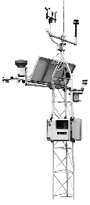

**2011** A solar powered environmental observatory is erected at USU. The observatory measures all standard weather conditions, five components of solar radiation, carbon dioxide in the air, and seven conditions underground. A state-of-the-art atmospheric visibility sensor measures the clarity of the air in Cache Valley, a unique feature of particular interest to local residents.

GOOD NEWS

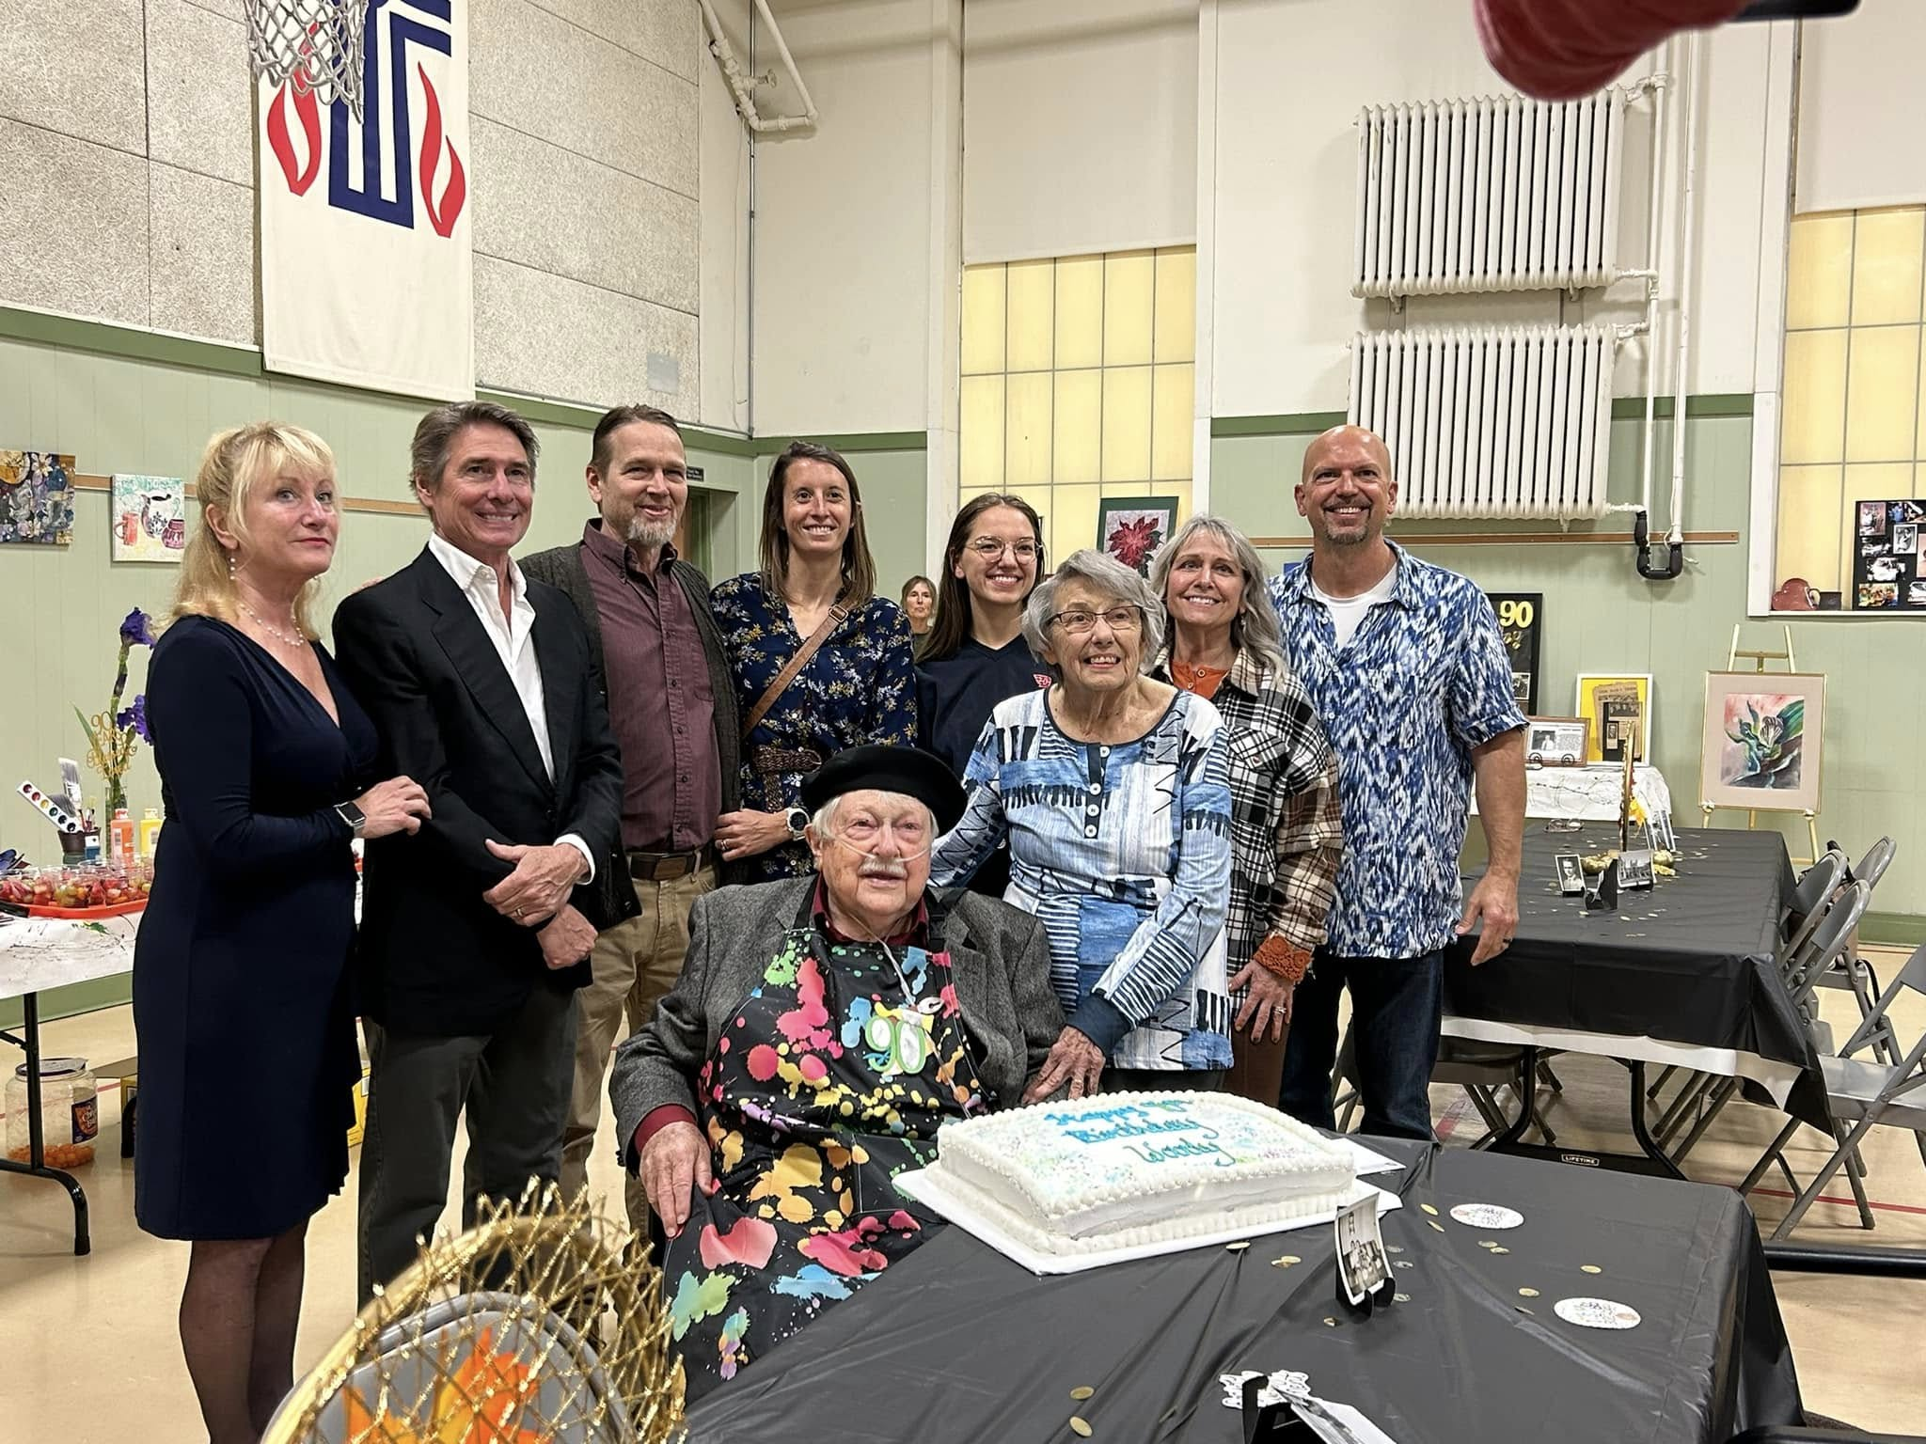

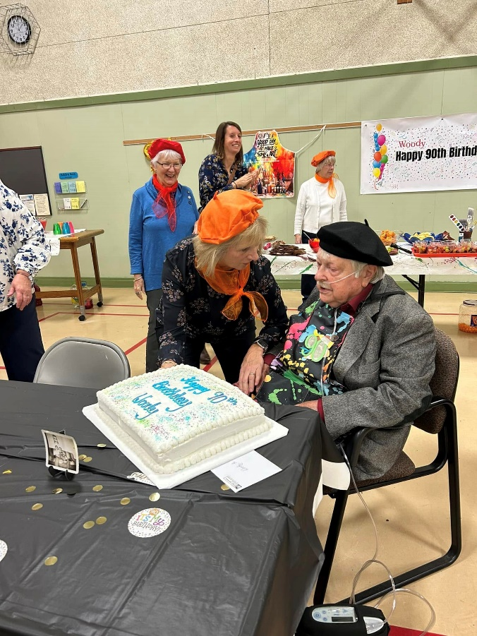

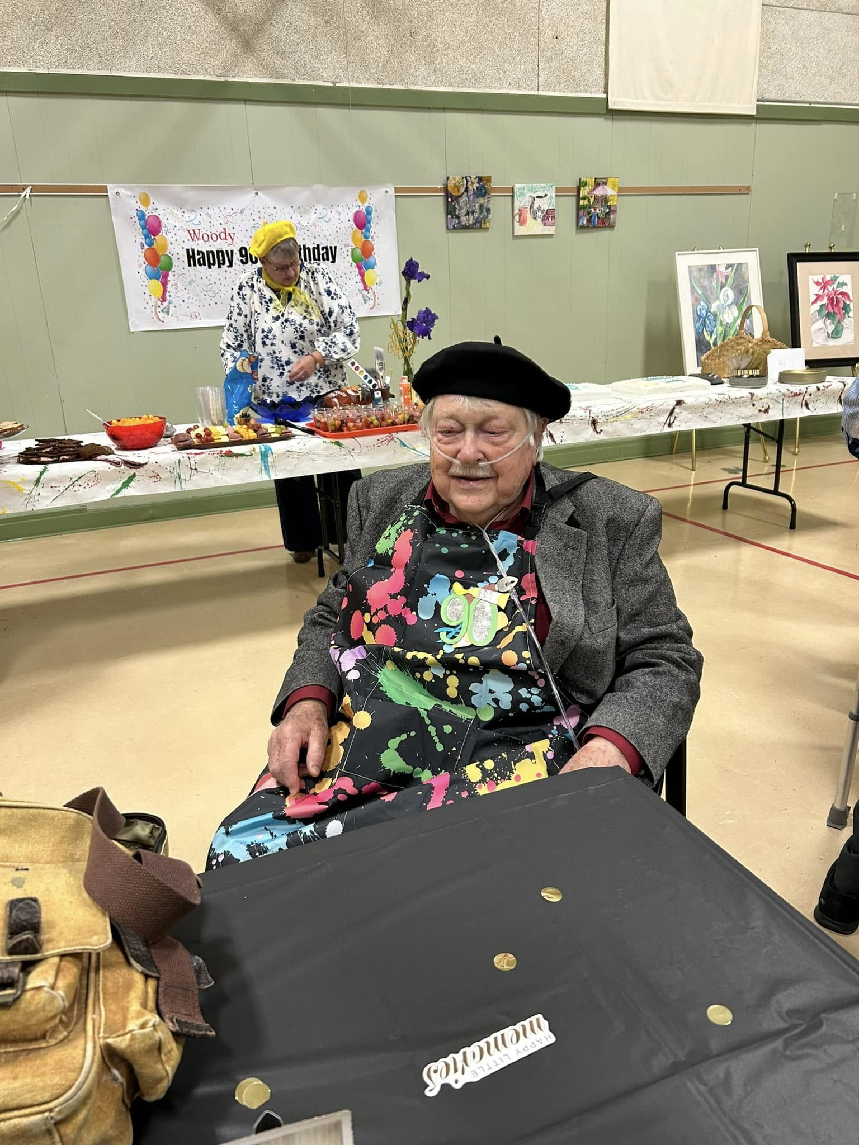

CONGRATULATIONS TO KELLEY FORSYTHE, granddaughter of Jim and Janet Kelley, who was recently crowned

SNOWBALL QUEEN

at Benjamin Logan High School!!

THANK YOU’S

Dear Church Friends,

Thank you so much for remembering my birthday! What a nice surprise to receive the

Happy Birthday poster in the mail last week. I put it on the side of my refrigerator for

my family to see! Thanks again, Dorothy Snapp

Dear Church Family, Thank you for the birthday party and all the cards I’ve received wishing me well. It is great to be part of this community of faith, which is an expression of God’s love. I love you all. ~Woody

What a welcome surprise to have a beautiful floral Christmas arrangement delivered to my home by one of our Deacons recently. It brought many smiles and was very much appreciated.

Thank you!! Marge Hines

The Mission Committee would like to thank **everyone** who participated in our project for Christmas 2024! Your generosity to those who are less fortunate was stunning! We were able to give out 30 food baskets to families, seniors, and singles. Gifts were purchased for seventeen children! It is just amazing what our church can do!

God Bless you all! ~Mission Committee

Thanks so much to the Deacons who do so much for church members. We do appreciate it. Poor Judy didn’t know it was so windy out here. But we did have a good visit.

Thank you, Joyce Core

Dear Deacons, A heartfelt thank you to all of you for the lovely Christmas arrangement along with a pretty card. How special to have Pat Ortli stop by with such holiday cheer. You are so caring and truly make your friends feel special and loved. Many thanks again.

Love Nate and Becky Weber

Thank you for delivering the beautiful planter, it is lovely. Merry Christmas and Happy New Year to all. I appreciate the kindness of the church immensely, may God bless you.

In Christian Love, Anne Heinlen

SPECIAL PRAYERS

Eleanor Brewer Carol Hess Craig Sickles Keren Keaton

Carl Wunderle Mark Amidon Bud Jackson Roxanne Fisher

The Amidons Anne Heinlen Tina Deardurff Mary Jane Baker

Chris Suman Alissa Ritter David Ritter

Requests from our guests at Dinner at the Pres:

Prayers for Linda, Jason, Earnie, Todd and Jen, Jim, and Michael.

With us IN SPIRIT

Sue Albano *104, 2739 Co. Rd. #91 Belleft. 43311

Byron Fullerton *316, 2739 Co. Rd. #91 Belleft. 43311

Vera Miller 10536 Manatee Drive Huntsville 43324

Lois Ashworth 209 E. Glen Belleft. 43311

June Coil 6559 US Rt. 68 S. West Liberty 43357

Bob Carter 6559 US Rt. 68 S. West Liberty 43357

Joyce Core 2450 Co. Rd. #118 Rushsylvania 43347

Bud and Mona Eichholtz 1328 Omaha Rd. Belleft. 43311

Anne Heinlen 741 E. Sandusky Ave. Belleft. 43311

Marcella Neeld 541 Center St. Belleft. 43311

Nate Weber 608 Newford Dr. Belleft. 43311

CELEBRATING A BIRTHDAY

December 3: Sara Stahler December 20: Woody Amidon

December 4: Carla Murdock December 21: Billie Jo Kennedy

December 8: Anne Brienza December 24: Eric Caughenbaugh

December 17: Adam Wunderle December 26: Sandi Chervenak, Julie Pulfer

December 18: Nora Lentz December 27: Anne Heinlen

December 19: Judy Bozman December 30: Calen McClelland

CELEBRATING AN ANNIVERSARY

January 20: Mark and Amy McIntyre

January 21: Lois and Gary McKenzie

Kids Corner

IN THE KITCHEN

**EASY GAZPACHO**

**Ingredients**

* 4 cups tomato juice
* 2 cups chopped tomatoes
* 1 onion, minced
* 1 green bell pepper, minced
* 1 cucumber, chopped
* 2 green onions, chopped
* ¼ cup chopped fresh parsley
* 3 tablespoons fresh lemon juice
* 2 tablespoons red wine vinegar
* 1 clove garlic, minced
* 1 teaspoon dried tarragon
* 1 teaspoon dried basil
* 1 teaspoon white sugar
* salt and pepper to taste
* **Directions**

1. Combine tomato juice, tomatoes, onion, bell pepper, cucumber, green onions, parsley, lemon juice, red wine vinegar, garlic, tarragon, basil, sugar, salt, and pepper in a blender or food processor. Blend until well combined but still slightly chunky.
2. Pour into a serving bowl and cover. Place in the refrigerator to chill before serving, at least 2 hours.



COMMITTEE CALENDAR

Our Daily Bread Bakers deliver desserts to Our Daily Bread on the third Monday of

each month between the hours of 8:30am and 6:00pm.

January 19 – 23

The Nursery is available during the Worship Service for those children aged Kindergarten and below.

Mark your calendars!! Sunday, January 5, following the Coffee Hour sponsored by the Session, we will take down the Christmas Decorations! Everyone is welcome to come and help!

The Worship Committee is in need of two volunteers to be part of the Welcome Teams for 2025. Duties would include passing out bulletins and collecting the offering.

The Welcome Teams work on a rotation basis meaning your group would be on call three months out of the year. If you are interested, please contact Nancy Wisse.

Say hello to Tiny Jesus! He is always among us and is watching over you! But

where is he watching from? He could be anywhere in the church and if you

happen to find him, you can bring him to the Church Office and win a prize!

You will know he is the one you want to find because he will have a black mark

on the bottom of one foot.

If you find his helpers, Tiny Jesus at the Pulpit, Tiny Jesus enjoying the bells, or Tiny

Jesus listening to Tom play the organ, please do not get too excited. Those Tiny Jesus

helpers are not eligible for a prize.

We have recently been gifted two walkers and two shower seats for anyone who may need to borrow them! The First Christian Church had been collecting items for their own use and ended up with many more than they really need. They have reached out to all the churches and offered to pass them along! A thank you card has been sent, but if you know anyone from that church, please thank them for their generosity!!

Pastor Greg would LOVE to put together a Youth Sunday and give our kids another chance to lead the service!! If your kids would be interested in participating in a Sunday, please contact the Church Office!! The more the merrier!

If you are interested in providing flowers for the Communion table on a Sunday, to honor

someone, or just because, please contact Holly in the Church Office (937) 592-6611 or

secretary@bellefontainepres.com for more information.

Volunteers to help in the nursery are always welcome!! You can spend time with our

little ones, coloring or playing games! Brenda Jenkins, our Nursery Attendant is happy

to have you during the time of the Worship Service. Contact Anne Brienza.

If you are fascinated by those who serve as Worship Leaders on Sunday morning and

want to take a leap of faith to help out, please contact Anne Brienza for availability dates!

The more Special Music, the BETTER!! We are looking for anyone and everyone who would like to participate in special music for our Worship Services! You can do just about anything!! Sing alone, sing in a group, play an instrument!! Age doesn’t matter, we want everyone to enjoy being a part of the musical section of the service! If you are available to participate, please contact the Church Office for more information!

How we love to see our acolytes bringing the Light of God and the Holy Bible each Sunday morning! This is not just an activity for the young ones, we would like to see our adults active in this part of the service! We would especially be happy to have family members working together! For more information, contact Sue Crawfis!

Do you have any small household projects that you just can’t get to due to mobility?

That pesky lightbulb that needs to be changed? An outlet that needs repair? A leak that

needs a small washer replaced?

The Mission Committee sponsors **HELPING HANDS**! We have members of the church

who would be happy to help you through those small jobs that you just can’t quite get

to! Applications are available in the Narthex and at the Elevator entrance from the alley.

There is no charge for this service! We just want everyone to be safe and comfortable in their own home!! Of course, there are some requirements. . .

If we are able to help you in any way, please fill out an application today, drop it in the offering plate or email it to the Church Office at [1stupc@bellefontainepres.com](mailto:1stupc@bellefontainepres.com). If you have any questions, please call the Church Office (937) 592-6611 for more information.

MEETING in January

The Church Office will be CLOSED, January 20, in observance of MLK Day!

The Book Study will meet Tuesdays, 11:00am.

The Property Team meets Thursday January 2, 1:30pm

The Stewardship and Finance Team meets Wednesday January 8, 12:00pm.

The CE Team meets Wednesday January 8, 5:30pm.

The Worship Team meets Tuesday January 14, 1:30pm.

The Deacons meet Tuesday January 14, 5:00pm.

The Mission Team will not meet in January.

The Session meets Thursday January 16, 6:00pm.

The PWA Leadership meets Sunday January 19, 12:00pm.

The Church Growth and Member Care Team meets Sunday January 26, 12:00pm.

SERVING in January

Deacons On-Call: Jim Wical, Andy Wunderle

Welcome Team: Mac Smith, Mike Brady, Andy and Julie Pulfer

Worship Leaders: Church Open and Close: Nursery Assistants:

January 5: Sue Crawfis January 5: Anne Brienza January 5: Sue Crawfis

January 12: January 12: Karen Brady January 12: Betty Lloyd

January 19: Mark Butler January 19: Bridget Hawkins January 19: Brenda Oda

January 26: Brenda Oda January 26: Betty Lloyd January 26: Amy McIntyre

When great minds think alike . . .

Financial Focus

December 1, 2024

On-Line Attendance: 0

Sunday School Attendance: 31 Sunday School Offering: $68.00

Worship Attendance: 93 Weekly Giving: $3,036.00

Received To Date: $195,510.71

December 8, 2024

On-Line Attendance: 10

Sunday School Attendance: 23 Sunday School Offering: $21.00

Worship Attendance: 106 Weekly Giving: $4,402.31

Received To Date: $199,913.02

December 15, 2024

On-Line Attendance: 16

Sunday School Attendance: 27 Sunday School Offering: $31.00

Worship Attendance: 85 Weekly Giving: $2,184.47

Received To Date: $202,097.49

December 22, 2024

On-Line Attendance: 19

Sunday School Attendance: 30 Sunday School Offering: $27.00

Worship Attendance: 80 Weekly Giving: $1,798.47

Received To Date: $203,895.96

December 29, 2024

On-Line Attendance: 21

Sunday School Attendance: 30 Sunday School Offering: $48.50

Worship Attendance: 80 Weekly Giving: $4,092.00

Received To Date: $207,987.96

LOOKING AHEAD

Our Daily Bread Bakers deliver desserts to Our Daily Bread on the third Monday of

each month between the hours of 8:30am and 6:00pm.

January 20 – 24, 2025

More information will be coming soon, however, it’s not early for everyone to be thinking about a Capital Campaign.

As you know we have an open space on the outside of our west wall, near our stained glass window that will need to be repaired in the spring.

We have also gone past our warranty on the current church roof and within the next two years that will need to be replaced.

The Stewardship and Finance Team are in discussions about these repairs, hoping to have these repairs at their most cost effective.

When Jesse met Mae.

Therefore, my beloved brothers, be steadfast, immovable,

always abounding in the work of the Lord,

knowing that in the Lord your labor is not in vain.

~[1 Corinthians 15:58](https://www.biblegateway.com/passage/?search=1+Corinthians+15%3A58&version=ESV)

Each month, the Board of Deacons encourages you to help meet the needs of our 1stUPC family through your donation to our **2 Cents for Compassion Offering**. Your donation will support the Deacons in their efforts to support those members of our church who are in need. Donate 2 Cents (or more) for every compassionate thought or deed you have experienced in the past month and place it in the “2 Cents for Compassion” envelope included in the Sunday bulletin.

Our Lord Jesus said, “I desire mercy, not sacrifice.”

**DINNER AT THE PRES!** The Mission Committee would like to thank everyone who has volunteered for Dinner at the Pres this year. We are suspending operations until March 2025. Our Daily Bread will continue to need our help with serving on certain days of each month. If you are available to help, please contact Evelyn at 937-592-6325!

God is not unjust; he will not forget your work and the love you have shown him as you have helped his people and continue to help them.

Through the **Community Cash Program**, shop at Community Market, bring in your receipts and place them in the Donation Centers outside the Sanctuary or in the Fellowship Hall and you can contribute! A portion of your sale will support the 1stUPC Sharing Fund, providing assistance to our church families as needed.

“Whoever brings blessing will be enriched

and one who waters will himself be watered.”

Using your Kroger Reward Card will support Youth Mission Trips! To make an automatic donation with your Kroger Plus Card, go to krogercommunityrewards.com. Log in or set up a new account. Our NPO (non-profit) ID number is HD313, and listed as First (not 1st) United Presbyterian Church. Each year, through the graciousness of our 1stUPC shoppers, this fund contributes $800 - $1000 to support our youth mission trips.

