2021 ANNUAL REPORT

FIRST
UNITED
PRESBYTERIAN
CHURCH

117 N. Main St. P.O. Box 579
Bellefontaine Ohio 43311

(937) 592-6611

Email: 1stupc@bellefontainepres.com
Website: http//www.bellefontainepres.com

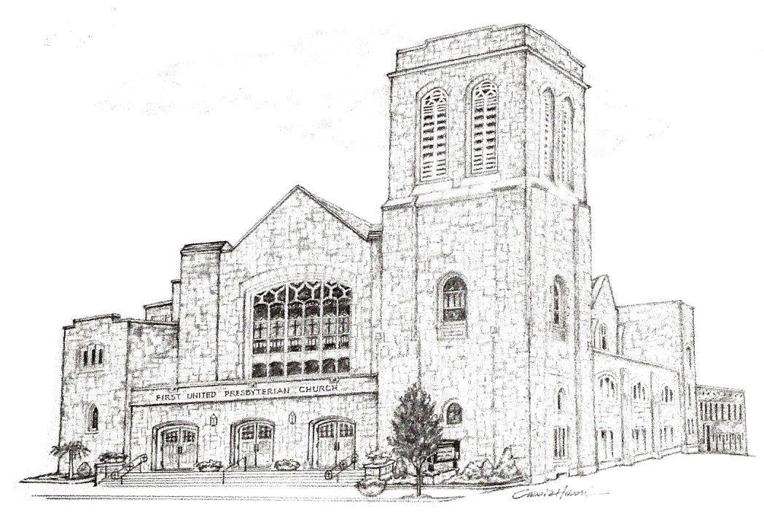

INDEX

Front Page…………………………………………………………………………………………………….…………………………1

Index ..……………………………………………………………………………………………………………………………………2

Annual Report of the Pastor ………………………………………………………………………………………………………3

FUPC Annual Joint Corporate and Congregational Meeting February 2021………….………..……….……….4

FUPC Annual Joint Corporate and Congregational Meeting November 2021………………………….………..5

Membership Statistics, Staff, Elders, Deacons ………………………………………………………..…………………..6

Deacons Report ………………………………………………………………………………………………………….…………..7

Deacons Treasurers Report …………………………………………………………………..……………………………….…8

Property Committee Report ………………………………………………………………………………..…………………….9

Mission Committee Report…………………………………………………………………………………………………..10-11

Christian Education Committee Report …………………………………………………………………………..…………12

Worship Committee Report ………………………………………………….…………………….……………………………13

Church Growth and Member Care Committee Report………………………………………………………………….14

Stewardship and Finance Committee Report………………………………………………………………………………15

General Operating Budget 2022……………………………………………………………………………………..…..16, 17

Endowment Fund Report…………………………………………………………………………………………………………18

Endowment Fund Spreadsheet……………………………………………………………………………………………19, 20

Presbyterian Women’s Association Report…………………………………………………………………………………21

Presbyterian Women’s Association Treasurer’s Report………………………………………………………………..22

Nominating Committee Report…………………………………………………………………………………………………23

Scholarship Committee Report…………………………………………………………………………………………………24

Vision Statement…………………………………………………………………………………………………………………….25

²⁰Those twelve stones, which they had taken out of the Jordan, Joshua set up in Gilgal, ²¹saying to the Israelites, “When your children ask their parents in time to come, ‘What do these stones mean?’ ²²then you shall let your children know, ‘Israel crossed over the Jordan here on dry ground.’ ²³For the Lord your God dried up the waters of the Jordan for you until you crossed over, as the Lord your God did to the Red Sea, which he dried up for us until we crossed over, ²⁴so that all the peoples of the earth may know that the hand of the Lord is mighty, and so that you may fear the Lord your God forever.” Joshua 4:20-24

Dear Members and Friends of 1st United Presbyterian Church,

The setting of this passage from Joshua takes place immediately after the Israelites crossed the Jordon River ending their forty years of wandering in the wilderness. According to the story the Jordon parted when the priests carried the Ark of the Covenant into the water… just like the Red Sea did for Moses and their parent’s generation when they fled Egypt, about forty years earlier. Joshua instructs the building of a 12 stone memorial so that they would remember what God had done for them; they were to tell their children. This call to remember what the Lord has done is a major reoccurring theme, call, and command throughout the entire length and breadth of the scriptures.

We are called to remember what God has done for us in the past, and then to look to Christ in our present. This helps us look into the future that the Holy Spirit has, is, and always will be preparing for us. That is one function of this Annual Report that you are holding. It is a memorial (though maybe not a dramatic as the 12 Stones memorial) to what God has been doing in, to, and through the members and friends of 1st UPC throughout 2021.

So, take a few minutes and read over all the pages of reports from our various committees. Take a look at what has been done and how God has been faithful even during this difficult time. As we move forward discerning the Spirit’s leading into the future God has for us, I ask you to join me in praying for the church.

In Christ,

Rev. Steve Merrin

First United Presbyterian Church
Joint Corporate and Congregational Meeting
2-21-2021

Meeting date & quorum
The Annual Congregational meeting had been set for January 31st. Due to heavy snowfall the meeting and church were cancelled. The meeting was rescheduled for February 21^{st.} Notice was given to the congregation via email on February 11th and announced during church service on Sunday the 14th.

Call To Order
Reverend Steve Merrin called the meeting to order. A quorum was declared with more than 10% of the membership present. (40 – 45 in person and 15 – 20 online.

Annual Report
Copies of the annual report were available to everyone present and had been available the previous two Sundays.

Minutes
The minutes from the January 26th 2020 congregational meeting and the minutes from the Fall Congregational Meeting on November 1, 2020 were approved with motions being made all voting in favor.

Pastor Terms of Call
Michael Brady, chairperson of the Stewardship and Finance committee presented the 2021 budget. Within the budget on page 19 of the annual report listed the Pastor’s budget/ terms of call. Rev. Merrin and family left the sanctuary as the terms were discussed. Michael shared that Pastor Steve did not request any changes be made to his terms of call. Motions were made to accept the Terms of Call. All voted in favor and motion passed. The Merrin’s were asked to return and Steve was informed that the terms were approved.

Budget
The 2021 budget had been presented by the Stewardship and Finance committee. Also approved by session. All members present approved the 2021 budget.

Approval of the Annual Report
With members having time to review the report, motions were made to approved the Annual Report. All were in favor; the 2020 report was approved.

Deacon & Nominating Committee Members
Rev. Merrin noted we had approved our Elders and some of our deacons and nominating committee at our November 2020 congregational meeting. The remaining positions have been secured.
Betty Lloyd was presented as a deacon for the class of 2023. Joyce Core and Carla Murdock were presented as nominating committee members for 2020. Motions were made to approve, Betty, Joyce and Carla for their positions. All were in favor with the motion passing.

Closing
Rev. Merrin closed the meeting with prayer.

Submitted in Christ Service

Karen Hesson Brady, Clerk of Session

1st United Presbyterian Church
Joint Corporate and Congregational Meeting
November 14th, 2021

The Fall Congregational Meeting was held on November 14, 202, after the congregation having been notified for 2 weeks prior to the date. Rev. Steve Merrin opened the meeting with prayer. The purpose of the meeting was to elect our Elders & Deacons for the class of 2024 & our Nominating Committee for 2022. It was also to provide an update on the church finances.

Nominations
Elders for the class of 2024:
Scott Costin, Margaret Dickenson, Beth Powers & Brandon Standley.

Deacons for the class or 2024:
Forest (Woody) Amidon, Mary Jane Lane, Suzi Neer & Pat Ortli.

Nominating Committee for 2022:
Holly Core, Mary Ann Patterson, Sara Stahler & Judy Wical.

A motion was made & seconded to close the nominations. A motion was made to approve the slate presented. The motion was seconded. Pastor Steve declared the motion passed.

Stewardship & Finance Report
Michael Brady, chairperson from the Stewardship and Finance Committee, provided a financial update. We are currently minus $18,719.00 from what is needed in our budget. Our Endowments are still making money, but we don’t want to live off the endowments. On a note of stewardship, Mike suggested we make a call to someone we haven’t seen in a while. Let them know they are missed.

There was no further business and Pastor Steve closed the meeting with prayer.

Submitted in Christ Service,

Karen Hesson Brady
Clerk of Session

MEMBERSHIP STATISTICAL REPORT

Communicant Members January 1, 2021………………………….263
Additions: Certificates, profession, restored, other 0
Losses: Deaths, Certificates, inactive roll, other……………………9

OFFICIAL MEMBERS

2011 2012 2013 2014 2015 2016 2017 2018 2019 2020 2021
Men 144 146 144 145 135 134 135 124 124 121 118
Women 195 200 199 196 165 166 167 147 145 145 145
Total 339 346 343 341 300 300 302 271 269 266 263

Family Units 214 194 192 191 190 164 163 163 139 139 139

STAFF

Pastor: Steven D. Merrin
Director of Christian Education & Youth Ministry: Anne Brienza/Trey Henderson
Treasurer: Sue Dearwester
Assistant Treasurer: Judy Wical
Secretary: Holly VanBuskirk
Custodian: Bret Stahler
Organist: Thomas W. Boone A.G.O.
Chancel Choir Director:
Handbell Choir Director: Cindy Jenkins

THE SESSION

Class of 2021 Class of 2022 Class of 2023
Aroon Datta Karl Kennedy Michael Brady
Vicky Shields Cindy Jenkins Mark Butler
Karen Brady Ruth Bowden Allen Hadley
Natasha Kennedy Adam Wunderle Bridget Hawkins

THE BOARD OF DEACONS

Class of 2021 Class of 2022 Class of 2023
Pam Ark Julie Caughenbaugh Sue Crawfis
Phyllis Lyons Laura Flora Betty Lloyd
Lois McKenzie Andrea Merrin Brenda Oda
Robyn Wunderle Julie Pulfer Holly VanBuskirk

2021 Board of Deacon’s Annual Report

A second year of Covid has come and gone. We have endured the changes and variations of the virus and have adjusted our routines accordingly to our beliefs.

The Deacon’s initiated 2021 with questions regarding the donation of our funds toward a better use. A representative of United Way, Dave Bezusko, was invited to give a presentation at the April meeting. His presentation was based on the 2021 Community Needs Assessment and showed that food is presently well funded. There were five identified needs: Mental Health, Substance Abuse, Housing, Workforce Collaboration and Healthy Living. As a result of these findings, the Deacon’s voted the Dinner at the Prez donation be stopped temporarily until COVID restrictions are lifted and the 2 cents a meal donation to Daily Bread be also stopped and volunteers offered to serve on the last Tuesday of the month. Use of 2 Cents a Meal donations were to be determined and the offering renamed 2 Cents for Compassion.

Deacons also were concerned regarding overlapping committee roles and Pastor Steve offered clarification.

In 2021, Deacon’s’ activities included a $1000 donation to Presbyterian Disaster Relief and a $1000 to Kirkmont to be used as needed, provision of daily meals over a 3-week period to one of our own congregation members until available services could be provided and volunteering at memorial services toward year’s end.

Funeral dinners were few. However, our services were provided as greeters on several occasions. A coffee hour was held after one memorial service instead of a meal. The loss of a beloved church member called us together with his family in a celebration of his life and dinner afterwards.

These were highlights of the year 2021 but do not include the monthly services of home visits, telephone calls, greeting cards, flowers, etc. that Deacons provide to our church family.

Respectfully submitted,
Phyllis Lyons
2021 Moderator

Board of Deacons Treasurers Report 2021

Our beginning balance for January: $2702.69

Deposits throughout the year from donations towards 2 Cents for Compassion and the 1stUPC Mission Funding: $3344.73

Payouts throughout the year to Kirkmont Center for use as needed for supplies, Kirkmont Center for camperships earned through the Building Blocks program, Presbyterian Disaster Assistance, Sweet Annie’s for Christmas flowers delivered to our homebound members, Pam Ark who takes care of card mailing to our homebound members: $3273.25

Our Funeral Dinner expenses were offset by donations of all items needed.

Our ending balance for the year: $2774.17

The Board of Deacons would like to thank the congregation for their continuing support of our missions!

2021 Property Ministry Team Report

Members, Art Lloyd, Bob Day, Brad Flora, Bret Stahler, Joe Forsythe, Karl Kennedy, Larry McCarthy, Ruth Bowden, & Steve Merrin.

First and foremost, I want to take this opportunity to thank the members of this team for their time and talents.

We are very conservative on the money that we spend.

We had 12 scheduled workdays, plus time when members would work on their own which include:

*Patching and painting mostly due to water damage throughout the church.
*Replace ceiling tiles at stage area due to ice buildup.
*Install water alarms at air conditioners for sanctuary.
*Plant flowers in the flower boxes.
*Holly Vanbuskirk painted the outside foyer at the main street entrance.
*Build safety railing in loft area at stage.
*Met with Cover Link Insurance to go over insurance questions.
*Place Presbyterian logo on the blocked-up windows at the back of the church.
*Took unused furniture to Habitat Store.
*Replace timer on refrigerator.
*Washed, sealed, and painted back parking lot.
*Rebuilt five toilets due to water usage.
*Power washed front of steps and planters. Prune tree,& bushes. Cleaned flowerbeds.
*Quality Paving worked on north alley due to water leakage into church.
*Repair lounge area floor due to rotten wood.
*Complete restoration of three pulpit chairs including reupholstery.
*Switch from Peacock Water and Hague Water to Easton Water due to cost savings.
*Cleaned church after Christmas Eve service.

We diid all the yearly inspections: boiler and maintenance, elevator, fire extinguishers, and roof.
Did many other smaller things from changing lightbulbs, Sloan Valves, furnace filters and anything else that needed done.

Respectfully submitted,
Karl Kennedy
Property Committee Chair

MISSION AND OUTREACH MINISTRY TEAM
First United Presbyterian Church
Annual Report 2021
Team Members: Cindy Jenkins (Chair). Mark Butler, Sue Crawfis, Bridget Hawkins, Vicky Shields, Michelle Suman, Holly VanBuskirk
OUR MISSION: It is the mission of this ministry team to encourage and enable the First United Presbyterian Church family of faith to reach out and serve both our local community as well as God’s people throughout the world in the name of Jesus Christ, our Lord and Savior. To that end, in 2021 we carried out a number of projects that impacted others in a positive way.
Due to the COVID-19 global pandemic, our monthly Dinner at the Pres was cancelled for the year. We are hopeful that at some point in 2022 we will again be able to host this meal.
BAGS FOR THE HOMELESS: Early in 2021 we prepared 10 bags to be taken to the homeless shelter in Bellefontaine. Included in the bags were toiletry items, food items, socks donated by Community Wellness Partners, hat, scarf, gloves, and a prayer cloth and inspirational card. At the beginning of summer, an additional 10 bags were filled with similar items appropriate for the summer season, including toothbrushes donated by Dr. Todd Heydinger, DDS. We also donated a bag of full size toiletries for use at the homeless shelter.
BELLEFONTAINE CITY SCHOOLS NURSES: One of our newer projects (taking the place of the back to school sharing tree) was to help our school nurses with some of the needs they have for students in their respective schools. This year we assisted them in early 2021 as well as in the fall for the start of school. Some of the items we provided to the school nurses for the various schools were: sweat pants and leggings, underwear, personal care items, toiletry and grooming items, and paper products. The nurses appreciated receiving these items that they often buy out of their own pocket.
ONE GREAT HOUR OF SHARING: This special offering was collected during Lent. For the first time in several years we were able to attain our goal of $2021.00! This offering benefits many people in need throughout the world.
OTHER SPECIAL OFFERINGS: In addition to OGHS, our congregation participated in 3 other special offerings. The Pentecost Offering was collected in May, while the Peace and Global Mission Offering was collected in the fall. A portion of these offerings stays with us and will help us to prepare more bags for the homeless. During Advent, the Christmas Joy offering was collected. It helps support church workers worldwide who are experiencing trying circumstances, at any time during their career.
ADULT MISSION TRIP: Five adults from the congregation traveled to Trotwood, near Dayton, Ohio, June 28-30, to assist with construction and repair of tornado damaged houses. This mission trip was sponsored by Brethren Disaster Ministries in partnership with our Presbytery. Participants worked at installing siding and windows, worked on bathroom construction, did interior painting, and landscaping. Although the weather was extremely hot and humid, all felt that it was a really worthwhile project! Those making the trip were: Anne Brienza, Bob Core, Cindy Jenkins, Larry McCarthy, and Steve Merrin.
BELLEFONTAINE CRUISE-IN: Despite the continuing pandemic, we were able to participate in the Cruise-In during August. This event had been cancelled in 2020. We served up our traditional brats and hot dogs, as well as delicious homemade pies donated by members of the congregation. In addition, we offered church tours given by Vicky Shields, and Bret Stahler and the 1st UPC youth did face painting and balloon animals. We would like to thank all those that helped or stopped by to have a meal and support us with a donation!
SHARING TREE FOR THE SUCCESS CENTER: In October, Molli Jackson, Coordinator of the Success Center at Bellefontaine High School, came and spoke during worship about the needs of her students. These students are sometimes working part-time, do virtual learning, or have other reasons that they can’t complete their schooling in the traditional way. Some of their needs were for shoes, and for Chieftain t-shirts that would help them participate in spirit days and feel part of the school culture at BHS. With money collected with a special Sharing Tree, we were able to give 4 shoe vouchers for needy students and to purchase 67 Chieftain t-shirts for these students. Thank you to everyone who donated toward this worthwhile project. The students were thrilled!
CHRISTMAS SHARING TREE: 25 families had a brighter Christmas as our congregation donated money for generous food baskets that included a ham, a large assortment of canned goods and meats, side dishes, bread, milk, eggs, and fruit. 17 children were also sponsored and received gifts and clothing. We were able to have a children’s shopping area this year too. A HUGE thank you goes out to everyone who helped in any way with the organization, donations of food and money, shopping, and distribution of the baskets and gifts. We thank you so much for donating your time and energy to this worthwhile cause.
THANK YOU!
The Mission and Outreach Ministry Team could not do any of this without YOU. We thank all of you who continue to support these projects that serve as the “hands and feet” of our church. Whether your support is by service, by donations, or in prayer, we thank you! We are always looking for new members to join us in our efforts and to help to come up with and carry out new ideas to serve the community and beyond. Please feel free to join us at our meetings on the second Tuesday of the month at 7:00pm in the church Library. We look forward to seeing you!
In Christ’s Service,
Cindy Jenkins
Chair, Mission and Outreach Ministry Team

Christian Education Ministry Team 2021

This was a year of many transitions for the CE Committee. As Covid-19 was still lingering, we encouraged the continuing of social distancing and mask wearing for our teachers and kids.

Anne Brienza adjusted her duties from Director of Christian Education to Director of Faith Formation, allowing the youth programs to be taken over by the Merrins. After Anne’s retirement, Trey Henderson was hired to take over as Interim CE Director.

The youth met twice monthly enjoying many activities including a Super Bowl Gathering, Laser Tag and Kahoot Bible Trivia games.

The Sunday School classes worked on their Building Blocks and did other projects along with making cards to send to those children who have not been attending.

Members of the Committee joined together to clean out the Craft Room. Joan Smith continues to keep the entrance to the Chapel up to date with the seasons as she puts together the bulletin board on a monthly basis.

Summer activities for the youth began with mulching and flower planting for various members of the congregation. Eleven youth members ventured to Michigan with chaperones Andrea Merrin and Michelle Suman for a mission trip. For three days they worked with Motown Missions helping to hand out lunches, restock a commissary, weed a community garden, and learn the inner workings of a soup kitchen.

Summer Sunday School was set up on a rotation structure, allowing various volunteers to teach different lessons centered around the Word of God. Bible skills and games, art, science and cooking were the highlights.

Vacation Bible School ran July 26-30. Approximately 30 children enjoyed many activities beginning in the morning in the Church Fellowship Hall and then moving to Kirkmont Center for a day of activities!
In addition, ten of our youth took advantage of the Day Camps at Kirkmont throughout the summer.

After sending out postcards as invitations, our Sunday School Kick Off in September began with a pancake breakfast! We introduced our Sunday School teachers for the year and discussed what everyone could look for in the future. We recognized and thanked our Summer Sunday School teachers for their hard work and dedication.

Rounding out the year was the Children’s Christmas Musical. Twelve of our very youngest members dressed as angels, shepherds, wise men, and Mary and Joseph to tell the story of the Nativity. Trey Henderson led them in song and dance to the delight of the congregation.

Looking forward into 2022 we are hopeful to continue a path of bringing more families into the church!

First United Presbyterian Church
Worship and Congregational Life Ministry Team
2021

2021 was an interesting year for the Worship Committee. Due to the restrictions of Covid-19, we were limited in many areas of our weekly worship service. However, we persevered!!

Beginning January, people were still a bit cautious about attending church in-person. We did and are continuing to stream our weekly worship service through You Tube and our Facebook page.

As we neared the Lenten Season, three Lenten Prayer Stations were assembled, each having a section for adults and children. These stations explained what the Lenten Season involves with questions to be answered. Those answers were written on provided paper and kept for the Pastor to approach in his sermon if necessary.

On Maundy Thursday, we had a small Communion service with self-serve Communion wafer and juice packs provided. Our Good Friday Service was accessible online with a video explaining the Stations of the Cross. Easter morning, we enjoyed a Sunrise Service held at the Kirkmont Pavilion. A small, masked choir assembled for our regularly scheduled Easter Service. This was the first time we had a choir sing in many months.

The Jenny Bell Award was discussed and opened to include those people who participate in the Hand Bell Choir. This year’s recipient is Carla Murdock.

As the Season of Advent began, and some Covid-19 restrictions were relaxed, many people showed up to help decorate the church with the Hanging of the Greens.

For the first time in two years, we were able to enjoy a Christ Potluck Lunch for the congregation.

We were fortunate to have wonderful families who lit the candles of the Advent Wreath each week. Our Christmas Eve service was well attended with Addy, Quincy, and Baby Mo Coleman depicting the Holy Family. Other members of the congregation rounded out the parts of animals, shepherds, Wise Men and Angels.

Looking ahead we are hoping to raise a Puppet Ministry including both children and adults. A Praise Band is in the works as well.

As always, the Worship Committee would welcome any new members to it ranks!! There are many plans for our services as we continue to welcome more of the congregation back into the building!

CHURCH GROWTH AND MEMBER CARE
First United Presbyterian Church
2021 Annual Report

Team members: Natasha R. Kennedy (Elder-Chair), Vicky Shields (Elder), Judy Wical, Phyllis Lyons (Deacon Rep), Beth Powers, Becky Lentz and Pastor Steve Merrin

Our mission is to actively share our faith with first time visitors through home visitation and information sharing, discerning their needs and interests with a goal to help them discover if this family of believers is right for them. We are also committed to encouraging our church family to participate in our programs of worship, fellowship, service, and learning. The team also monitors membership rolls to determine active or inactive status.

The Church Growth and Member Care activities in 2021 included but were not limited to:

CHURCH GROWTH
Joined the Logan County Chamber of Commerce
Speaking engagements at first Thursday Chamber event and Kiwanis Club of Bellefontaine
Planned and organized the downtown church walking tour
Discussed a plan of action to clean up the church rolls
Discussed plans for a 5k in 2022
Discussed plans for FUPC shirts in 2022

MEMBER CARE
Planned and organized the Fall Family Festival
Assumed the role of organizing coffee hour
Created handmade greeting cards to send to those who have been worshiping at home
Worked with other teams to plan Kick-Off Sunday
Found nursey attendant to help care for the younger children during Sunday school and Worship
Planned for the creation of a bulletin board in memory of Gene Marine that would display newspaper articles related to our church family members, a project created by Gene many years ago.

Church Growth in collaboration with the Methodist , Lutheran and Christian churches did a walking tour or churches during the 1st first Friday Christmas parade from 5PM to 7 PM. During this time the community at large was invited to come into the churches and see the beautifully decorated sanctuaries! At our church visitors heard the organ being played by Tom and was treated to information amount our beginnings to current information about us. They also got a nice warm cup of chocolate or Tea and a cookie. Pamphlets were given to everyone to take on the church services and other valuable information. They were encouraged to see the other local churches as well. We are hoping to make this a yearly event. We were blessed with about 80 visitors!

Thank you to all who helped plan, organize, and implement the various ideas of the Church Growth and Member Care Team. We look forward to a prosperous 2022. If you would like to join our crew, please let one of us know. We would love to have you!
Yours in Christ,

Natasha R. Kennedy
Church Growth and Member Care, Chair

Stewardship and Finance Ministry Team
Annual Report for 2021

For 2021, team members are Michael Brady- Chair, Bridget Hawkins- Elder, Sue Dearwester- Church Treasurer, Jim Hilliker, Gary McKenzie, and Warren Taylor. This team is staffed by Pastor Steve Merrin and Church Financial Secretary Holly VanBuskirk.

The Annual In-House Audit was performed on February 13, 2021, looking at the records for the year 2020. Everything was found to be in good order and well organized. No items of concern were found.

The team continued to meet monthly through the year. There was always a review of financial reports from the various committees that are funded by the church and found expenses are within the budget. The team compared actual income and expenditures with the budget. Those numbers were then reported to Session at each of their meetings.

Our Stewardship Champaign began later than usual. Stewardship Sunday was set for November 28th. Highlighting that we are still, and want to continue to be an active church, our total pledging for 2022 is as follows:

53 Pledges received totaling: $179,043.20
24 Pledges remained the same totaling: $88,701.20
21 Pledges increased totaling: $78,012.00
4 Pledges decreased totaling: $2,920.00
4 Pledges are new totaling: $4,930.00
1 Pledge was not renewed totaling: $600.00

Family Pledges: 28
Individual Pledges: 25

In comparison, total pledges for prior years are as follows:

2021- 62 Pledges totaling $187,321.20
2020- 67 Pledges totaling $192.751.00
2019- 62 Pledges totaling $186,361.00
2018- 76 Pledges totaling $212,840.00
2017- 78 Pledges totaling $221,773.00

The budget for 2022 has been set and approved by Session, based on income from our Pledgers, projected numbers from Non-Pledgers, the Loose Offering, Sunday School Offering, funds from the Endowments, and income from outside sources renting the Fellowship Hall. This year we are hopeful and confident that support from our church family will be strong.

The Stewardship and Finance Ministry Team thanks all those who continue to support our church with their time, talents, and treasures. THANK YOU!

Respectfully submitted,

Michael Brady
Chairperson

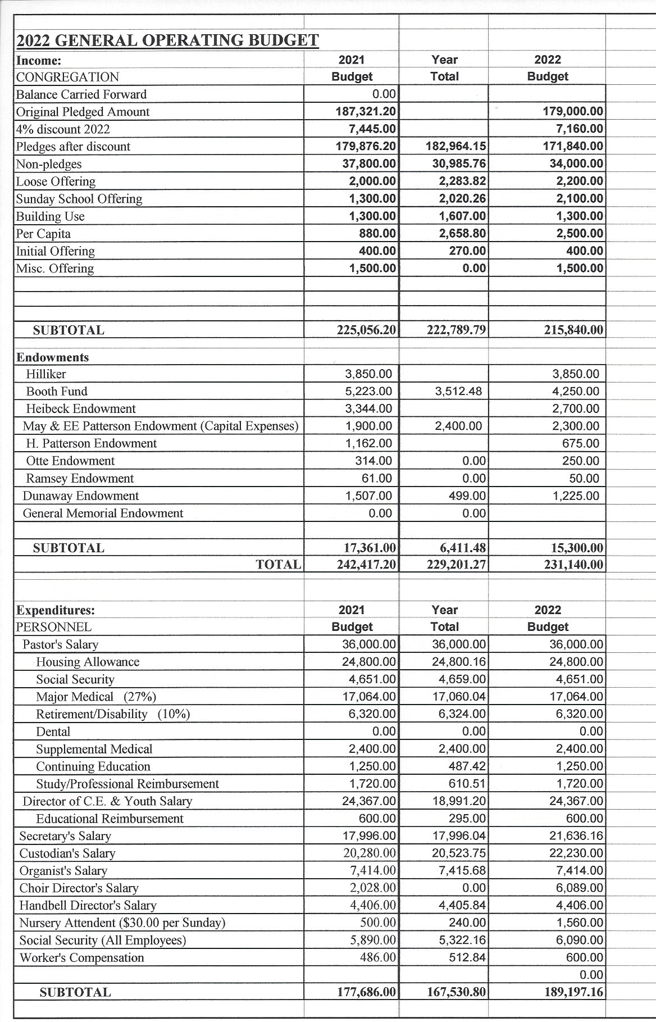

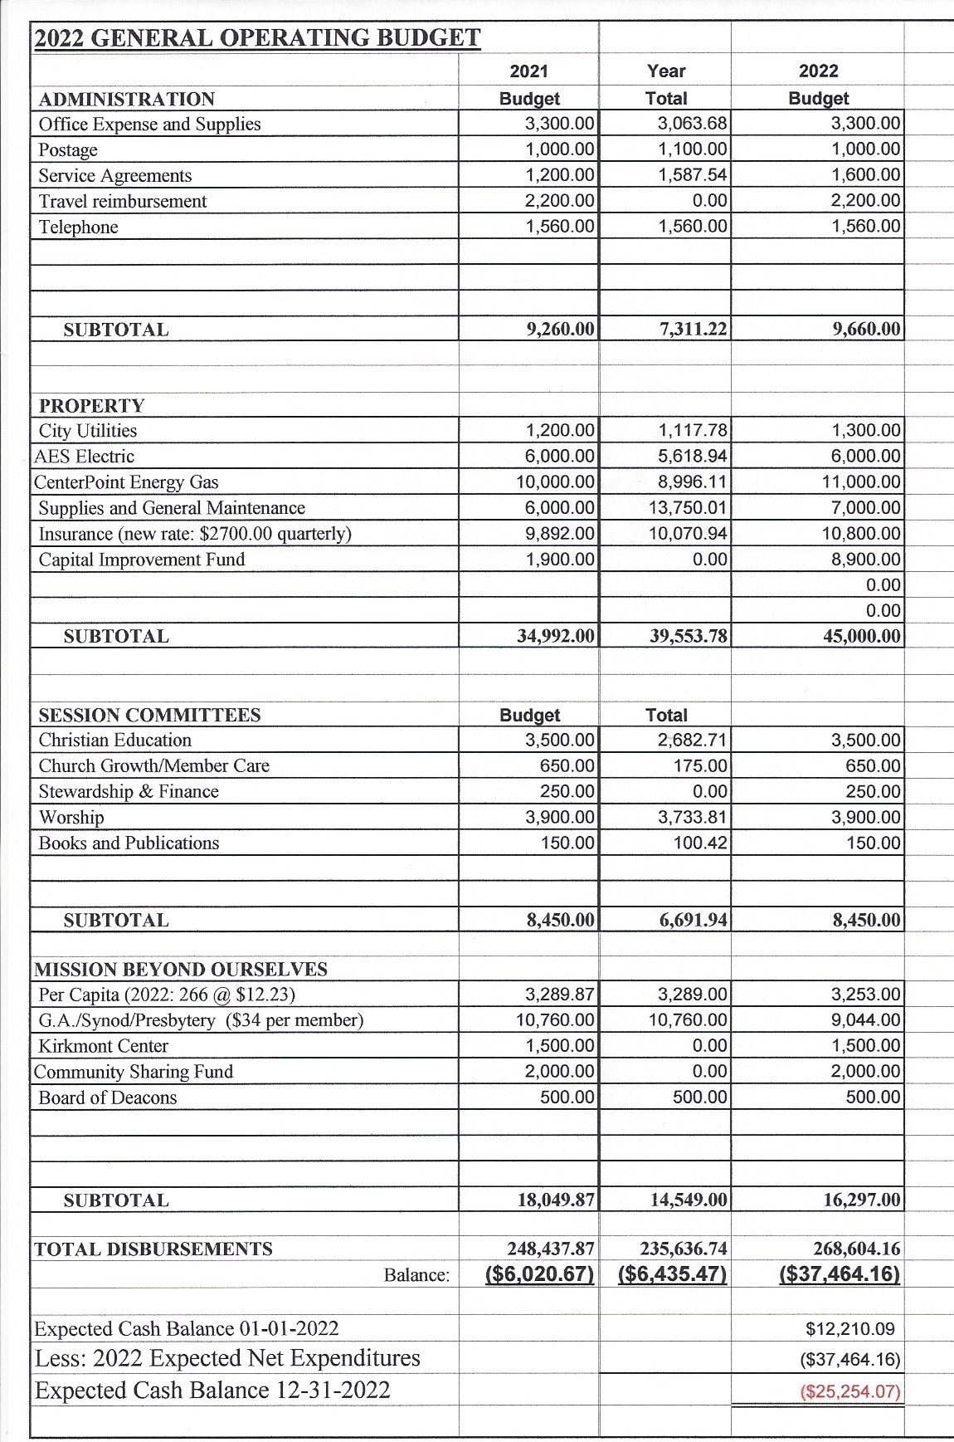

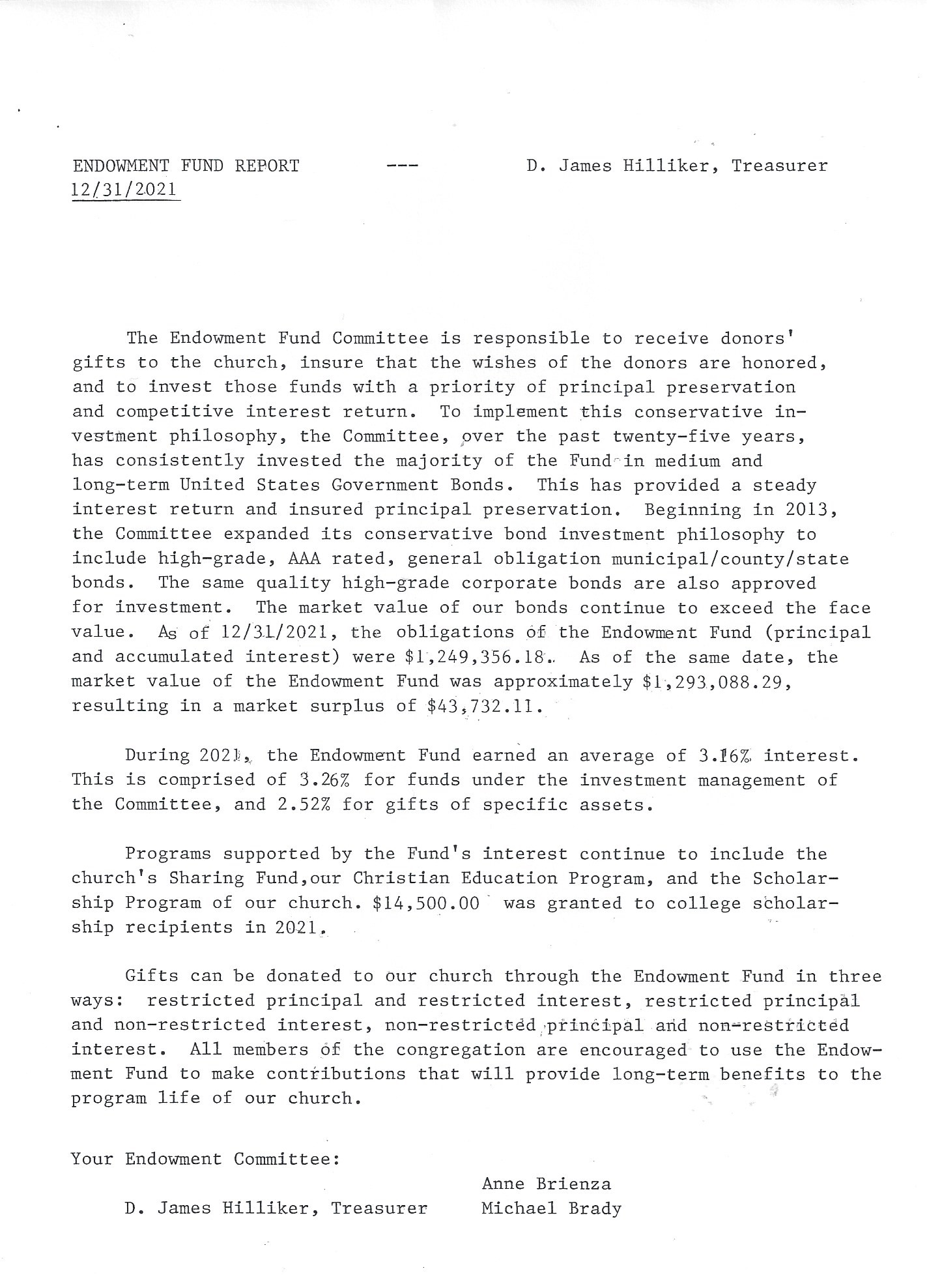

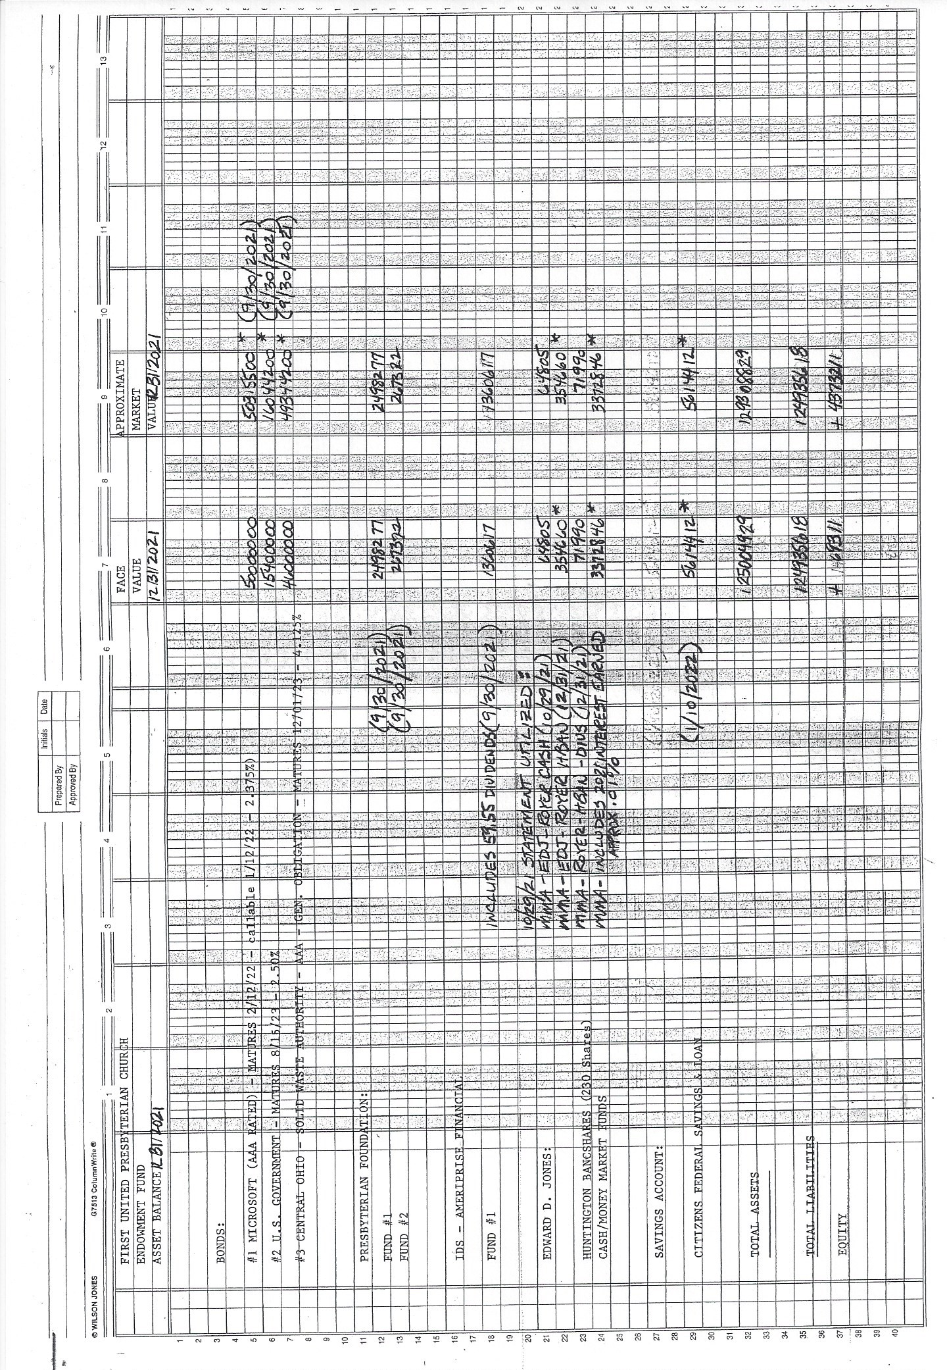

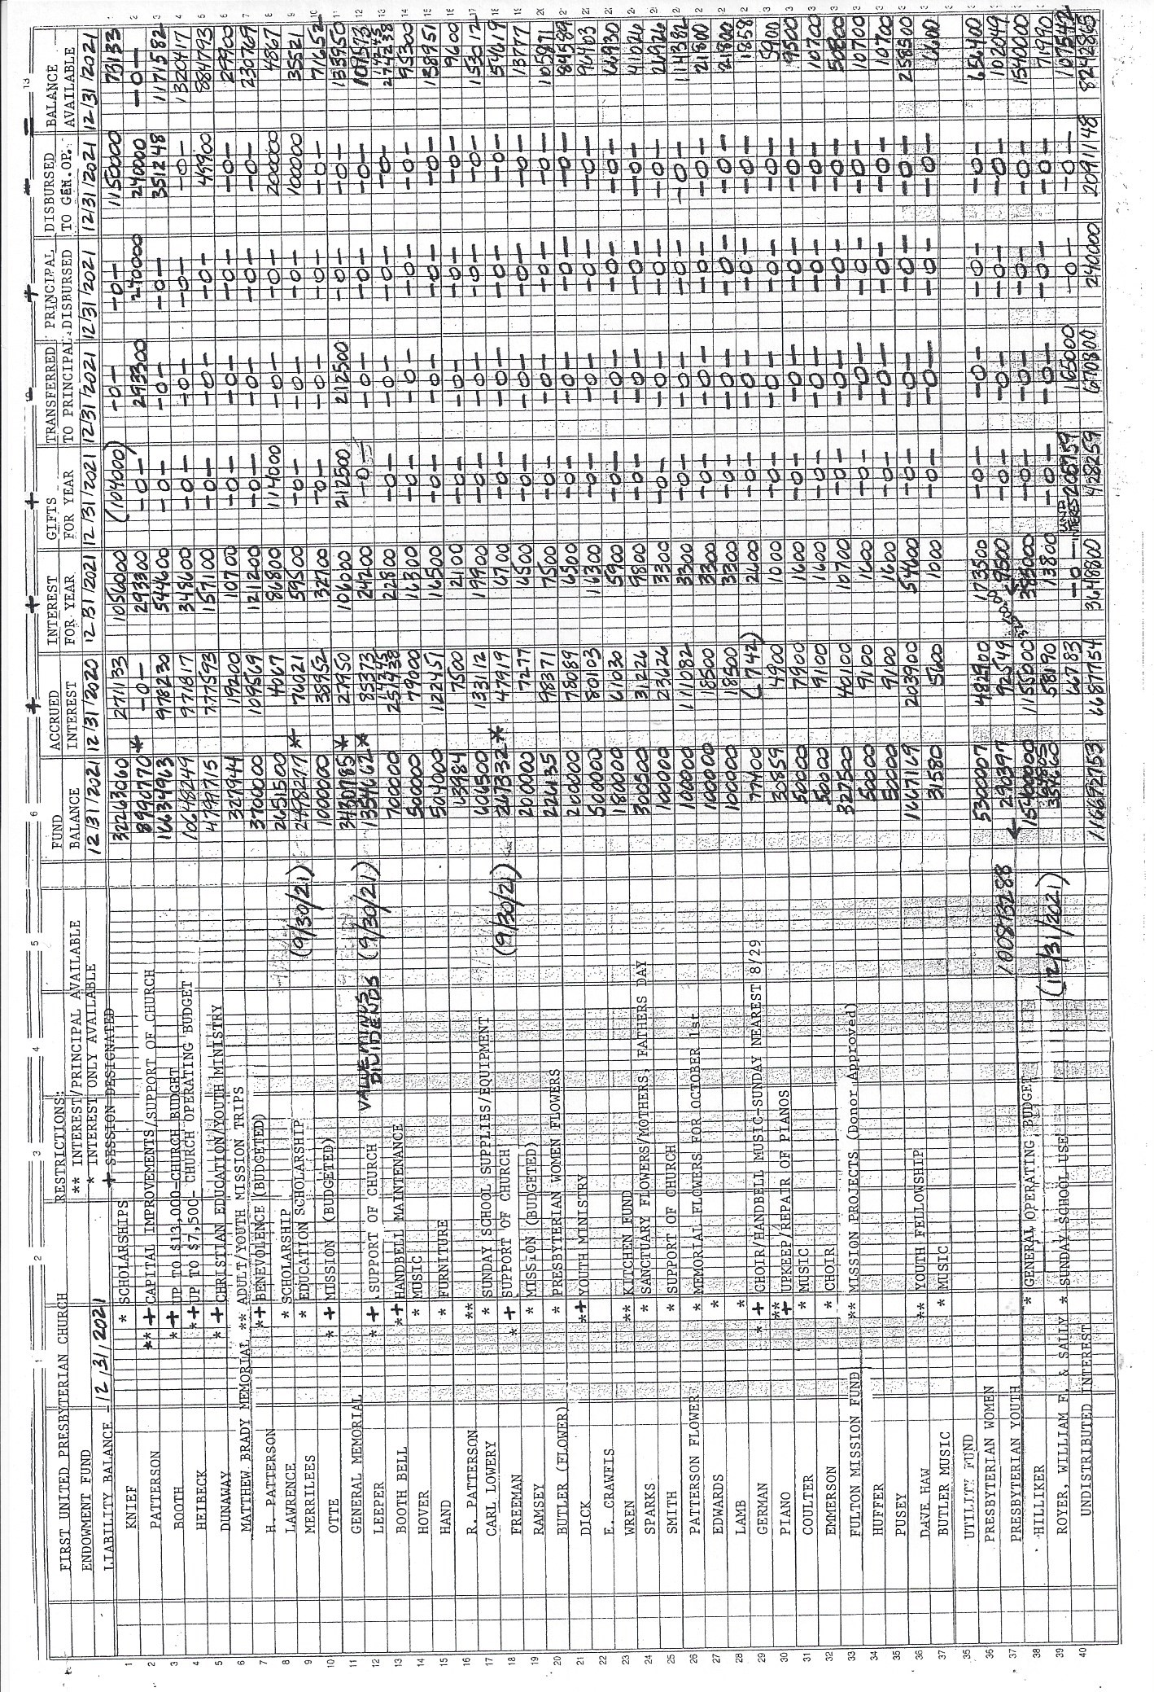

PWA 2020-2021 ANNUAL REPORT

2020 – The year 2020 the year of the pandemic resulting in cancellation of our normal activities in March 2020. Under the leadership of our Moderator, Natasha Kennedy we were able to send out the Valentine treats to college students and those in the military. In addition, we prepared the chocolate eggs for Easter and they were sold and distributed. The PWA Book club continued, and we met outside and via zoom when the weather no longer permitted outside gatherings. No other activities were conducted by the PWA in 2020.
2021 – The pandemic continued through 2021 and once again the Presbyterian Women were limited in what activities we could participate in.
PWA Book Club – The book club met monthly in 2021 under the leadership of Karen Brady. We read and discussed many interesting books.
In February we once again sent Valentine treats (McDonald’s gift cards) and Valentine cards to our college students.
In July we gathered together at the Olive Tree in Bellefontaine on their patio enjoying the fellowship of one another and participated in tasting a variety of sauces, salsas, and oils. Approximately 22 women participated in this event. A good time was had by all.
In October in preparation for the election day luncheon, Noodle making took place over three Tuesdays in October. Many volunteers participated in this activity.
In November the Election Day Luncheon was held. Due to the pandemic the luncheon was limited to carry outs and deliveries. The luncheon was spearheaded by Andrea Merrin and with the assistance of Sarah Stahler and Sue Crawfis as well as many other volunteers the luncheon was a success. The PWA thanks everyone who participated and made this luncheon a success.
The nominating committee met on December 2, 2021 to nominate those to serve on the PWA 2022 Coordinating Team: Natasha Kennedy shall be moved to Moderator, Anne Brienza, Vice Moderator, Karen Brady, Treasurer, Judy Wical as Secretary, Holly Core, Eva Rinehart, Ruth Bowden, and Jamie McClellan will serve as team members. Bridget Hawkins will serve as Past Moderator.
Through fundraising and endowment interest we provided funds for new baby roses, paper products, Kirkmont and meat for our Christmas meal. Funds will also be sent to Miami Valley Presbytery for mission and from the least coin offering.
I would like to thank all the women of the church for keeping our association active during 2020 and 2021 and we hope for bigger and better things in 2022. It has been my pleasure to serve as your Moderator.
Sincerely in Christ’s Service,
Bridget D. Hawkins
PWA Moderator

Presbyterian Womens Association Treasurers Report

Our beginning balance for the year 2021: 1497.16

Deposits/Interest earned throughout the year: $ .67

Paid out for supplies for the Election Day Luncheon: $333.33

Ending Balance for 2021: $1146.50

2021 NOMINATING COMMITTEE

Karen Brady Chair, Vicky Shields Elder, Betty Lloyd Deacon, Carla Murdock, Joyce Core, Nancy Wisse.

Treasurer: Sue Dearwester

Elder class 2024
Scott Costin
Margaret Dickenson
Beth Powers
Brandon Standley

Deacon class of 2024
Woody Amidon
Mary Jane Lane
Suzi Neer
Pat Ortli

Nominating Committee 2022
Holly Core
Mary Ann Patterson
Sara Stahler
Judy Wical

2021 HIGHER EDUCATION SCHOLARSHIP REPORT

Members: Beth Powers Chair, Mark Barlow, Mike Brady, Mark Butler, Joyce Core, Bob Day,
Kyle Lentz
Staff: Anne Brienza

Through the generosity of the estates of Richard and Evaline Knief, Wayne and Pearl Lawrence and Nancy J Merrilees , $14,500 has been awarded to fourteen students who are members of First United Presbyterian Church, Bellefontaine, First Presbyterian Church, Belle Center and Huntsville Presbyterian Church (all PCUSA churches).

Bellefontaine First United Presbyterian Church
Kaitey Chervenak Ben Core
Caroline Eader Olivia Eader*
Elijah Merrin** Ben Sailors*

Belle Center United Presbyterian Church
Grace Beaverson Megan Beaverson
Denay Brunner Faith Butler
Alex Jacobs Clay Jacobs

Huntsville Presbyterian Church
Matt Risner Jacob Zarnosky

Those with no designation received the Richard and Evaline Knief Scholarship
*Lawrence Scholarship Recipients
** Nancy J. Merrilees Scholarship for education majors

We wish to thank our benefactors who established these endowments to support higher learning in our Presbyterian youth.

Respectfully submitted,

Beth Powers
Chairperson

VISION STATEMENT
of the
First United Presbyterian Church
Bellefontaine, Ohio

Responding to the amazing grace of God made real in our lives
by the power of the Holy Spirit,
we are a community of faith called to witness to the Good News of God’s love
for all people.

Our congregation will be a vital, vibrant center of
Christian faith and practice
where Jesus Christ is personally known,
where people’s needs are truly met,
from which people are sent
scattered in effective ministry and mission
in the home, the marketplace, the community, and the world.

We will build our church on the firm foundation of Jesus Christ
who is Lord and head of the Church,
and upon the rich heritage of our congregation.
We will embrace the wonderful diversity of our God-given gifts,
yet value the common life of faith we share together
as followers of Christ.

As disciples of the Living Lord, we are called to:
witness to the glory of God,
care for one another in the community of faith,
minister to the needs and challenges of our individual members,
nourish growth toward faithful discipleship,
give ourselves in ministry as servants of the gospel,
Work to establish local and international missions,
respond in faithfulness to the changing issues of the world,
inviting all people to share in the joy of Christian faithfulness.

From the heart of a city set high on a hill,
we believe we are called to live the teaching of our Lord Jesus Christ:
“Your light must shine in the sight of all people,
so that seeing your good deeds,
they may give praise to your Father in heaven.”
(Matthew 5:16)

Reaching Out to Nurture God’s People with the
Good News of Christ’s Love!

